UNITED STATES
SECURITIES AND EXCHANGE COMMISSION
Washington, D.C. 20549
______________________
FORM 8-K
______________________
CURRENT REPORT
Pursuant to Section 13 or 15(d)
of the Securities Exchange Act of 1934
Date of Report (Date of earliest event reported): May 1, 2026
______________________
Origin Materials, Inc.
(Exact name of registrant as specified in its charter)
______________________
Delaware |  |  | 001-39378 |  |  | 87-1388928
(State or other jurisdiction  of incorporation) |  |  | (Commission  File Number) |  |  | (IRS Employer  Identification No.)

930 Riverside Parkway, Suite 10  West Sacramento, CA |  |  | 95605
(Address of principal executive offices) |  |  | (Zip Code)
Registrant’s telephone number, including area code: +1 (916) 231-9329
N/A
(Former Name or Former Address, if Changed Since Last Report)
______________________
Check the appropriate box below if the Form 8-K filing is intended to simultaneously satisfy the filing obligations of the registrant under any of the following provisions:
☐ |  |  | Written communications pursuant to Rule 425 under the Securities Act (17 CFR 230.425)
☐ |  |  | Soliciting material pursuant to Rule 14a-12 under the Exchange Act (17 CFR 240.14a-12)
☐ |  |  | Pre-commencement communications pursuant to Rule 14d-2(b) under the Exchange Act (17 CFR 240.14d-2(b))
☐ |  |  | Pre-commencement communications pursuant to Rule 13e-4(c) under the Exchange Act (17 CFR 240.13e-4(c))
Securities registered pursuant to Section 12(b) of the Act:

Title of each class |  |  |  |  |  | Trading  Symbol(s) |  |  |  |  |  | Name of each exchange  on which registered
Common Stock, par value $0.0001 per share |  |  |  |  |  | ORGN |  |  |  |  |  | The NASDAQ Capital Market
Warrants, each whole warrant exercisable for 1/30th of a share of Common Stock at an exercise price of $11.50 per share |  |  |  |  |  | ORGNW |  |  |  |  |  | The NASDAQ Capital Market
Indicate by check mark whether the registrant is an emerging growth company as defined in Rule 405 of the Securities Act of 1933 (§230.405 of this chapter) or Rule 12b-2 of the Securities Exchange Act of 1934 (§240.12b-2 of this chapter).
Emerging growth company ☐
If an emerging growth company, indicate by check mark if the registrant has elected not to use the extended transition period for complying with any new or revised financial accounting standards provided pursuant to Section 13(a) of the Exchange Act. ☐

Item 2.05 Costs Associated with Exit or Disposal Activities
On May 1, 2026, Origin Materials, Inc. (the “Company” or “Origin”) announced that its the Board of Directors (the “Board”) had approved the dissolution and liquidation of the Company pursuant to a plan of complete liquidation and dissolution (the “Plan of Dissolution”), subject to stockholder approval. Origin intends to call a special meeting of the stockholders to seek approval of the Plan of Dissolution and will file proxy materials relating to the special meeting with the Securities and Exchange Commission (the “SEC”) as soon as practicable.
In connection with the Plan of Dissolution, the Board also approved a reduction-in-force, which Origin implemented on May 1, 2026 to enable Origin to maximize shareholder value through the orderly sale of its technology and assets followed by dissolution and wind down. To reduce costs and support the planned sale and wind down, Origin is reducing its workforce by approximately 59%, resulting in an approximately $14.0 million decrease in annual operating expenses. Origin anticipates that it will incur approximately $2.1 million in restructuring charges in connection with the workforce reduction, primarily consisting of cash expenditures of approximately $2.1 million for severance and benefits costs. Origin expects to incur the majority of expenses related to the workforce reduction by the end of the second quarter of 2026. The estimated charges are subject to a number of assumptions, including legal requirements in various jurisdictions, and actual results may differ materially from these estimates. Origin may incur additional costs not currently contemplated due to events that may occur as a result of, or that are associated with, the workforce reduction.

Item 5.02 Departure of Directors or Certain Officers; Election of Directors; Appointment of Certain Officers; Compensatory Arrangements of Certain Officers.
Departure of Executive Officer
In connection with the reduction-in-force discussed in Item 2.05 above, John Bissell has stepped down as Chief Executive Officer, effective May 1, 2026. Mr. Bissell will continue to serve as a director on the Board. Mr. Bissell is entitled to certain severance payments pursuant to an Executive Officer Retention Agreement, dated March 9, 2026, the form of which is filed as Exhibit 10.45 to the Company’s Amendment No. 1 to its Annual Report on Form 10-K filed with the SEC on April 29, 2026. Pursuant to such agreement, provided Mr. Bissell provides Origin with a release of claims covering the period of his employment:
•Mr. Bissell will receive a severance payment equivalent to four months of his base salary plus four months of COBRA benefits premiums, less applicable withholdings and deductions.
Appointment of Executive Officer
Matt Plavan, age 62, our Chief Financial Officer and Chief Operating Officer has been appointed Interim Chief Executive Officer, effective May 1, 2026. Mr. Plavan has no family relationships with any member of Origin’s board of directors or Origin’s other executive officers. For additional information regarding Mr. Plavan required by this Item 5.02 please see Origin’s Amendment No. 1 to its Annual Report on Form 10-K filed with the SEC on April 29, 2026.
Amended and Restated Retention Agreements
To retain their services implementing the dissolution and liquidation of the Company, Mr. Plavan and our General Counsel and Chief Compliance Officer, Joshua Lee, each entered into an Amended and Restated Executive Officer Retention Agreement and General Release, dated May 1, 2026 (an "A&R Retention Agreement"), a copy of the form of which is attached to this Current Report on Form 8-K as
1

Exhibit 10.1. The A&R Retention Agreement amends and restates the Executive Officer Retention Agreements (each a "Retention Agreement") that Messrs. Plavan and Lee entered into in March 2026, a copy of the form of which is filed as exhibit 10.45 to Amendment No. 1 to its Annual Report on Form 10-K filed with the SEC on April 29, 2026. Pursuant to the A&R Retention Agreements, Messrs. Plavan and Lee each signed and provided the Company with a release of claims covering the period of their employment through the effective date of the A&R Retention Agreement (the "First Release"). In lieu of the benefits described in the prior Retention Agreements, the A&R Retention Agreements provide that Messrs. Plavan and Lee will be entitled to:
•a 25% increase to their respective base salary; and
•a retention bonus (Mr. Plavan - $183,618 and Mr. Lee - $153,696) such amount equal to six months of their respective base salaries and six months of COBRA benefits premiums, paid 20% in the last pay period of each month for up to four months, with the final payment of 20% paid upon the termination of Messrs. Plavan's and Lee's employment, other than for cause, provided that each timely signs and provides the Company with an effective release of claims covering the period from the First Release through the date of terminations.
In addition, in the event Mr. Plavan or Mr. Lee is terminated other than for cause prior to receiving one or more of the four monthly payments, their final payment upon termination would include such payments in addition to the final 20% payment. Messrs. Plavan and Lee will not be eligible for any additional or separate severance payments.
Forward-Looking Statements
This Current Report on Form 8-K contains certain forward-looking statements within the meaning of the federal securities laws. These statements are based on our estimates and assumptions as of the date of the Current Report on Form 8-K and are subject to risks and uncertainties. Forward-looking statements generally are accompanied by words such as “believe,” “may,” “will,” “estimate,” “continue,” “anticipate,” “intend,” “expect,” “should,” “would,” “plan,” “predict,” “project,” “potential,” “seem,” “seek,” “target,” “future,” “outlook,” “guidance,” “maintain,” and similar expressions that predict or indicate future events or trends or that are not statements of historical matters. For example, all statements Origin makes regarding the proposed dissolution pursuant to the Plan of Dissolution, timing of filing of the certificate of dissolution and holding a special shareholder meeting to approve the Plan of Dissolution, the amount and timing of liquidating distributions, if any, in connection with the dissolution, the amount of planned reserves, Origin’s ability to maximize shareholder value through the orderly sale of its technology and assets, the estimate and timing of the charges that will be incurred and actual reductions in operating expenses achieved in connection with the reduction in headcount, and similar statements are forward-looking. All forward-looking statements are based on various assumptions, whether or not identified in this Current Report on Form 8-K, and on the current expectations of Origin’s management, and are not predictions of actual performance. Such risks and uncertainties include, among others, the availability, timing and amount of liquidating distributions; the amounts that will need to be set aside by Origin; the adequacy of such reserves to satisfy Origin’s obligations; potential unknown contingencies or liabilities, including tax claims, and Origin’s ability to favorably resolve them or at all; the amount of proceeds that might be realized from the sale or other disposition of any remaining assets; the application of, and any changes in, applicable tax laws, regulations, administrative practices, principles and interpretations; the incurrence by Origin of expenses relating to the dissolution; the ability of the Board of Directors to abandon, modify or delay implementation of the Plan of Dissolution, even after shareholder approval; and the uncertain macroeconomic environment. These forward-looking statements are provided for illustrative purposes only and are not intended to serve as, and you must not rely on them as, a guarantee, an assurance, a prediction, or a definitive statement of fact or probability. Actual events and
2

circumstances are difficult or impossible to predict and will differ from assumptions. Many actual events and circumstances are beyond Origin’s control. These forward-looking statements are subject to a number of risks and uncertainties including those factors discussed in Origin’s Annual Report on Form 10-K filed with the SEC on March 30, 2026 under the heading “Risk Factors,” and other documents Origin has filed, or will file, with the SEC. These filings, when available, are available on the investor relations section of Origin’s website at investors.originmaterials.com and on the SEC’s website at www.sec.gov. If any of these risks materialize or Origin’s assumptions prove incorrect, actual results could differ materially from the results implied by these forward-looking statements. There may be additional risks that Origin does not presently know or currently believes are immaterial that could also cause actual results to differ from those contained in the forward-looking statements. Given these risks and uncertainties, readers are cautioned not to place undue reliance on such forward-looking statements. Origin undertakes no obligation to revise or publicly release the results of any revision to these forward-looking statements, except as required under applicable law. These forward-looking statements should not be relied upon as representing Origin’s assessments of any date subsequent to the date of this press release. Accordingly, undue reliance should not be placed upon the forward-looking statements.

IMPORTANT ADDITIONAL INFORMATION
In connection with the proposed Plan of Dissolution, the Company intends to file with the SEC a proxy statement and other relevant materials. BEFORE MAKING ANY VOTING DECISION, INVESTORS AND SECURITY HOLDERS ARE URGED TO READ THE DEFINITIVE PROXY STATEMENT, ANY AMENDMENTS OR SUPPLEMENTS THERETO, ANY OTHER SOLICITING MATERIALS AND ANY OTHER DOCUMENTS TO BE FILED WITH THE SEC IN CONNECTION WITH THE PLAN OF DISSOLUTION AND RELATED MATTERS OR INCORPORATED BY REFERENCE IN THE PROXY STATEMENT WHEN IT BECOMES AVAILABLE BECAUSE IT WILL CONTAIN IMPORTANT INFORMATION ABOUT ORIGIN MATERIALS, INC., THE PLAN OF DISSOLUTION AND RELATED MATTERS. Shareholders may obtain a free copy of the proxy statement and the other relevant materials (when they become available), and any other documents filed by the Company with the SEC, at the SEC’s website at http://www.sec.gov or on the “Investors” section of Origin’s website at www.originmaterials.com.
Participants in the Solicitation
Origin Materials and its executive officers and directors may be deemed to be participants in the solicitation of proxies from its shareholders with respect to the proposed Plan of Dissolution and related matters, and any other matters to be voted on at the special meeting of shareholders. Information regarding the names, affiliations, and interests of such directors and executive officers will be included in the proxy statement (when available). Additional information regarding such directors and executive officers is included in Origin’s Amendment No. 1 to its Annual Report on Form 10-K filed with the SEC on April 29, 2026. Information regarding the persons who may, under SEC rules, be deemed participants in the solicitation of proxies of Origin’s shareholders in connection with the Plan of Dissolution and related matters and any other matters to be voted upon at the special meeting will be set forth in the proxy statement (when available). These documents are available free of charge as described in the preceding section.

3

Item 9.01. Financial Statements and Exhibits.
(d) Exhibits.

Exhibit No. |  |  |  |  |  | Description
10.1 |  |  |  |  |  | Form of Amended and Restated Executive Officer Retention Agreement
104 |  |  |  |  |  | Cover Page Interactive Data File, formatted in Inline XBRL (embedded within the Inline XBRL document).

4

SIGNATURES
Pursuant to the requirements of the Securities Exchange Act of 1934, the Company has duly caused this report to be signed on its behalf by the undersigned hereunto duly authorized.
 |  |  | ORIGIN MATERIALS, INC.
Dated: May 1, 2026
 |  |  | By: |  |  | /s/ Matt Plavan
 |  |  |  |  |  | Matt Plavan
 |  |  |  |  |  | Interim Chief Executive Officer

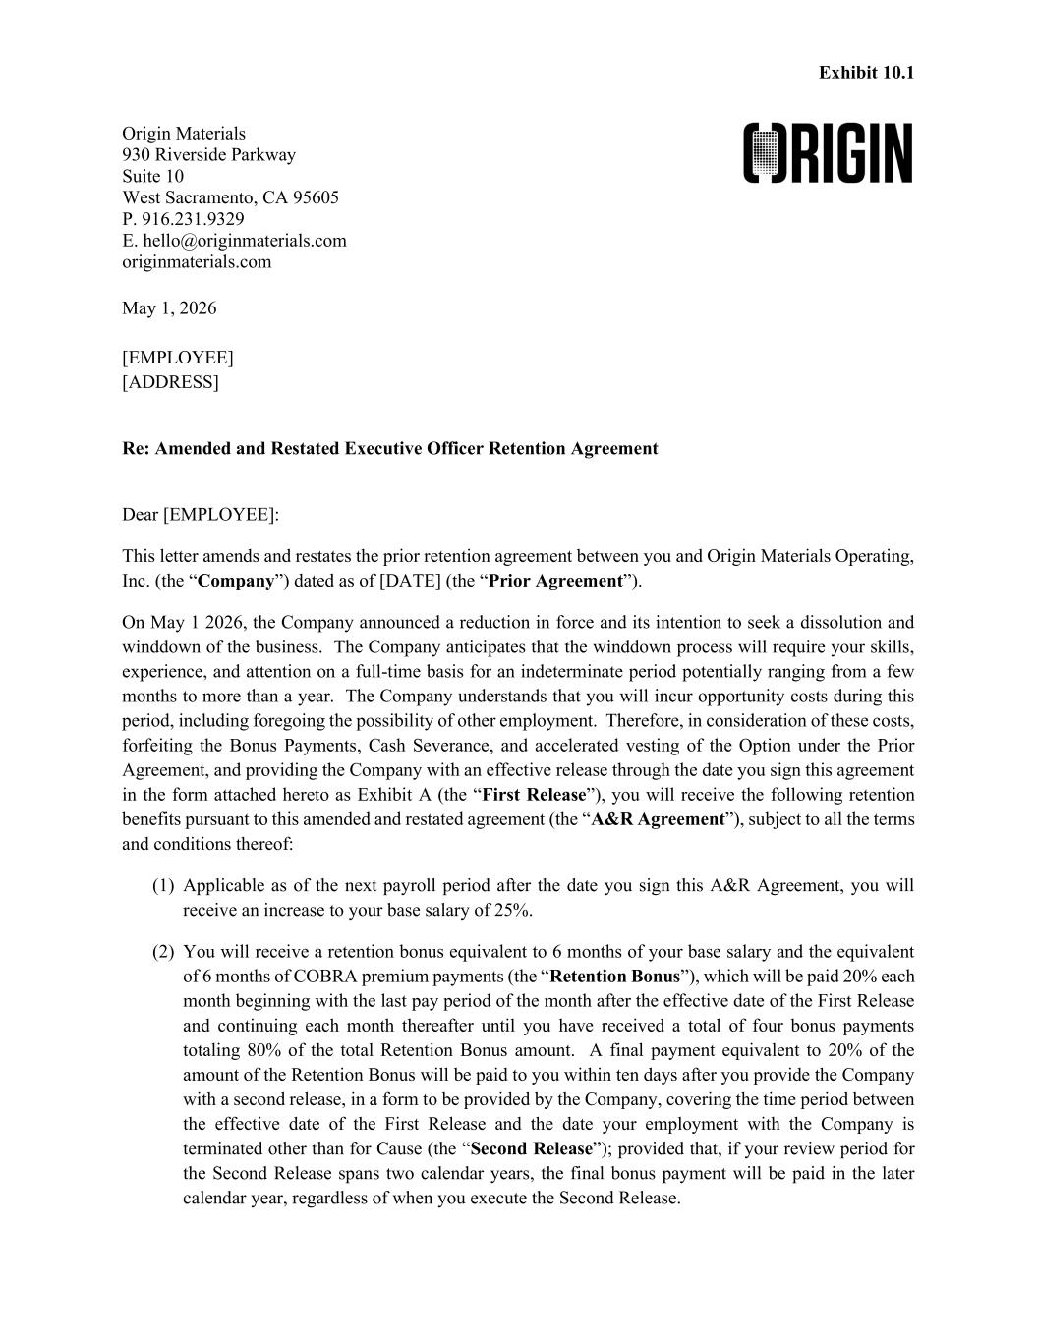
5
Exhibit 10.1 Origin Materials 930 Riverside Parkway Suite 10 West Sacramento, CA 95605 P. 916.231.9329 E. hello@originmaterials.com originmaterials.com May 1, 2026 [EMPLOYEE] [ADDRESS] Re: Amended and Restated Executive Officer Retention Agreement Dear [EMPLOYEE]: This letter amends and restates the prior retention agreement between you and Origin Materials Operating, Inc. (the “Company”) dated as of [DATE] (the “Prior Agreement”). On May 1 2026, the Company announced a reduction in force and its intention to seek a dissolution and winddown of the business. The Company anticipates that the winddown process will require your skills, experience, and attention on a full-time basis for an indeterminate period potentially ranging from a few months to more than a year. The Company understands that you will incur opportunity costs during this period, including foregoing the possibility of other employment. Therefore, in consideration of these costs, forfeiting the Bonus Payments, Cash Severance, and accelerated vesting of the Option under the Prior Agreement, and providing the Company with an effective release through the date you sign this agreement in the form attached hereto as Exhibit A (the “First Release”), you will receive the following retention benefits pursuant to this amended and restated agreement (the “A&R Agreement”), subject to all the terms and conditions thereof: (1) Applicable as of the next payroll period after the date you sign this A&R Agreement, you will receive an increase to your base salary of 25%. (2) You will receive a retention bonus equivalent to 6 months of your base salary and the equivalent of 6 months of COBRA premium payments (the “Retention Bonus”), which will be paid 20% each month beginning with the last pay period of the month after the effective date of the First Release and continuing each month thereafter until you have received a total of four bonus payments totaling 80% of the total Retention Bonus amount. A final payment equivalent to 20% of the amount of the Retention Bonus will be paid to you within ten days after you provide the Company with a second release, in a form to be provided by the Company, covering the time period between the effective date of the First Release and the date your employment with the Company is terminated other than for Cause (the “Second Release”); provided that, if your review period for the Second Release spans two calendar years, the final bonus payment will be paid in the later calendar year, regardless of when you execute the Second Release.

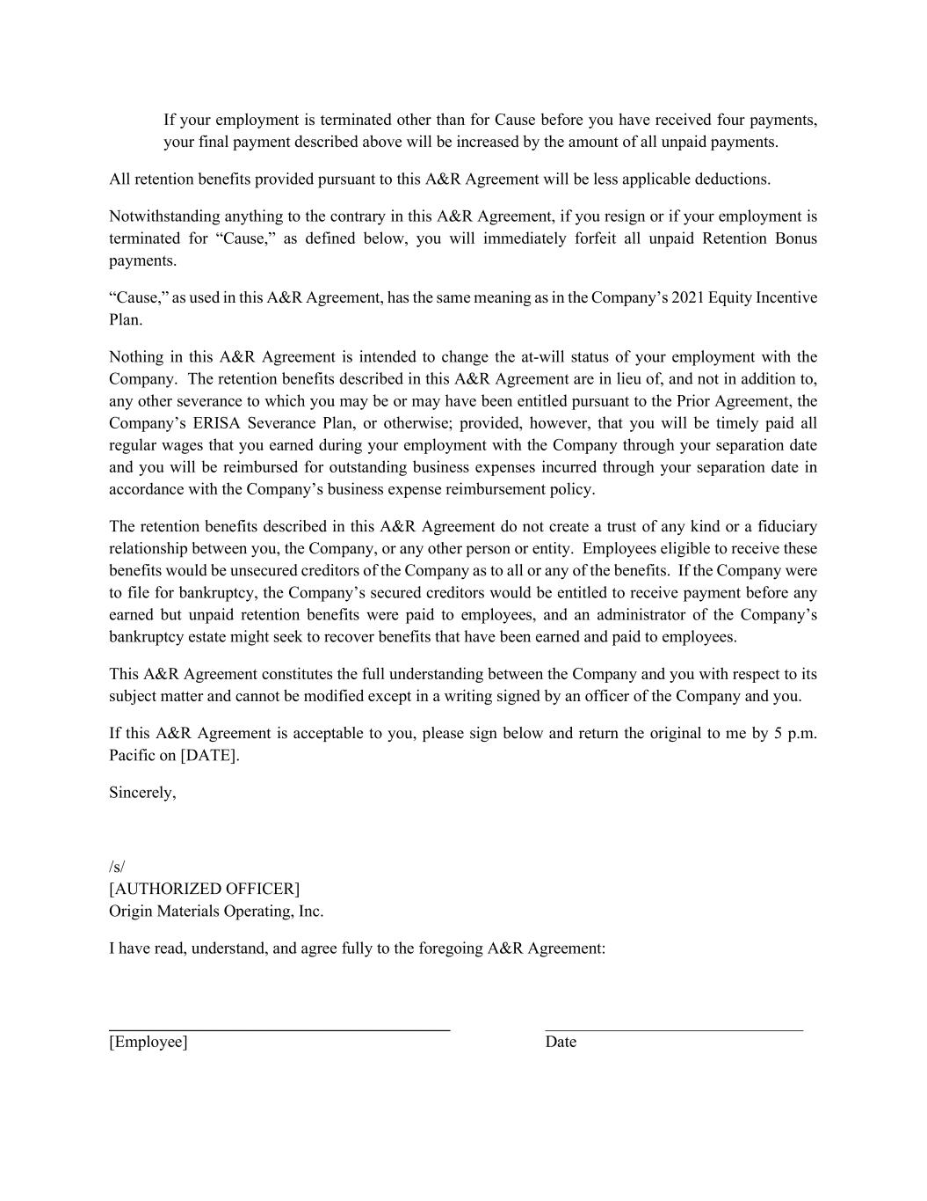
If your employment is terminated other than for Cause before you have received four payments, your final payment described above will be increased by the amount of all unpaid payments. All retention benefits provided pursuant to this A&R Agreement will be less applicable deductions. Notwithstanding anything to the contrary in this A&R Agreement, if you resign or if your employment is terminated for “Cause,” as defined below, you will immediately forfeit all unpaid Retention Bonus payments. “Cause,” as used in this A&R Agreement, has the same meaning as in the Company’s 2021 Equity Incentive Plan. Nothing in this A&R Agreement is intended to change the at-will status of your employment with the Company. The retention benefits described in this A&R Agreement are in lieu of, and not in addition to, any other severance to which you may be or may have been entitled pursuant to the Prior Agreement, the Company’s ERISA Severance Plan, or otherwise; provided, however, that you will be timely paid all regular wages that you earned during your employment with the Company through your separation date and you will be reimbursed for outstanding business expenses incurred through your separation date in accordance with the Company’s business expense reimbursement policy. The retention benefits described in this A&R Agreement do not create a trust of any kind or a fiduciary relationship between you, the Company, or any other person or entity. Employees eligible to receive these benefits would be unsecured creditors of the Company as to all or any of the benefits. If the Company were to file for bankruptcy, the Company’s secured creditors would be entitled to receive payment before any earned but unpaid retention benefits were paid to employees, and an administrator of the Company’s bankruptcy estate might seek to recover benefits that have been earned and paid to employees. This A&R Agreement constitutes the full understanding between the Company and you with respect to its subject matter and cannot be modified except in a writing signed by an officer of the Company and you. If this A&R Agreement is acceptable to you, please sign below and return the original to me by 5 p.m. Pacific on [DATE]. Sincerely, /s/ [AUTHORIZED OFFICER] Origin Materials Operating, Inc. I have read, understand, and agree fully to the foregoing A&R Agreement: _________________________________________ _______________________________ [Employee] Date

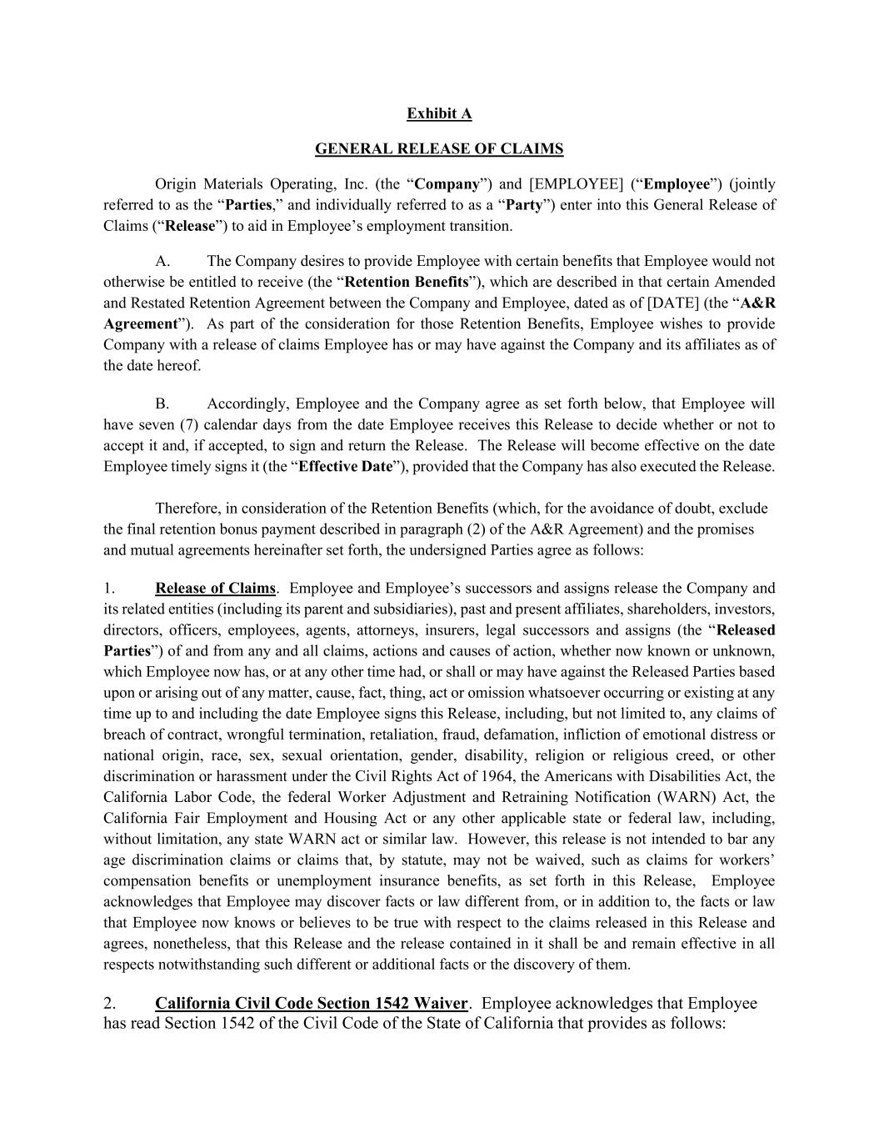
Exhibit A GENERAL RELEASE OF CLAIMS Origin Materials Operating, Inc. (the “Company”) and [EMPLOYEE] (“Employee”) (jointly referred to as the “Parties,” and individually referred to as a “Party”) enter into this General Release of Claims (“Release”) to aid in Employee’s employment transition. A. The Company desires to provide Employee with certain benefits that Employee would not otherwise be entitled to receive (the “Retention Benefits”), which are described in that certain Amended and Restated Retention Agreement between the Company and Employee, dated as of [DATE] (the “A&R Agreement”). As part of the consideration for those Retention Benefits, Employee wishes to provide Company with a release of claims Employee has or may have against the Company and its affiliates as of the date hereof. B. Accordingly, Employee and the Company agree as set forth below, that Employee will have seven (7) calendar days from the date Employee receives this Release to decide whether or not to accept it and, if accepted, to sign and return the Release. The Release will become effective on the date Employee timely signs it (the “Effective Date”), provided that the Company has also executed the Release. Therefore, in consideration of the Retention Benefits (which, for the avoidance of doubt, exclude the final retention bonus payment described in paragraph (2) of the A&R Agreement) and the promises and mutual agreements hereinafter set forth, the undersigned Parties agree as follows: 1. Release of Claims. Employee and Employee’s successors and assigns release the Company and its related entities (including its parent and subsidiaries), past and present affiliates, shareholders, investors, directors, officers, employees, agents, attorneys, insurers, legal successors and assigns (the “Released Parties”) of and from any and all claims, actions and causes of action, whether now known or unknown, which Employee now has, or at any other time had, or shall or may have against the Released Parties based upon or arising out of any matter, cause, fact, thing, act or omission whatsoever occurring or existing at any time up to and including the date Employee signs this Release, including, but not limited to, any claims of breach of contract, wrongful termination, retaliation, fraud, defamation, infliction of emotional distress or national origin, race, sex, sexual orientation, gender, disability, religion or religious creed, or other discrimination or harassment under the Civil Rights Act of 1964, the Americans with Disabilities Act, the California Labor Code, the federal Worker Adjustment and Retraining Notification (WARN) Act, the California Fair Employment and Housing Act or any other applicable state or federal law, including, without limitation, any state WARN act or similar law. However, this release is not intended to bar any age discrimination claims or claims that, by statute, may not be waived, such as claims for workers’ compensation benefits or unemployment insurance benefits, as set forth in this Release, Employee acknowledges that Employee may discover facts or law different from, or in addition to, the facts or law that Employee now knows or believes to be true with respect to the claims released in this Release and agrees, nonetheless, that this Release and the release contained in it shall be and remain effective in all respects notwithstanding such different or additional facts or the discovery of them. 2. California Civil Code Section 1542 Waiver. Employee acknowledges that Employee has read Section 1542 of the Civil Code of the State of California that provides as follows:

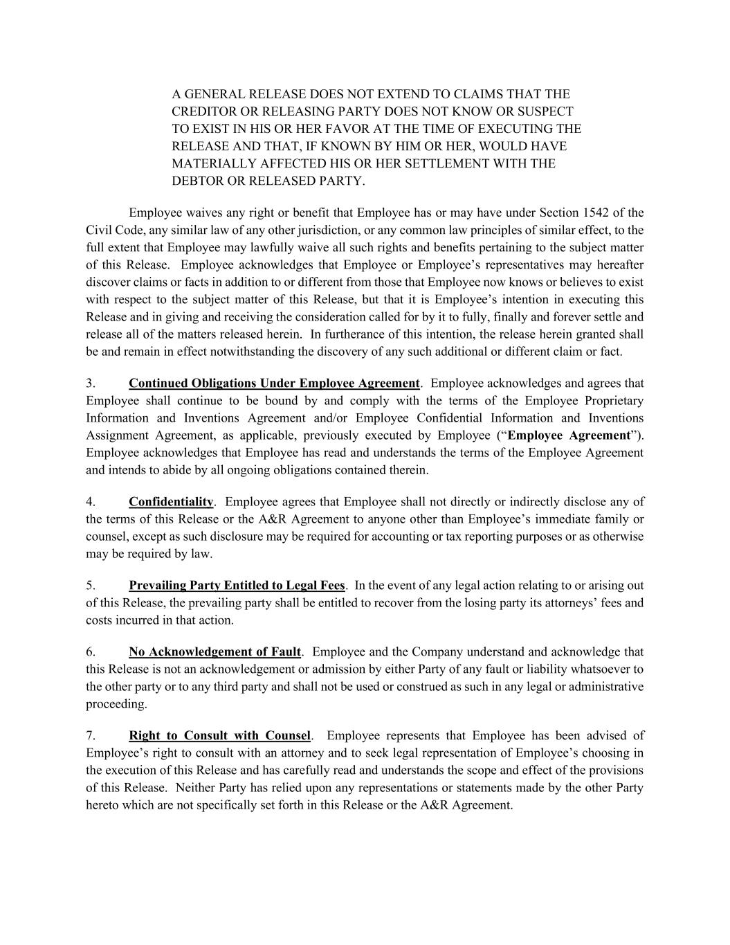
A GENERAL RELEASE DOES NOT EXTEND TO CLAIMS THAT THE CREDITOR OR RELEASING PARTY DOES NOT KNOW OR SUSPECT TO EXIST IN HIS OR HER FAVOR AT THE TIME OF EXECUTING THE RELEASE AND THAT, IF KNOWN BY HIM OR HER, WOULD HAVE MATERIALLY AFFECTED HIS OR HER SETTLEMENT WITH THE DEBTOR OR RELEASED PARTY. Employee waives any right or benefit that Employee has or may have under Section 1542 of the Civil Code, any similar law of any other jurisdiction, or any common law principles of similar effect, to the full extent that Employee may lawfully waive all such rights and benefits pertaining to the subject matter of this Release. Employee acknowledges that Employee or Employee’s representatives may hereafter discover claims or facts in addition to or different from those that Employee now knows or believes to exist with respect to the subject matter of this Release, but that it is Employee’s intention in executing this Release and in giving and receiving the consideration called for by it to fully, finally and forever settle and release all of the matters released herein. In furtherance of this intention, the release herein granted shall be and remain in effect notwithstanding the discovery of any such additional or different claim or fact. 3. Continued Obligations Under Employee Agreement. Employee acknowledges and agrees that Employee shall continue to be bound by and comply with the terms of the Employee Proprietary Information and Inventions Agreement and/or Employee Confidential Information and Inventions Assignment Agreement, as applicable, previously executed by Employee (“Employee Agreement”). Employee acknowledges that Employee has read and understands the terms of the Employee Agreement and intends to abide by all ongoing obligations contained therein. 4. Confidentiality. Employee agrees that Employee shall not directly or indirectly disclose any of the terms of this Release or the A&R Agreement to anyone other than Employee’s immediate family or counsel, except as such disclosure may be required for accounting or tax reporting purposes or as otherwise may be required by law. 5. Prevailing Party Entitled to Legal Fees. In the event of any legal action relating to or arising out of this Release, the prevailing party shall be entitled to recover from the losing party its attorneys’ fees and costs incurred in that action. 6. No Acknowledgement of Fault. Employee and the Company understand and acknowledge that this Release is not an acknowledgement or admission by either Party of any fault or liability whatsoever to the other party or to any third party and shall not be used or construed as such in any legal or administrative proceeding. 7. Right to Consult with Counsel. Employee represents that Employee has been advised of Employee’s right to consult with an attorney and to seek legal representation of Employee’s choosing in the execution of this Release and has carefully read and understands the scope and effect of the provisions of this Release. Neither Party has relied upon any representations or statements made by the other Party hereto which are not specifically set forth in this Release or the A&R Agreement.

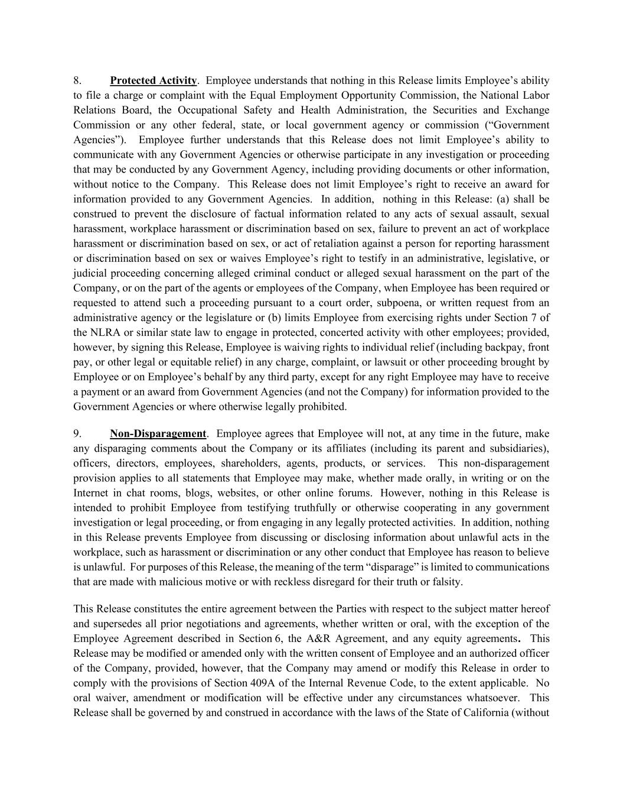
8. Protected Activity. Employee understands that nothing in this Release limits Employee’s ability to file a charge or complaint with the Equal Employment Opportunity Commission, the National Labor Relations Board, the Occupational Safety and Health Administration, the Securities and Exchange Commission or any other federal, state, or local government agency or commission (“Government Agencies”). Employee further understands that this Release does not limit Employee’s ability to communicate with any Government Agencies or otherwise participate in any investigation or proceeding that may be conducted by any Government Agency, including providing documents or other information, without notice to the Company. This Release does not limit Employee’s right to receive an award for information provided to any Government Agencies. In addition, nothing in this Release: (a) shall be construed to prevent the disclosure of factual information related to any acts of sexual assault, sexual harassment, workplace harassment or discrimination based on sex, failure to prevent an act of workplace harassment or discrimination based on sex, or act of retaliation against a person for reporting harassment or discrimination based on sex or waives Employee’s right to testify in an administrative, legislative, or judicial proceeding concerning alleged criminal conduct or alleged sexual harassment on the part of the Company, or on the part of the agents or employees of the Company, when Employee has been required or requested to attend such a proceeding pursuant to a court order, subpoena, or written request from an administrative agency or the legislature or (b) limits Employee from exercising rights under Section 7 of the NLRA or similar state law to engage in protected, concerted activity with other employees; provided, however, by signing this Release, Employee is waiving rights to individual relief (including backpay, front pay, or other legal or equitable relief) in any charge, complaint, or lawsuit or other proceeding brought by Employee or on Employee’s behalf by any third party, except for any right Employee may have to receive a payment or an award from Government Agencies (and not the Company) for information provided to the Government Agencies or where otherwise legally prohibited. 9. Non-Disparagement. Employee agrees that Employee will not, at any time in the future, make any disparaging comments about the Company or its affiliates (including its parent and subsidiaries), officers, directors, employees, shareholders, agents, products, or services. This non-disparagement provision applies to all statements that Employee may make, whether made orally, in writing or on the Internet in chat rooms, blogs, websites, or other online forums. However, nothing in this Release is intended to prohibit Employee from testifying truthfully or otherwise cooperating in any government investigation or legal proceeding, or from engaging in any legally protected activities. In addition, nothing in this Release prevents Employee from discussing or disclosing information about unlawful acts in the workplace, such as harassment or discrimination or any other conduct that Employee has reason to believe is unlawful. For purposes of this Release, the meaning of the term “disparage” is limited to communications that are made with malicious motive or with reckless disregard for their truth or falsity. This Release constitutes the entire agreement between the Parties with respect to the subject matter hereof and supersedes all prior negotiations and agreements, whether written or oral, with the exception of the Employee Agreement described in Section 6, the A&R Agreement, and any equity agreements. This Release may be modified or amended only with the written consent of Employee and an authorized officer of the Company, provided, however, that the Company may amend or modify this Release in order to comply with the provisions of Section 409A of the Internal Revenue Code, to the extent applicable. No oral waiver, amendment or modification will be effective under any circumstances whatsoever. This Release shall be governed by and construed in accordance with the laws of the State of California (without

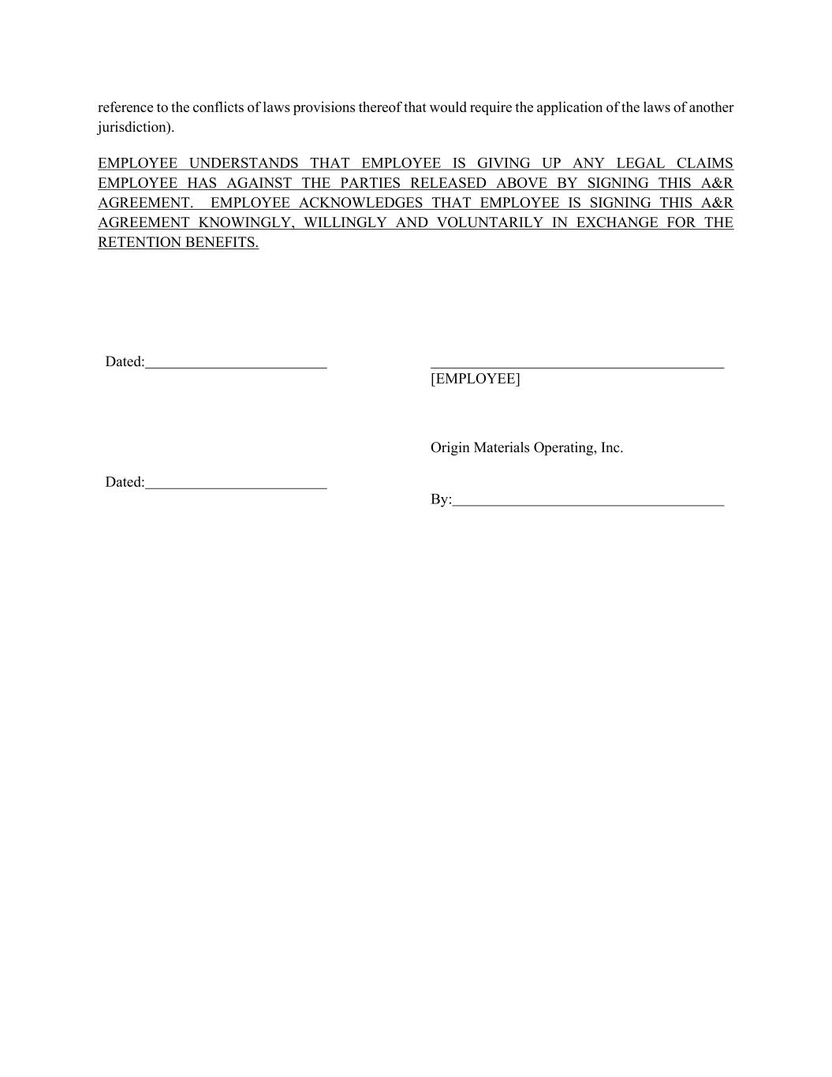
reference to the conflicts of laws provisions thereof that would require the application of the laws of another jurisdiction). EMPLOYEE UNDERSTANDS THAT EMPLOYEE IS GIVING UP ANY LEGAL CLAIMS EMPLOYEE HAS AGAINST THE PARTIES RELEASED ABOVE BY SIGNING THIS A&R AGREEMENT. EMPLOYEE ACKNOWLEDGES THAT EMPLOYEE IS SIGNING THIS A&R AGREEMENT KNOWINGLY, WILLINGLY AND VOLUNTARILY IN EXCHANGE FOR THE RETENTION BENEFITS. Dated: [EMPLOYEE] Dated: Origin Materials Operating, Inc. By:

