UNITED STATES
SECURITIES AND EXCHANGE COMMISSION
WASHINGTON, D.C. 20549
__________________________
FORM 10-Q
__________________________
(Mark One)
x |  |  | QUARTERLY REPORT PURSUANT TO SECTION 13 OR 15(d) OF THE SECURITIES EXCHANGE ACT OF 1934
For the quarterly period ended March 31, 2026
OR
o |  |  | TRANSITION REPORT PURSUANT TO SECTION 13 OR 15(d) OF THE SECURITIES EXCHANGE ACT OF 1934
For the transition period from to
Commission file number 001-39378
__________________________
ORIGIN MATERIALS, INC.
(Exact name of registrant as specified in its charter)
__________________________
Delaware |  |  | 87-1388928
(State or other jurisdiction of  incorporation or organization) |  |  | (I.R.S. Employer  Identification No.)
930 Riverside Parkway, Suite 10  West Sacramento, CA |  |  | 95605
(Address of principal executive offices) |  |  | (Zip Code)
(916) 231-9329
(Registrant’s telephone number, including area code)
N/A
(Former name or former address, if changed since last report)
__________________________
Securities registered pursuant to Section 12(b) of the Act:
Title of each class: |  |  |  |  |  | Trading Symbol(s) |  |  |  |  |  | Name of each exchange on which registered:
Common Stock, $0.0001 par value per share |  |  |  |  |  | ORGN |  |  |  |  |  | The Nasdaq Capital Market
Warrants, each whole warrant exercisable for 1/30th of a share of Common Stock at an exercise price of $11.50 per share |  |  |  |  |  | ORGNW |  |  |  |  |  | The Nasdaq Capital Market
Indicate by check mark whether the registrant (1) has filed all reports required to be filed by Section 13 or 15(d) of the Securities Exchange Act of 1934 during the preceding 12 months (or for such shorter period that the registrant was required to file such reports), and (2) has been subject to such filing requirements for the past 90 days. Yes x No o
Indicate by check mark whether the registrant has submitted electronically every Interactive Data File required to be submitted pursuant to Rule 405 of Regulation S-T (§232.405 of this chapter) during the preceding 12 months (or for such shorter period that the registrant was required to submit such files). Yes x No o
Indicate by check mark whether the registrant is a large accelerated filer, an accelerated filer, a non-accelerated filer, smaller reporting company, or an emerging growth company. See the definitions of “large accelerated filer,” “accelerated filer,” “smaller reporting company,” and “emerging growth company” in Rule 12b-2 of the Exchange Act.
Large accelerated filer |  |  | o |  |  |  |  |  | Accelerated filer |  |  | o
Non-accelerated filer |  |  | ☒ |  |  |  |  |  | Smaller reporting company |  |  | ☒
 |  |  |  |  |  |  |  |  | Emerging growth company |  |  | ☐
If an emerging growth company, indicate by check mark if the registrant has elected not to use the extended transition period for complying with any new or revised financial accounting standards provided pursuant to Section 13(a) of the Exchange Act. ☐
Indicate by check mark whether the registrant is a shell company (as defined in Rule 12b-2 of the Exchange Act). Yes ☐ No x
The number of shares of the registrant’s common stock, par value $0.0001 per share outstanding was 5,502,770, as of May 8, 2026.

ORIGIN MATERIALS, INC.
TABLE OF CONTENTS
Page
No.
PART I. — FINANCIAL INFORMATION
Item 1 |  |  | Condensed Consolidated Financial Statements (unaudited) |  |  | 2
 |  |  | Condensed Consolidated Balance Sheets (unaudited) |  |  | 2
 |  |  | Condensed Consolidated Statements of Operations and Comprehensive Loss (unaudited) |  |  | 4
 |  |  | Condensed Consolidated Statements of Stockholders’ Equity (unaudited) |  |  | 5
 |  |  | Condensed Consolidated Statements of Cash Flows (unaudited) |  |  | 6
 |  |  | Notes to Unaudited Condensed Consolidated Financial Statements |  |  | 7
Item 2 |  |  | Management’s Discussion and Analysis of Financial Condition and Results of Operations |  |  | 27
Item 3 |  |  | Quantitative and Qualitative Disclosures About Market Risk |  |  | 34
Item 4 |  |  | Controls and Procedures |  |  | 34
PART II. — OTHER INFORMATION |  |  |  |  |  | 35
Item 1 |  |  | Legal Proceedings |  |  | 35
Item 1A |  |  | Risk Factors |  |  | 35
Item 2 |  |  | Unregistered Sales of Equity Securities and Use of Proceeds |  |  | 39
Item 3 |  |  | Defaults Upon Senior Securities |  |  | 39
Item 4 |  |  | Mine Safety Disclosures |  |  | 39
Item 5 |  |  | Other Information |  |  | 39
Item 6 |  |  | Exhibits |  |  | 40
SIGNATURES |  |  |  |  |  | 41

WHERE YOU CAN FIND MORE INFORMATION

Investors and others should note that we announce material financial information to our investors using our investor relations website, which can be found at https://investors.originmaterials.com/, as well as press releases, our filings with the Securities and Exchange Commission (the “SEC”), and public conference calls and webcasts. We also use other mediums, including the following social media channels as a means of disclosing information about the company, our products, our planned financial and other announcements and attendance at upcoming investor and industry conferences, and other matters and for complying with our disclosure obligations under Regulation FD:
Origin X (f/k/a Twitter) Account (https://twitter.com/OriginMaterials)
Origin LinkedIn Page (https://www.linkedin.com/company/origin-materials)
Origin Facebook Page (https://www.facebook.com/people/Origin-Materials/100057468488825)
These channels may be updated from time to time on our investor relations website. The information we post through these channels may be deemed material. Accordingly, investors should monitor them in addition to following our investor relations website, press releases, SEC filings, and public conference calls and webcasts. This list may be updated from time to time. The information we post through these channels is not a part of this Quarterly Report on Form 10-Q.

1
Table of contents
PART I. — FINANCIAL INFORMATION

Item 1. Financial Statements

ORIGIN MATERIALS, INC.
CONDENSED CONSOLIDATED BALANCE SHEETS
(In thousands, except share and per share data) |  |  | March 31, 2026  (Unaudited) |  |  |  |  |  | December 31,  2025
ASSETS
Current assets
Cash and cash equivalents |  |  | $ | 19,191 |  |  |  |  | $ | 32,923
Marketable securities |  |  | 13,457 |  |  |  |  |  | 20,545
Accounts receivable net of allowance for credit losses of $5,448 and $828, respectively |  |  | 5,362 |  |  |  |  |  | 13,049
Other receivables |  |  | 1,587 |  |  |  |  |  | 2,101
Inventory |  |  | 682 |  |  |  |  |  | 684
Prepaid expenses and other current assets |  |  | 1,126 |  |  |  |  |  | 2,448
Land held for sale |  |  | 9,125 |  |  |  |  |  | 9,126
Total current assets |  |  | 50,530 |  |  |  |  |  | 80,876
Property, plant, and equipment, net |  |  | 79,726 |  |  |  |  |  | 72,852
Operating lease right-of-use asset |  |  | 3,080 |  |  |  |  |  | 3,149
Intangible assets, net |  |  | 24 |  |  |  |  |  | 32
Other long-term assets |  |  | 1,715 |  |  |  |  |  | 751
Total assets |  |  | $ | 135,075 |  |  |  |  | $ | 157,660
LIABILITIES AND STOCKHOLDERS’ EQUITY
Current liabilities
Accounts payable |  |  | $ | 1,331 |  |  |  |  | $ | 3,568
Accrued expenses |  |  | 4,717 |  |  |  |  |  | 4,947
Operating lease liabilities, current |  |  | 316 |  |  |  |  |  | 306
Notes payable, short-term |  |  | 4,450 |  |  |  |  |  | 4,511
Convertible notes, net of issuance costs |  |  | 6,979 |  |  |  |  |  | 14,970
Other liabilities, current |  |  | 1,231 |  |  |  |  |  | 231
Total current liabilities |  |  | 19,024 |  |  |  |  |  | 28,533
Earnout liability |  |  | 24 |  |  |  |  |  | 24
Canadian Government Research and Development Program liability |  |  | 16,496 |  |  |  |  |  | 16,776
Common stock warrants liability |  |  | 89 |  |  |  |  |  | 167
Notes payable, long-term |  |  | 7,654 |  |  |  |  |  | 4,386
Operating lease liabilities |  |  | 3,449 |  |  |  |  |  | 3,533
Other liabilities, long-term |  |  | 19 |  |  |  |  |  | 30
Total liabilities |  |  | 46,755 |  |  |  |  |  | 53,449
2

(In thousands, except share and per share data) |  |  | March 31, 2026  (Unaudited) |  |  |  |  |  | December 31,  2025
Commitments and contingencies (See Note 16)
STOCKHOLDERS’ EQUITY
Preferred stock, $0.0001 par value, 10,000,000 shares authorized; no shares issued and outstanding as of March 31, 2026 and December 31, 2025 |  |  | — |  |  |  |  |  | —
Common stock, $0.0001 par value, 1,000,000,000 shares authorized; 5,499,307 and 5,173,884, issued and outstanding as of March 31, 2026 and December 31, 2025, respectively (including 50,000 and 50,000, respectively, of Sponsor Vesting Shares) |  |  | 15 |  |  |  |  |  | 15
Additional paid-in capital |  |  | 404,667 |  |  |  |  |  | 402,378
Accumulated deficit |  |  | (305,475) |  |  |  |  |  | (287,825)
Accumulated other comprehensive loss |  |  | (10,887) |  |  |  |  |  | (10,357)
Total stockholders’ equity |  |  | 88,320 |  |  |  |  |  | 104,211
Total liabilities and stockholders’ equity |  |  | $ | 135,075 |  |  |  |  | $ | 157,660

The accompanying notes are an integral part of these unaudited condensed consolidated financial statements.

3

ORIGIN MATERIALS, INC.
CONDENSED CONSOLIDATED STATEMENTS OF OPERATIONS AND COMPREHENSIVE LOSS
(Unaudited)
Three Months Ended
March 31,
(In thousands, except share and per share data) |  |  |  |  |  |  | 2026 |  |  |  |  |  | 2025
Revenues:
Products |  |  |  |  |  |  | $ | 477 |  |  |  |  | $ | 5,430
Total revenues |  |  |  |  |  |  | 477 |  |  |  |  |  | 5,430
Cost of revenues (exclusive of depreciation and amortization shown separately below) |  |  |  |  |  |  | 337 |  |  |  |  |  | 5,317
Operating expenses:
Research and development |  |  |  |  |  |  | 2,758 |  |  |  |  |  | 3,301
General and administrative |  |  |  |  |  |  | 12,708 |  |  |  |  |  | 10,111
Depreciation and amortization |  |  |  |  |  |  | 1,185 |  |  |  |  |  | 2,714
Impairment of assets |  |  |  |  |  |  | — |  |  |  |  |  | 16,610
Total operating expenses |  |  |  |  |  |  | 16,651 |  |  |  |  |  | 32,736
Loss from operations |  |  |  |  |  |  | (16,511) |  |  |  |  |  | (32,623)
Other income (expenses):
Investment income |  |  |  |  |  |  | 611 |  |  |  |  |  | 1,206
Interest expenses |  |  |  |  |  |  | (16) |  |  |  |  |  | (48)
Loss in fair value of derivatives |  |  |  |  |  |  | — |  |  |  |  |  | (38)
Gain in fair value of common stock warrants liability |  |  |  |  |  |  | 78 |  |  |  |  |  | 2,778
Gain in fair value of earnout liability |  |  |  |  |  |  | — |  |  |  |  |  | 2,462
Loss in fair value of convertible notes |  |  |  |  |  |  | (1,890) |  |  |  |  |  | —
Other income (expenses), net |  |  |  |  |  |  | 78 |  |  |  |  |  | (119)
Total other income, net |  |  |  |  |  |  | (1,139) |  |  |  |  |  | 6,241
Loss before income tax provision |  |  |  |  |  |  | (17,650) |  |  |  |  |  | (26,382)
Income tax provision |  |  |  |  |  |  | — |  |  |  |  |  | (59)
Net loss |  |  |  |  |  |  | $ | (17,650) |  |  |  |  | $ | (26,441)
Other comprehensive (loss) income:
Unrealized (loss) gain on marketable securities |  |  |  |  |  |  | $ | (32) |  |  |  |  | $ | 159
Foreign currency translation adjustment |  |  |  |  |  |  | (498) |  |  |  |  |  | 236
Total other comprehensive (loss) income |  |  |  |  |  |  | (530) |  |  |  |  |  | 395
Total comprehensive loss |  |  |  |  |  |  | $ | (18,180) |  |  |  |  | $ | (26,046)
Net loss per share, basic |  |  |  |  |  |  | $ | (3.28) |  |  |  |  | $ | (5.40)
Net loss per share, diluted |  |  |  |  |  |  | $ | (3.28) |  |  |  |  | $ | (5.40)
Weighted-average common shares outstanding, basic |  |  |  |  |  |  | 5,377,854 |  |  |  |  |  | 4,895,078
Weighted-average common shares outstanding, diluted |  |  |  |  |  |  | 5,377,854 |  |  |  |  |  | 4,895,078
The accompanying notes are an integral part of these unaudited condensed consolidated financial statements.

4

ORIGIN MATERIALS, INC.
CONDENSED CONSOLIDATED STATEMENTS OF STOCKHOLDERS’ EQUITY
(Unaudited)
(In Thousands, Except Share Amounts)
 |  |  |  |  |  |  |  |  |  |  |  |  |  |  |  |  |  |  |  |  | Accumulated Deficit |  |  |  |  |  | Accumulated  Other  Comprehensive  Loss |  |  |  |  |  | Total  Stockholders’  Equity
 |  |  | Common Stock |  |  |  |  |  |  |  |  |  |  |  | Additional  Paid-in  Capital
 |  |  | Shares |  |  |  |  |  | Amount
Balance at December 31, 2024 |  |  | 4,952,475 |  |  |  |  |  | $ | 15 |  |  |  |  | $ | 393,186 |  |  |  |  | $ | (38,127) |  |  |  |  | $ | (16,709) |  |  |  |  | $ | 338,365
Common stock issued upon exercise of stock options |  |  | 71 |  |  |  |  |  | — |  |  |  |  |  | — |  |  |  |  |  | — |  |  |  |  |  | — |  |  |  |  |  | —
Vested common stock awards |  |  | 31,012 |  |  |  |  |  | — |  |  |  |  |  | — |  |  |  |  |  | — |  |  |  |  |  | — |  |  |  |  |  | —
Stock-based compensation |  |  | — |  |  |  |  |  | — |  |  |  |  |  | 2,289 |  |  |  |  |  | — |  |  |  |  |  | — |  |  |  |  |  | 2,289
Net loss |  |  | — |  |  |  |  |  | — |  |  |  |  |  | — |  |  |  |  |  | (26,441) |  |  |  |  |  | — |  |  |  |  |  | (26,441)
Other comprehensive income |  |  | — |  |  |  |  |  | — |  |  |  |  |  | — |  |  |  |  |  | — |  |  |  |  |  | 395 |  |  |  |  |  | 395
Balance at March 31, 2025 |  |  | 4,983,558 |  |  |  |  |  | $ | 15 |  |  |  |  | $ | 395,475 |  |  |  |  | $ | (64,568) |  |  |  |  | $ | (16,314) |  |  |  |  | $ | 314,608
 |  |  |  |  |  |  |  |  |  |  |  |  |  |  |  |  |  |  |  |  | Accumulated Deficit |  |  |  |  |  | Accumulated  Other  Comprehensive  Loss |  |  |  |  |  | Total  Stockholders’  Equity
 |  |  | Common Stock |  |  |  |  |  |  |  |  |  |  |  | Additional  Paid-in  Capital
 |  |  | Shares |  |  |  |  |  | Amount
Balance at December 31, 2025 |  |  | 5,173,884 |  |  |  |  |  | $ | 15 |  |  |  |  | $ | 402,378 |  |  |  |  | $ | (287,825) |  |  |  |  | $ | (10,357) |  |  |  |  | $ | 104,211
Common stock issued upon exercise of stock options |  |  | — |  |  |  |  |  | — |  |  |  |  |  | — |  |  |  |  |  | — |  |  |  |  |  | — |  |  |  |  |  | —
Shares issued for convertible notes |  |  | 231,441 |  |  |  |  |  | — |  |  |  |  |  | 1,241 |  |  |  |  |  | — |  |  |  |  |  | — |  |  |  |  |  | 1,241
Vested common stock awards |  |  | 19,706 |  |  |  |  |  | — |  |  |  |  |  | — |  |  |  |  |  | — |  |  |  |  |  | — |  |  |  |  |  | —
Common stock issued in lieu of fractional share |  |  | 74,276 |  |  |  |  |  | — |  |  |  |  |  | — |  |  |  |  |  | — |  |  |  |  |  | — |  |  |  |  |  | —
Stock-based compensation |  |  | — |  |  |  |  |  | — |  |  |  |  |  | 1,048 |  |  |  |  |  | — |  |  |  |  |  | — |  |  |  |  |  | 1,048
Net loss |  |  | — |  |  |  |  |  | — |  |  |  |  |  | — |  |  |  |  |  | (17,650) |  |  |  |  |  | — |  |  |  |  |  | (17,650)
Other comprehensive loss |  |  | — |  |  |  |  |  | — |  |  |  |  |  | — |  |  |  |  |  | — |  |  |  |  |  | (530) |  |  |  |  |  | (530)
Balance at March 31, 2026 |  |  | 5,499,307 |  |  |  |  |  | $ | 15 |  |  |  |  | $ | 404,667 |  |  |  |  | $ | (305,475) |  |  |  |  | $ | (10,887) |  |  |  |  | $ | 88,320
The accompanying notes are an integral part of these unaudited condensed consolidated financial statements.

5

ORIGIN MATERIALS, INC.
CONDENSED CONSOLIDATED STATEMENTS OF CASH FLOWS
(Unaudited)
 |  |  | Three Months Ended March 31,
(in thousands) |  |  | 2026 |  |  |  |  |  | 2025
Cash flows from operating activities
Net loss |  |  | $ | (17,650) |  |  |  |  | $ | (26,441)
Adjustments to reconcile net loss to net cash used in operating activities:
Depreciation and amortization |  |  | 1,185 |  |  |  |  |  | 2,714
Provision for credit losses |  |  | 4,620 |  |  |  |  |  | —
Stock-based compensation |  |  | 1,048 |  |  |  |  |  | 2,289
Impairment of assets |  |  | — |  |  |  |  |  | 16,610
Realized (gain) loss on marketable securities |  |  | (88) |  |  |  |  |  | 61
Amortization of premium and discount of marketable securities, net |  |  | (19) |  |  |  |  |  | (38)
Change in fair value of derivative |  |  | — |  |  |  |  |  | 38
Change in fair value of common stock warrants liability |  |  | (78) |  |  |  |  |  | (2,778)
Change in fair value of earnout liability |  |  | — |  |  |  |  |  | (2,462)
Change in fair value of convertible notes |  |  | 1,890 |  |  |  |  |  | —
Deferred tax provision |  |  | — |  |  |  |  |  | 58
Other non-cash expenses |  |  | 51 |  |  |  |  |  | 88
Changes in operating assets and liabilities:
Accounts receivable net and other receivables |  |  | 3,580 |  |  |  |  |  | (521)
Inventory |  |  | 2 |  |  |  |  |  | —
Prepaid expenses and other current assets |  |  | 1,322 |  |  |  |  |  | 300
Other long-term assets |  |  | (965) |  |  |  |  |  | 60
Accounts payable |  |  | 460 |  |  |  |  |  | 130
Accrued expenses |  |  | (193) |  |  |  |  |  | 1,409
Operating lease liabilities |  |  | (74) |  |  |  |  |  | (79)
Other liabilities, current |  |  | 54 |  |  |  |  |  | 134
Other liabilities, long-term |  |  | (12) |  |  |  |  |  | (11)
Net cash used in operating activities |  |  | (4,867) |  |  |  |  |  | (8,439)
Cash flows from investing activities
Purchases of property, plant, and equipment |  |  | (6,969) |  |  |  |  |  | (6,994)
Proceeds from sale of property, plant, and equipment |  |  | 36 |  |  |  |  |  | —
Purchases of marketable securities |  |  | (128,153) |  |  |  |  |  | (280,000)
Sales of marketable securities |  |  | 132,792 |  |  |  |  |  | 282,405
Maturities of marketable securities |  |  | 2,538 |  |  |  |  |  | 5,129
Net cash (used in) provided by investing activities |  |  | 244 |  |  |  |  |  | 540
Cash flows from financing activities
Payment of notes payable short-term |  |  | — |  |  |  |  |  | (4,542)
Payment of convertible notes |  |  | (8,640) |  |  |  |  |  | —
Net cash used in financing activities |  |  | (8,640) |  |  |  |  |  | (4,542)
Effects of foreign exchange rate changes on the balance of cash and cash equivalents held in foreign currencies |  |  | (469) |  |  |  |  |  | (31)
Net decrease in cash and cash equivalents |  |  | (13,732) |  |  |  |  |  | (12,472)
Cash and cash equivalents beginning of the period |  |  | 32,923 |  |  |  |  |  | 56,307
Cash and cash equivalents end of the period |  |  | $ | 19,191 |  |  |  |  | $ | 43,835
Supplemental disclosure of cash flow information
Purchases of fixed assets included in accounts payable and accrued expenses |  |  | $ | 1,021 |  |  |  |  | $ | 4,166
Non-cash investing activity
Purchases of property, plant, and equipment included in notes payable |  |  | $ | 3,207 |  |  |  |  | $ | —
Amount of shares issued for convertible notes |  |  | $ | 1,241 |  |  |  |  | $ | —
Cash paid during the period:
Interest payment |  |  | $ | — |  |  |  |  | $ | 50
The accompanying notes are an integral part of these unaudited condensed consolidated financial statements.

6

ORIGIN MATERIALS, INC.
NOTES TO UNAUDITED CONDENSED CONSOLIDATED FINANCIAL STATEMENTS

1.Organization and Business
Unless the context otherwise requires, references in these notes to “Origin”, “the Company”, “we”, “us” and “our” and any related terms are intended to mean Origin Materials, Inc. and its consolidated subsidiaries.
In June 2021, Artius Acquisition Inc. (“Artius”), a special purpose acquisition company, completed a merger with Micromidas, Inc., a Delaware corporation (now known as Origin Materials Operating, Inc. (“Legacy Origin”)). Pursuant to the terms of the Merger Agreement (the agreement formalizing the business combination between Artius and Legacy Origin), Legacy Origin became a wholly-owned subsidiary of Artius (the “Merger”) and Artius changed its name to Origin Materials, Inc. (together with its subsidiaries, the “Company”). The Company is a technology company with a mission to enable the world’s transition to sustainable materials. Origin has developed multiple sustainable and performance-enhanced solutions for improving recycling and circularity, including our polyethylene terephthalate (“PET”) closures, as well as low-carbon material solutions for a wide variety of products and applications. The Company’s furanics technology can transform sustainable feedstocks, such as sustainably harvested wood, agricultural waste, wood waste and corrugated cardboard, into materials and products that are currently made from fossil feedstocks, such as petroleum and natural gas.
Origin announced its PET closures business in August 2023 after several years of application development related to its furanics technologies. Origin’s announced products include the PCO 1881 compliant PET closure and a tethered PET closure designed to comply with European cap tethering mandates and keep caps connected to bottles. Origin has announced several manufacturing partnerships with machine subsystem suppliers, including slit and fold specialists and a provider of visual inspection systems. In September 2024, Origin’s first PET closure manufacturing system (“CapFormer”) successfully completed its Factory Acceptance Test (“FAT”), which involves a series of tests performed on the system to ensure that it meets our requirements and functions as intended. Due to absent near-term financing, the decision was made to indefinitely suspend all further furanics platform development and plant operations for Origin 1 in February 2026.
Reverse Stock Split
On February 17, 2026, the Company held a special meeting of stockholders at which its stockholders approved the amendment of its amended and restated certificate of incorporation to effect a reverse split of its common stock at a ratio in the range of one-for-two to one-for-fifty, such ratio to be determined in the discretion of its board of directors. On March 4, 2026, the Company's board of directors approved the filing of a certificate of amendment with the Secretary of State of the State of Delaware to effect a one-for-thirty reverse stock split of its outstanding common stock. On March 19, 2026, the Company filed the certificate of amendment with the Secretary of State of Delaware to effect the reverse split. All issued and outstanding common stock, options to purchase common stock, and per share amounts contained in the unaudited condensed consolidated financial statements have been retroactively adjusted to reflect the reverse stock split for all periods presented.
The Company’s publicly traded warrants will continue to trade on the Nasdaq Capital Market under the symbol “ORGNW” with an exercise price of $11.50 per share; however, warrant holders will need to exercise 30 warrants for an aggregate exercise price of $345.00 to receive one share of common stock. No fractional shares will be issued upon the exercise of the warrants.
Plan of Dissolution
On April 28, 2026, the Board of Directors (the “Board”) of the Company unanimously approved the dissolution and liquidation of the Company pursuant to a plan of complete liquidation and dissolution (the “Plan of Dissolution”), subject to stockholder approval. In connection with the approval of the Plan of Dissolution, the Board also approved a reduction-in-force, which the Company implemented on May 1, 2026 to enable the Company to maximize shareholder value through the orderly sale of its technology and assets followed by dissolution and wind down. If its stockholders authorize the Plan of Dissolution, the Company plans to file a Certificate of Dissolution with the Secretary of the State of Delaware in the second quarter of 2026.
Liquidity and going concern
As reflected in the unaudited condensed consolidated financial statements, the Company had $32.6 million in cash, cash equivalents, and marketable securities as of March 31, 2026. The Company has experienced net losses and negative cash flows from operating activities since its inception and had an accumulated deficit of $305.5 million as of March 31, 2026.
7

The Company has incurred a net loss and net cash used in operating activities of $17.7 million and $4.9 million, respectively, for the three months ended March 31, 2026.
In accordance with Accounting Standards Codification, or ASC, 205-40, Going Concern, the Company evaluated whether there are conditions and events, considered in the aggregate, that raise substantial doubt about its ability to continue as a going concern within one year after the date that these unaudited condensed consolidated financial statements are issued on May 14, 2026. The Company has determined that its cash, cash equivalents, and marketable securities as of March 31, 2026 would be insufficient to fund its operations which raises substantial doubt regarding the Company's ability to continue as a going concern. The Company intends to implement the Plan of Dissolution which will result in the dissolution and liquidation of the Company.
As the Plan of Dissolution has not yet been brought to a vote of or approved by the Company's stockholders, the Company concluded that the liquidation basis of accounting should not be applied as of the balance sheet date. Accordingly, the accompanying unaudited condensed consolidated financial statements are prepared in accordance with generally accepted accounting principles applicable to a going concern, which contemplates the realization of assets and the satisfaction of liabilities in the normal course of business. The Company’s unaudited condensed consolidated financial statements have been prepared assuming that the Company will continue as a going concern and do not include any adjustments relating to the recoverability and classification of recorded asset amounts or the amounts and classification of liabilities that might result from the outcome of this uncertainty.

2.Summary of Significant Accounting Policies
Basis of Presentation
The Company’s unaudited condensed consolidated financial statements have been prepared in conformity with accounting principles generally accepted in the United States of America (“U.S. GAAP”) as determined by the Financial Accounting Standards Board (“FASB”) Accounting Standards Codification (“ASC”) and pursuant to the regulations of the U.S. Securities and Exchange Commission (“SEC”).
Use of Estimates
The preparation of the unaudited condensed consolidated financial statements in accordance with U.S. GAAP requires management to make estimates and assumptions that affect the reported amounts of assets and liabilities and disclosure of commitments and contingencies at the date of the financial statements as well as reported amounts of revenues, costs and expenses during the reporting periods. Estimates made by the Company include, but are not limited to, allowance for credit losses, valuation of the convertible debt, valuation of the earnout liability, carrying amount and useful lives of property, plant and equipment and intangible assets, impairment assessments, stock-based compensation expense and probabilities of achievement of performance conditions on performance-based stock unit (“PSU”) awards, among others. The Company bases these estimates on historical experience and on various other assumptions that it believes are reasonable under the circumstances, the results of which form the basis for making judgments about the carrying amounts of assets and liabilities that are not readily apparent from other sources. Actual results could differ materially from those estimates.
Unaudited Condensed Consolidated Financial Statements
The December 31, 2025 unaudited condensed consolidated balance sheet was derived from the annual audited consolidated financial statements included in the Company's Form 10-K as filed with the SEC on March 27, 2026 (the “Form 10-K”). The accompanying unaudited condensed consolidated balance sheet as of March 31, 2026, the unaudited condensed consolidated statements of operations and comprehensive loss, and stockholders’ equity for the three months ended March 31, 2026 and 2025, the unaudited condensed consolidated statements of cash flows for the three months ended March 31, 2026 and 2025, and the notes to such unaudited condensed consolidated financial statements are unaudited.
These unaudited condensed consolidated financial statements have been prepared in accordance with U.S. GAAP and the applicable rules and regulations of the SEC for interim financial information. As permitted under those rules, we condensed or omitted certain footnotes or other financial information that are normally required by GAAP for annual financial statements.
8

The unaudited condensed consolidated financial statements have been prepared on the same basis as the annual audited consolidated financial statements and, in management’s opinion, include all adjustments consisting of only normal recurring adjustments necessary for the fair presentation of the Company’s financial position as of March 31, 2026 and its results of operations for the three months ended March 31, 2026 and 2025 and cash flows for the three months ended March 31, 2026 and 2025. The results of operations for the three months ended March 31, 2026 are not necessarily indicative of the results to be expected for the full fiscal year or any other period.
These unaudited condensed consolidated financial statements should be read in conjunction with the Company’s audited annual financial statements and notes thereto for the year ended December 31, 2025 included in the Form 10-K.
Principles of Consolidation
The unaudited condensed consolidated financial statements have been prepared in accordance with U.S. GAAP and applicable rules and regulations of the SEC and include the accounts of the Company and its wholly-owned subsidiaries. All intercompany accounts and transactions have been eliminated in consolidation.
Concentration of Credit Risk
Financial instruments that potentially subject the Company to concentrations of credit risk are primarily cash, cash equivalents, marketable securities and accounts receivable. The Company maintains its cash and cash equivalents at financial institutions insured by the Federal Deposit Insurance Corporation (“FDIC”) up to $250,000 per institution. As the account balances at each institution periodically exceed the FDIC insurance coverage, there is a concentration of credit risk related to amounts in excess of such coverage. While the Company has not experienced losses of these deposits to date, future disruptions of financial institutions where we bank or have credit arrangements, or disruptions of the financial services industry in general, could adversely affect the Company’s ability to access our cash and cash equivalents. If the Company is unable to access its cash and cash equivalents as needed, its financial position and ability to operate its business could be adversely affected. The Company’s marketable securities consist of investment-grade securities diversified among security types that are held at financial institutions that management believes to be of high credit quality.
The Company records the provision for credit losses within general and administrative expenses on the unaudited condensed consolidated statements of operations and comprehensive loss, up to the amount of total outstanding accounts receivable to date. The Company’s top two customers from product sales, in the aggregate, accounted for 100% of total accounts receivable outstanding balances each as of March 31, 2026 and December 31, 2025, and accounted for 100% and 99% of total revenue for the three months ended March 31, 2026 and 2025, respectively.
Accounts Receivable Net
Accounts receivable net consisted of the following as of:
(in thousands) |  |  | March 31, 2026 |  |  |  |  |  | December 31, 2025
Accounts receivable |  |  | $ | 10,810 |  |  |  |  | $ | 13,877
Allowance for credit losses |  |  | (5,448) |  |  |  |  |  | (828)
Accounts receivable net |  |  | $ | 5,362 |  |  |  |  | $ | 13,049
The Company assesses collectability by reviewing accounts receivable on a general basis where similar characteristics exist. In determining the amount of the allowance for credit losses, the Company considers historical collectability based on past due status, the age of the accounts receivable balances, credit quality of the Company’s customers based on ongoing credit evaluations, discussions with the customers, and other factors that may affect the Company’s ability to collect from customers. The increase in allowance for credit losses is based on updated estimates of collectability as of March 31, 2026.
9

Inventory
Inventory consisted of the following as of:
(in thousands) |  |  | March 31, 2026 |  |  |  |  |  | December 31, 2025
Finished goods |  |  | $ | 49 |  |  |  |  | $ | 49
Raw materials |  |  | 594 |  |  |  |  |  | 594
Spare parts |  |  | 39 |  |  |  |  |  | 41
Total |  |  | $ | 682 |  |  |  |  | $ | 684
Intangible Assets
Intangible assets consisted of the following as of:
(in thousands) |  |  | March 31, 2026 |  |  |  |  |  | December 31, 2025
Patents |  |  | $ | 362 |  |  |  |  | $ | 367
Less accumulated amortization |  |  | (338) |  |  |  |  |  | (335)
Total intangible assets |  |  | $ | 24 |  |  |  |  | $ | 32
The remaining useful life of the patent was 0.80 years as of March 31, 2026. For the three months ended March 31, 2026 and 2025, amortization expense was immaterial and annual amortization expense over the remaining useful life is not expected to be material.
Held for Sale Classification
Assets are classified as held for sale when management having the authority to approve the action commits to a plan to sell the assets, the sale is probable to occur within the next 12 months at a price that is reasonable in relation to its current fair value and certain other criteria are met. The assets classified as held for sale are recorded at the lower of their carrying amount or estimated fair value less cost to sell. When the proceeds expected to be received from the sale exceed the carrying amount of the assets, a gain is recognized when the sale closes. Assets classified as held for sale are presented separately on the face of the unaudited condensed consolidated balance sheets. (See Note 6 for additional details)
In April 2025, the Company sold 35 of the total 183 acres of land held for sale for proceeds of $2.2 million, which approximates the carrying value.
Impairment of Long-Lived Assets
The Company reviews its long-lived assets for impairment whenever events or changes in circumstances indicate that the carrying amounts of the assets may not be fully recoverable. If indicators of impairment exist, management identifies the asset group which includes the potentially impaired long-lived asset, at the lowest level at which there are separate, identifiable cash flows. The determination of recoverability is based on an estimate of undiscounted cash flows expected to result from the use of an asset group and its eventual disposition or its estimated fair value based on the best information available. If the total of the expected undiscounted future net cash flows or the estimated fair value for the asset group is less than the carrying amount of the asset group, a loss is recognized for the difference between the estimated fair value and carrying amount of the asset group.
The decision was made to indefinitely suspend all further furanics platform development and plant operations for Origin 1. As a result, during the year ended December 31, 2025, the Company determined that indicators of impairment existed for the Origin 1 asset group. We evaluated the fair value of the Origin 1 asset group under an orderly liquidation approach as the primary valuation methodology, with corroborative consideration given to an alternative use undiscounted cash flow and eventual disposition approach. The fair value of the Origin 1 asset group was approximated at $18.0 million. As such, the Company recorded an impairment charge of $134.5 million.
The Company determined that indicators of impairment existed for Origin 2 asset group, as well, with the decision to indefinitely suspend the furanics platform development. The Company concluded the carrying costs of the labor, benefits and external engineering fees that had been capitalized to construction in progress for the Origin 2 asset group were no longer recoverable. As such, the Company recorded an impairment charge of $31.4 million to impairment of assets on the unaudited condensed consolidated statements of operations and comprehensive loss for the year ended December 31, 2025.
10

In addition, the Company had entered into a nonexclusive patent license agreement for use in connection with the production of Origin 2 and made nonrefundable payments totaling $12.9 million in prior years towards securing a license. The Company believes that the payments made towards the license agreement are no longer recoverable and recorded an impairment charge of $12.9 million to impairment of assets on the unaudited condensed consolidated statements of operations and comprehensive loss for the years ended December 31, 2025.
Convertible Notes
In November 2025, the Company entered into a securities purchase agreement (the “Purchase Agreement”) with an institutional purchaser, providing for the issuance in tranches of senior secured convertible notes (the “Convertible Notes”) with a principal face amount of up to $100.0 million and a 10.0% original issue discount, as discussed in Note 8. The Convertible Notes bear no interest rate (except upon event of default) and, unless earlier converted or redeemed, will mature on the date that is the thirty-month anniversary of the last day of the month in which the closing with respect to the applicable Convertible Notes occurs. The Convertible Notes will be convertible, at any time at the holder’s option, into shares of the Company’s common stock, par value $0.0001 per share, at an initial conversion price per share of $0.62616 (the “Conversion Shares”) and $18.78 (after the reverse stock split), which conversion price is subject to adjustment pursuant to the terms of the Convertible Notes. The conversion price is subject to customary adjustments upon any stock dividend, stock split, stock combination, reclassification, recapitalization, or similar transaction that proportionately decreases or increases the price of our common stock.
The Company has elected to account for the Convertible Notes at fair value under the fair value option, under which the Convertible Notes are initially measured at fair value and subsequently remeasured during each reporting period. Changes in fair value will be reflected within loss in fair value of convertible notes on the unaudited condensed consolidated statements of operations and comprehensive loss, except for the portions, if any, related to the instrument specific credit risk which would be recorded in other comprehensive (loss) income. Please see note 8 for further discussion.
Common Stock Warrants Liability
The Company assumed 24,149,960 public warrants (the “Public Warrants”) and 11,326,667 private placement warrants (the “Private Placement Warrants”, and the Public Warrants together with the Private Placement Warrants, the “Common Stock Warrants” or “Warrants”) upon the Merger, all of which were issued in connection with Artius’ initial public offering and entitle each holder to purchase one share of common stock at an exercise price of at $11.50 per share; however, warrant holders will need to exercise 30 warrants for an aggregate exercise price of $345.00 to receive one share of common stock. No fractional shares will be issued upon the exercise of the warrants. As of March 31, 2026, 24,149,960 Public Warrants and 11,326,667 Private Placement Warrants are outstanding. The Public Warrants are publicly traded and are exercisable for cash unless certain conditions occur, such as the failure to have an effective registration statement related to the shares issuable upon exercise or redemption by the Company under certain conditions, at which time the Public Warrants may be cashless exercised. The Private Placement Warrants are transferable, assignable or salable in certain limited exceptions. The Private Placement Warrants are exercisable for cash or on a cashless basis, at the holder’s option, and are non-redeemable so long as they are held by the initial purchasers or their permitted transferees. If the Private Placement Warrants are held by someone other than the initial purchasers or their permitted transferees, the Private Placement Warrants will cease to be Private Placement Warrants, and become Public Warrants and be redeemable by the Company and exercisable by such holders on the same basis as the other Public Warrants. There were no Private Placement Warrants that became Public Warrants through March 31, 2026.
The Company evaluated the Common Stock Warrants under ASC 815-40, Derivatives and Hedging-Contracts in Entity’s Own Equity (“ASC 815-40”), and concluded they do not meet the criteria to be classified in stockholders’ equity. Specifically, the exercise of the Common Stock Warrants may be settled in cash upon the occurrence of a tender offer or exchange that involves 50.0% or more of the Company’s Class A stockholders. Because not all of the voting stockholders need to participate in such tender offer or exchange to trigger the potential cash settlement and the Company does not control the occurrence of such an event, the Company concluded that the Common Stock Warrants do not meet the conditions to be classified in equity. Since the Common Stock Warrants meet the definition of a derivative under ASC 815, the Company recorded these Warrants as liabilities on the unaudited condensed consolidated balance sheets at fair value, with subsequent changes in their respective fair values recognized in the gain in fair value of common stock warrants liability within the unaudited condensed consolidated statements of operations and comprehensive loss at each reporting date. The Public Warrants were publicly traded and thus had an observable market price to estimate fair value, and the Private Placement Warrants were effectively valued similar to the Public Warrants, as described in Note 5.
11

Revenue Recognition
The Company’s revenues are from product sales and service agreements. The majority of the Company’s contracts with customers typically contain multiple products and services. The Company accounts for individual products and services separately if they are distinct—that is, if a product or service is separately identifiable from other items in the contract and if a customer can benefit from it on its own or with other resources that are readily available to the customer.
The Company recognizes revenue in accordance with ASC 606, Revenue from Contracts with Customers (“ASC 606”). The core principle of ASC 606 requires that an entity recognize revenue to depict the transfer of promised goods or services to customers in an amount that reflects the consideration to which the Company expects to be entitled in exchange for those goods or services. In determining the appropriate amount of revenue to be recognized as the Company fulfills its obligations under its product revenue and service agreements, the Company performs the following steps:
1.Identifying the contract with a customer;
2.Identifying the performance obligations in the contract;
3.Determining the transaction price;
4.Allocating the transaction price to the performance obligations; and
5.Recognizing revenue when, or as, the performance obligations are satisfied.
The Company accounts for a contract with a customer when there is approval and commitment from both parties, the rights of the parties are identified, payment terms are identified, the contract has commercial substance and collectability of consideration is probable. Non-cancellable purchase orders received from customers to deliver a specific quantity of product, when combined with the Company’s order confirmation, in exchange for future consideration, create enforceable rights and obligations on both parties and constitute a contract with a customer.
The Company’s service agreements are customized, specified, and often include various stages at which transaction prices are agreed to. These service agreements often include multiple performance obligations within each stage. The Company identifies each performance obligation at contract inception and allocates the consideration to each distinct performance obligation based on the stand-alone selling price of each performance obligation. The Company’s services are tailored to each individual customer and the stand-alone selling prices are not directly observable. Because the Company’s service agreements include customers that are not in similar geographic markets and for different services, the Company uses the expected cost plus margin approach to estimate the stand-alone selling price for each of its performance obligations. The Company recognizes revenue from the service agreements over the period during which the services are performed and recognizes the associated costs as they are incurred.
In general, the Company recognizes revenue when, or as, its performance obligations under the terms of a contract with its customer are satisfied. For product sales, this happens when the Company transfers control of its products and risk of loss to the customer or when title passes upon shipment. Revenue is measured as the amount of consideration the Company expects to receive in exchange for transferring its products. Taxes collected from customers and remitted to governmental authorities are excluded from revenues. The Company recognizes its revenue from direct product sales which is recognized at a point in time when the performance obligation is satisfied upon delivery of the product.
For service agreements, the timing of satisfying performance obligations may differ from the timing of the invoicing of customers and the receipt of customer payments. The Company records a receivable prior to payment if there is an unconditional right to payment. Alternatively, when payment precedes the provision of the related services, the Company records contract liability (deferred revenue) until the performance obligations are satisfied.
Revenue is recorded in an amount that reflects that consideration the Company expects to be entitled to in exchange for those goods or services. The Company has elected to treat shipping and handling activities as fulfillment costs.
Basic and Diluted Net Loss Per Share
Basic net loss per common share is calculated by dividing the net loss attributable to common stockholders by the weighted-average number of common shares outstanding during the period, without consideration of potentially dilutive securities. Diluted net loss per share is computed by dividing the net loss attributable to common stockholders by the weighted-average number of common stock and potentially dilutive securities outstanding for the period. For the purposes of the diluted net loss per share calculation, common stock options, restricted stock unit (“RSU”) awards, performance stock awards, warrants, earnout shares, and Sponsor Vesting Shares (as defined in Note 9) are considered to be potentially dilutive securities. For the periods presented that the Company has reported a net loss, diluted net loss per common share is the same as basic net loss per common share for those periods.

12

3.Recent Accounting Pronouncements

In July 2025, the FASB issued ASU 2025-05, Financial Instruments – Credit Losses (“Topic 326”) – Measurement of Credit Losses for Accounts Receivable and Contract Assets, to provide a practical expedient for all entities to address the challenges encountered when applying the guidance in Topic 326, Financial Instruments – Credit losses, to current accounts receivable and current contract assets arising from transactions accounted for under Topic 606, Revenue from Contracts with Customers. All entities may elect a practical expedient that assumes the current conditions as of the balance sheet date do not change the remaining life of the asset to reduce the complexity in developing the reasonable and supportable forecasts as part of estimating expected credit losses. ASU 2025-05 is effective for annual reporting periods beginning after December 15, 2025, and interim reporting periods within those annual reporting periods, and early adoption is permitted. The Company adopted the new standard as of September 30, 2025. The adoption of the standard had no material impact on its unaudited condensed consolidated financial statements.
In December 2023, the FASB issued ASU 2023-09, Income Taxes (“Topic 740”) - Improvements to Income Tax Disclosures, which modifies the rules on income tax disclosures to require entities to disclose (1) specific categories in the rate reconciliation, (2) the income or loss from continuing operations before income tax expense or benefit (separated between domestic and foreign) and (3) income tax expense or benefit from continuing operations (separated by federal, state and foreign). ASU 2023-09 also requires entities to disclose their income tax payments to international, federal, state and local jurisdictions, among other changes. The guidance should be applied on a prospective basis; however, a retrospective application is permitted. The standard became effective on January 1, 2025 and will be effective for the Company for annual periods beginning after December 15, 2024. Accordingly, the standard was adopted on a prospective basis for the Company's Annual Report on Form 10-K for the year ended December 31, 2025. The adoption of the standard did not have any material impact on the Company’s financial position, results of operations or cash flows, other than additional disclosures, which were included in the Company's annual consolidated financial statements for the year ending December 31, 2025.
In December 2025, the FASB issued ASU 2025-11, Interim Reporting (Topic 270): Narrow-Scope Improvements, which is intended to improve the navigability of the guidance in ASC 270, Interim Reporting, and clarify when it applies. Under the amendments, an entity is subject to ASC 270 if it provides interim financial statements and notes in accordance with GAAP. ASU 2025-11 also addresses the form and content of such financial statements, interim disclosures requirements, and establishes a principle under which an entity must disclose events since the end of the last annual reporting period that have a material impact on the entity. ASU 2025-11 is effective for interim reporting periods within annual reporting periods beginning after December 15, 2027, and early adoption is permitted. The Company does not expect that the adoption of this guidance will have a material impact on its unaudited condensed consolidated financial statements and disclosures.
In November 2024, the FASB issued ASU 2024-03, Income Statement-Reporting Comprehensive Income-Expense Disaggregation Disclosures (Subtopic 220-40), to enhance the transparency and decision usefulness of financial information presented in the income statement by requiring disaggregated information about certain income statement expense line items. ASU 2024-03 is effective for annual periods beginning after December 15, 2026, and interim reporting periods within annual reporting periods beginning after December 15, 2027, and early adoption is permitted. The Company does not expect that the adoption of this guidance will have a material impact on its unaudited condensed consolidated financial statements, other than additional disclosures in the notes to the unaudited condensed consolidated financial statements.
The Company has determined that all other recently issued accounting pronouncements will not have a material impact on the Company’s unaudited condensed consolidated financial statements or do not apply to its operations.

13

4.Revenues
The Company recognizes revenues when, or as, its performance obligations under the terms of a contract with its customer are satisfied (see Note 2 for additional details). The Company generally procures, will produce, and sells product to be utilized in the manufacturing of finished products, for which it recognizes revenue upon shipment. Currently, the majority of the Company’s revenue is generated from the supply chain activation program in which the Company purchases materials from various vendors and sells them to its customers for a moderate margin as it establishes the logistics and invoicing capabilities for its own products. The Company’s service contracts generally pay the Company at the commencement of the agreement and then at additional intervals as outlined in each contract. The Company recognizes contract liabilities for such payments and then recognizes revenue as it satisfies the related performance obligations. To the extent collectible revenue recognized under this method exceeds the consideration received, the Company recognizes contract assets for such unbilled consideration. The Company recognizes revenue from the service agreements over the period during which the services are performed.
The Company did not receive payment before the provision of services during the three months ended March 31, 2026 and 2025. Therefore, deferred revenue was zero.

5.Fair Value Measurement
The Company’s financial assets and liabilities subject to fair value measurements on a recurring basis and the level of inputs used for such measurements were as follows:
 |  |  | Fair Value as of March 31, 2026
(in thousands) |  |  | Level 1 |  |  |  |  |  | Level 2 |  |  |  |  |  | Level 3 |  |  |  |  |  | Total
Assets:
Cash equivalents |  |  | $ | 3,993 |  |  |  |  | $ | — |  |  |  |  | $ | — |  |  |  |  | $ | 3,993
Marketable securities |  |  | — |  |  |  |  |  | 13,457 |  |  |  |  |  | — |  |  |  |  |  | 13,457
Total fair value |  |  | $ | 3,993 |  |  |  |  | $ | 13,457 |  |  |  |  | $ | — |  |  |  |  | $ | 17,450
Liabilities:
Common stock warrants (Public) |  |  | $ | 60 |  |  |  |  | $ | — |  |  |  |  | $ | — |  |  |  |  | $ | 60
Common stock warrants (Private Placement) |  |  | — |  |  |  |  |  | 29 |  |  |  |  |  | — |  |  |  |  |  | 29
Earnout liability |  |  | — |  |  |  |  |  | — |  |  |  |  |  | 24 |  |  |  |  |  | 24
Convertible notes, net of issuance costs |  |  | — |  |  |  |  |  | — |  |  |  |  |  | 6,979 |  |  |  |  |  | 6,979
Total fair value |  |  | $ | 60 |  |  |  |  | $ | 29 |  |  |  |  | $ | 7,003 |  |  |  |  | $ | 7,092
 |  |  | Fair Value as of December 31, 2025
(in thousands) |  |  | Level 1 |  |  |  |  |  | Level 2 |  |  |  |  |  | Level 3 |  |  |  |  |  | Total
Assets:
Cash equivalents |  |  | $ | 21,171 |  |  |  |  | $ | — |  |  |  |  | $ | — |  |  |  |  | $ | 21,171
Marketable securities |  |  | — |  |  |  |  |  | 20,545 |  |  |  |  |  | — |  |  |  |  |  | 20,545
Total fair value |  |  | $ | 21,171 |  |  |  |  | $ | 20,545 |  |  |  |  | $ | — |  |  |  |  | $ | 41,716
Liabilities:
Common stock warrants (Public) |  |  | $ | 114 |  |  |  |  | $ | — |  |  |  |  | $ | — |  |  |  |  | $ | 114
Common stock warrants (Private Placement) |  |  | — |  |  |  |  |  | 53 |  |  |  |  |  | — |  |  |  |  |  | 53
Earnout liability |  |  | — |  |  |  |  |  | — |  |  |  |  |  | 24 |  |  |  |  |  | 24
Convertible notes, net of issuance costs |  |  | — |  |  |  |  |  | — |  |  |  |  |  | 14,970 |  |  |  |  |  | 14,970
Total fair value |  |  | $ | 114 |  |  |  |  | $ | 53 |  |  |  |  | $ | 14,994 |  |  |  |  | $ | 15,161

The Company performs routine procedures such as comparing prices obtained from independent sources to ensure that appropriate fair values are recorded. The cash equivalents and Public Warrants are categorized as Level 1 instruments as the fair value was determined based on the unadjusted quoted prices are available in active markets for identical assets or liabilities as of the reporting date. The marketable securities are categorized as Level 2 instruments as the estimated fair
14

value was determined based on the estimated or actual bids and offers of the marketable securities in an over-the-counter market on the last business day of the period. The Private Placement Warrants are classified within Level 2 because the transfer of Private Placement Warrants to anyone outside of certain permitted transferees of Artius Acquisition Partners LLC (the “Sponsor”) would result in the Private Placement Warrants having substantially the same terms as the Public Warrants, the Company determined that the fair value of each Private Placement Warrant is consistent with that of a Public Warrant. Accordingly, the Private Placement Warrants are classified as Level 2 financial instruments.
The value of the earnout liability is classified as Level 3 measurements under the fair value hierarchy, as these liabilities have been valued based on significant inputs not observable in the market (see Note 9 for additional details). Zero and a gain of $2.5 million during the three months ended March 31, 2026 and 2025, respectively, was recorded on the unaudited condensed consolidated statements of operations and comprehensive loss in the gain in fair value of earnout liability.
The value of the convertible notes, net of issuance costs is classified as a Level 3 measurements under the fair value hierarchy, as these liabilities have been valued based on significant inputs that are both observable and unobservable in the market. The Company utilized the Black-Scholes Merton model to estimate the fair value of the convertible notes. The key inputs and assumptions used in the Black-Scholes Merton model, including volatility and risk-free rate, were utilized to estimate the fair value of the associated liability (see Note 8 for additional details).
The following table summarizes the activities for the earnout liability during the three months ended March 31, 2026 and 2025:
Three Months Ended
March 31,
(in thousands) |  |  |  |  |  |  | 2026 |  |  |  |  |  | 2025
Balance at beginning of period |  |  |  |  |  |  | $ | 24 |  |  |  |  | $ | 2,486
Gain in fair value of earnout liability |  |  |  |  |  |  | — |  |  |  |  |  | (2,462)
Balance at end of period |  |  |  |  |  |  | $ | 24 |  |  |  |  | $ | 24

As of March 31, 2026 and December 31, 2025, the carrying values of accounts receivable, other receivables, accounts payable, and accrued expenses approximate their respective fair values due to their short-term nature. The Company has determined the fair value of notes payable and Canadian government research and development program liability approximates the carrying value due to the standard terms of the arrangement including but not limited to the amount borrowed, the term, and the interest rate.
Nonrecurring Fair Value Measurements
The Company estimates the value of certain long-lived assets associated with suspension of the furanics platform development and land held of sale using Level 3 measurements under the fair value hierarchy due to the absence of observable market prices and significant reliance on management judgment and estimation techniques. These assets include:
•Assets meeting the held for sale classification that are actively being marketed for sale. We utilized an estimated fair market based on a portion of the land sold previously, including costs to sell, as there were no observable market prices available. We expect to complete the sale of land in fiscal year 2026.
•Origin 1 plant which included property, plant, and equipment, net, that do not meet the held for sale classification but are capable of being sold through alternate use purposes. These assets were evaluated for recoverability and the impairment loss was measured using an orderly liquidation valuation approach. The impairment loss was recognized as the difference between the estimated liquidation value and the net book value of the assets as of March 31, 2026 and December 31, 2025. There have been no significant changes in the estimated net realizable value for the remaining assets as of March 31, 2026 and December 31, 2025.
15

The table below presents the nonrecurring fair value measurements of these long-lived assets, categorized within the fair value hierarchy:
 |  |  | Fair Value as of March 31, 2026
(in thousands) |  |  | Level 1 |  |  |  |  |  | Level 2 |  |  |  |  |  | Level 3 |  |  |  |  |  | Total
Assets:
Land held for sale |  |  | $ | — |  |  |  |  | $ | — |  |  |  |  | $ | 9,125 |  |  |  |  | $ | 9,125
Origin 1 (within property, plant, and equipment, net) |  |  | — |  |  |  |  |  | — |  |  |  |  |  | 18,034 |  |  |  |  |  | 18,034
Total fair value |  |  | $ | — |  |  |  |  | $ | — |  |  |  |  | $ | 27,159 |  |  |  |  | $ | 27,159
 |  |  | Fair Value as of December 31, 2025
(in thousands) |  |  | Level 1 |  |  |  |  |  | Level 2 |  |  |  |  |  | Level 3 |  |  |  |  |  | Total
Assets:
Land held for sale |  |  | $ | — |  |  |  |  | $ | — |  |  |  |  | $ | 9,126 |  |  |  |  | $ | 9,126
Origin 1 (within property, plant, and equipment, net) |  |  | — |  |  |  |  |  | — |  |  |  |  |  | 18,041 |  |  |  |  |  | 18,041
Total fair value |  |  | $ | — |  |  |  |  | $ | — |  |  |  |  | $ | 27,167 |  |  |  |  | $ | 27,167
Marketable Securities
The Company’s marketable securities that are measured at fair value on a recurring basis and are categorized using the fair value hierarchy. Amortized cost net of unrealized gain (loss) is equal to fair value. The following table summarizes the marketable securities by major security type as follows:
 |  |  | As of March 31, 2026
(in thousands) |  |  | Amortized Cost |  |  |  |  |  | Unrealized Gains |  |  |  |  |  | Unrealized Losses |  |  |  |  |  | Fair Value
Corporate bonds |  |  | $ | 2,584 |  |  |  |  | $ | 9 |  |  |  |  | $ | (1) |  |  |  |  | $ | 2,592
Asset-backed securities |  |  | 10,415 |  |  |  |  |  | 9 |  |  |  |  |  | (517) |  |  |  |  |  | 9,907
U.S. government and agency securities |  |  | 1,043 |  |  |  |  |  | — |  |  |  |  |  | (85) |  |  |  |  |  | 958
Total marketable securities |  |  | $ | 14,042 |  |  |  |  | $ | 18 |  |  |  |  | $ | (603) |  |  |  |  | $ | 13,457
 |  |  | As of December 31, 2025
(in thousands) |  |  | Amortized Cost |  |  |  |  |  | Unrealized Gains |  |  |  |  |  | Unrealized Losses |  |  |  |  |  | Fair Value
Corporate bonds |  |  | $ | 3,480 |  |  |  |  | $ | 10 |  |  |  |  | $ | (2) |  |  |  |  | $ | 3,488
Asset-backed securities |  |  | 11,195 |  |  |  |  |  | 8 |  |  |  |  |  | (518) |  |  |  |  |  | 10,685
U.S. government and agency securities |  |  | 6,434 |  |  |  |  |  | 1 |  |  |  |  |  | (63) |  |  |  |  |  | 6,372
Total marketable securities |  |  | $ | 21,109 |  |  |  |  | $ | 19 |  |  |  |  | $ | (583) |  |  |  |  | $ | 20,545
The realized gains and losses are included in other income (expenses), net in the unaudited condensed consolidated statements of operations and comprehensive loss.
The Company sold marketable securities for proceeds of $132.8 million and $282.4 million during the three months ended March 31, 2026 and 2025, respectively. As a result of those sales, the Company realized a gain of $0.1 million and a loss of $0.1 million during the three months ended March 31, 2026 and 2025, respectively. The Company regularly reviews its available-for-sale marketable securities in an unrealized loss position and evaluates the current expected credit loss by considering factors such as historical experience, market data, issuer-specific factors, and current economic conditions. The aggregate fair value of the marketable securities in an unrealized loss position was $10.5 million and $10.8 million as of March 31, 2026 and December 31, 2025, respectively. The unrealized losses were attributable to changes in interest rates that impacted the value of the investments, and not related to increased credit risk. Accordingly, the Company has not recorded an allowance for credit losses associated with these investments.
16

The contractual maturities of the investments classified as marketable securities are as follows:
 |  |  | As of March 31, 2026
(in thousands) |  |  | Mature within one year |  |  |  |  |  | Mature after one year through two years |  |  |  |  |  | Mature over two years |  |  |  |  |  | Fair Value
Corporate bonds |  |  | $ | 1,195 |  |  |  |  | $ | 1,397 |  |  |  |  | $ | — |  |  |  |  | $ | 2,592
Asset-backed securities |  |  | — |  |  |  |  |  | — |  |  |  |  |  | 9,907 |  |  |  |  |  | 9,907
U.S. government and agency securities |  |  | — |  |  |  |  |  | — |  |  |  |  |  | 958 |  |  |  |  |  | 958
Total marketable securities |  |  | $ | 1,195 |  |  |  |  | $ | 1,397 |  |  |  |  | $ | 10,865 |  |  |  |  | $ | 13,457
 |  |  | As of December 31, 2025
(in thousands) |  |  | Mature within one year |  |  |  |  |  | Mature after one year through two years |  |  |  |  |  | Mature over two years |  |  |  |  |  | Fair Value
Corporate bonds |  |  | $ | 1,392 |  |  |  |  | $ | 2,096 |  |  |  |  | $ | — |  |  |  |  | $ | 3,488
Asset-backed securities |  |  | — |  |  |  |  |  | — |  |  |  |  |  | 10,685 |  |  |  |  |  | 10,685
U.S. government and agency securities |  |  | 5,269 |  |  |  |  |  | — |  |  |  |  |  | 1,103 |  |  |  |  |  | 6,372
Total marketable securities |  |  | $ | 6,661 |  |  |  |  | $ | 2,096 |  |  |  |  | $ | 11,788 |  |  |  |  | $ | 20,545
Derivative Assets and Liabilities
The Company entered into foreign currency derivative contracts with financial institutions to reduce foreign exchange risk related to certain marketable securities denominated in foreign currency. Foreign currency derivative contracts are marked-to-market at the end of each reporting period with gains and losses recognized as other income (expenses). The Company recognized zero and a net loss of less than $0.1 million during the three months ended March 31, 2026 and 2025, on the fair value adjustment of the foreign currency derivative contracts. The notional amount of foreign currency derivative contracts as of March 31, 2026 and December 31, 2025 was zero.

6.Property, Plant and Equipment
Property, plant, and equipment consisted of the following as of:
(in thousands) |  |  | March 31, 2026 |  |  |  |  |  | December 31, 2025
Land |  |  | $ | 56 |  |  |  |  | $ | 56
Land improvements and infrastructure |  |  | 13,060 |  |  |  |  |  | 13,281
Closure manufacturing equipment |  |  | 8,272 |  |  |  |  |  | 4,149
Manufacturing equipment and pilot plant |  |  | 28,489 |  |  |  |  |  | 28,890
Computer equipment and software |  |  | 2,165 |  |  |  |  |  | 2,268
Lab equipment |  |  | 4,002 |  |  |  |  |  | 3,637
Furniture, fixtures, and machinery |  |  | 383 |  |  |  |  |  | 389
Leasehold improvements |  |  | 4,766 |  |  |  |  |  | 4,766
Total |  |  | 61,193 |  |  |  |  |  | 57,436
Less accumulated depreciation and amortization |  |  | (29,406) |  |  |  |  |  | (28,654)
Construction in process |  |  | 47,939 |  |  |  |  |  | 44,070
Total property, plant, and equipment, net |  |  | $ | 79,726 |  |  |  |  | $ | 72,852
The depreciation and amortization expense totaled $1.2 million and $2.7 million during the three months ended March 31, 2026 and 2025, respectively.
During the three months ended March 31, 2026, the Company incurred an additional $3.2 million for equipment purchased for the closure business that was financed through the Note (see Note 7 for additional details), which was included in construction in process.
As of March 31, 2026, the land purchased in Geismar, Louisiana in 2022 met the criteria to be presented as asset held for sale. It is the Company’s intention to complete the sale of the land within the next 12 months. The carrying value of $9.1
17

million, classified as land held for sale, was included in total current assets in the unaudited condensed consolidated balance sheets.
Capitalized interest costs are included in property, plant and equipment, net and are depreciated over the useful life of the related asset. Capitalized interest was $0.9 million and zero for the three months ended March 31, 2026 and 2025, respectively.

7.Notes Payable
In November 2016, Legacy Origin received a $5.0 million prepayment from a legacy stockholder for product from Origin 1 pursuant to an “Offtake Agreement,” a type of agreement that generally provides for binding take-or-pay commitments to purchase certain annual volumes of product from our planned manufacturing facilities at specified prices, subject to satisfaction of certain conditions precedent, which was amended through August 2022. The prepayment was to be credited against the purchase of products over the term of the Offtake Agreement and was secured by a promissory note to be repaid in cash in the event that the prepayment could not be credited against the purchase of product. The repayment in the amount of $2.7 million and $1.9 million were paid on September 1, 2024 and 2025, respectively, and $1.8 million is due on September 1, 2026 (inclusive of accrued but unpaid interest of 3.5% per annum). At March 31, 2026, the total remaining note principal outstanding balance was $1.7 million in notes payable, short-term, and unpaid accrued interest of less than $0.1 million was recorded in other liabilities, current. At December 31, 2025, the total remaining note principal outstanding balance was $1.7 million in notes payable, short-term, and unpaid accrued interest of less than $0.1 million was recorded in other liabilities, current. In addition, the amendment reflected the legacy stockholder’s exercise of its option to enter into a new Offtake Agreement to buy a specified annual amount of product from Origin 2 for an initial term of up to 10 years.
In September 2025, Origin Closures, LLC, a wholly-owned subsidiary of the Company, executed a Secured Promissory Note (the “Note”) with Starlinger & Co Gesellschaft m.b.H. (“Starlinger”), one of the Company’s manufacturers, in the principal amount of €9.5 million (approximately $11.2 million based on the exchange rate in effect on September 22, 2025) to finance the purchase of certain equipment used to produce PET sheet. The Note is effective as of October 7, 2025, the date that Starlinger executed and delivered the Note to the Company. Interest under the Note accrues at a rate of 10.6% per annum and the Note is to be repaid in semi-annual installments of principal and interest on the last day of April and October, respectively, beginning in April 2026 and continuing until fully repaid in October 2029. At March 31, 2026, the total note principal outstanding balance was $10.4 million, of which $2.7 million was recorded in notes payable, short-term and $7.7 million was recorded in notes payable, long-term with $1.1 million accrued interest outstanding was recorded in other liabilities, current. At December 31, 2025, the outstanding principal of $7.2 million, of which $2.8 million was recorded in notes payable, short-term and $4.4 million was recorded in notes payable, long-term with $0.1 million accrued interest outstanding was recorded in other liabilities, current.

8.Convertible Notes
In November 2025, the Company entered into the Purchase Agreement with an institutional purchaser, providing for the issuance in tranches of the Convertible Notes with a principal face amount of up to $100.0 million and a 10.0% original issue discount. The Convertible Notes bear no interest rate (except upon event of default) and, unless earlier converted or redeemed, will mature on the date that is the thirty-month anniversary of the last day of the month in which the closing with respect to the applicable convertible notes occurs. The Convertible Notes will be convertible, at any time at the holder’s option, into shares of the Company’s common stock, par value $0.0001 per share, at an initial conversion price per share of $0.62616 (the “Conversion Shares”) and $18.78 (after the reverse stock split), which conversion price is subject to adjustment pursuant to the terms of the Convertible Notes. The conversion price is subject to customary adjustments upon any stock dividend, stock split, stock combination, reclassification, recapitalization, or similar transaction that proportionately decreases or increases the price of our common stock. At the initial closing, the Company issued $16.7 million in aggregate principal amount of Convertible Notes and received $15.0 million, net with the original issue discount.
The outstanding balance of the Convertible Notes was $7.0 million and $15.0 million as of March 31, 2026 and December 31, 2025, respectively. The Company utilized the Black-Scholes Merton model to value the Convertible Notes. The key inputs and assumptions used in the valuation model, including the risk-free interest rate and the expected volatility of the price of the underlying stock, were utilized to estimate the fair value of the associated liability. The Company measures the fair value at each reporting period, with changes in fair value recorded within loss in fair value of convertible notes on the unaudited condensed consolidated statements of operations and comprehensive loss. The Company recognized a loss of $1.9 million which included 8% premium for the convertible notes cash repayment of $0.6 million in the changes in fair values of convertible debt during three months ended March 31, 2026. The Company was in compliance with all financial covenants as of March 31, 2026.

18

9.Earnout Liability
As additional consideration for the Merger, within ten business days after the occurrence of a “Triggering Event,” as defined below, the Company shall issue or cause to be issued to each Legacy Origin stockholder a certain number of shares of the Company Class A common stock. The number of such shares is equal to the product of (i) the number of shares of Company common stock, Company Series A Preferred Stock, Company Series B Preferred Stock, Company Series C Preferred Stock, and the net number of shares of Company Capital Stock that would be issuable in respect of “Vested Company Options” in the event such options were exercised (on a net exercise basis with respect to only the applicable exercise price, immediately prior to the “Closing” and settled in the applicable number of shares of Company common stock, rounded down to the nearest whole share) held by such Legacy Origin stockholder as of immediately prior to the “Effective Time”; and (ii) the “Earnout Exchange Ratio” (such issued shares of Artius Class A common stock, collectively, the “Earnout Shares”), where “Vested Company Options,” “Closing,” “Effective Time,” and “Earnout Exchange Ratio” have the meanings set forth in the Merger Agreement. The Company cannot be required to issue more than 833,333 Earnout Shares in the aggregate. Additionally, such Earnout Shares will also become issuable in the event the Company enters into a definitive agreement with respect to an Artius Sale (as defined in the Merger Agreement) on or before the fifth anniversary of the Closing Date. A Triggering Event is defined as the following:
(a)the volume weighted average price of Common Stock (“VWAP”) equaling or exceeding $450.00 for ten consecutive trading days during the three year period following the closing date of June 25, 2021, ending June 25, 2024;
(b)the VWAP equaling or exceeding $600.00 for ten consecutive trading days during the four year period following the closing date, ending June 25, 2025; or
(c)the VWAP equaling or exceeding $750.00 for ten consecutive trading days during the five year period following the closing date, ending June 25, 2026.
A Sponsor Letter Agreement was delivered in connection with the Merger such that 150,000 of the shares held by Sponsor (“Sponsor Vesting Shares”) shall be subject to forfeiture based on the same vesting requirements as the Earnout Shares. The first and second Triggering Events were not met by the respective June 25, 2024 and June 25, 2025 deadlines, and the number of Sponsor Vesting Shares valued in the Earnout Liability balance were reduced accordingly. The 50,000 shares that expired on June 25, 2025 were cancelled on July 1, 2025. The remaining 50,000 shares shall not be transferred prior to the date in which they vest. Dividends and other distributions with respect to Sponsor Vesting Shares shall be set aside by the Company and shall be paid to the Sponsor upon the vesting of such Sponsor Vesting Shares.
The Company evaluated the earnout liability under ASC 815-40, Derivatives and Hedging-Contracts in Entity’s Own Equity (“ASC 815-40”), and concluded they do not meet the criteria to be classified in stockholders’ equity. Specifically, there are contingent exercise provisions and settlement provisions that exist. Holders may receive differing amounts of shares depending on the company’s stock price or the price paid in a change of control. All remaining shares would be issuable (or the forfeiture provisions would lapse) upon any change of control involving the Company and all remaining shares would be issuable (or the forfeiture provisions would lapse) upon a bankruptcy or insolvency of the Company. This means that settlement is not solely impacted by the share price of the Company (that is, the share price observed in or implied by a qualifying change-in-control event), but also by the occurrence of a qualifying change-in-control event. This causes the arrangement to not be indexed to the Company’s own shares and liability classification is appropriate. The Company records these instruments as liabilities on the unaudited condensed consolidated balance sheets at fair value, with subsequent changes in their respective fair values recognized in earnings at each reporting date. The earnout liability was fair valued using a Monte Carlo open-ended model. The inputs used for the model were a dividend yield of 0%, volatility of 100%, and interest rate of 3.92% at each of March 31, 2026 and December 31, 2025.

10.Canadian Government Research and Development Program Liability
In April 2019, the Company entered into a contribution agreement related to the research and development and construction associated with the operation of Origin 1 in which the Company will participate in a Canadian government research and development program (the “R&D Agreement”). Pursuant to the R&D Agreement, the Company received funding for eligible expenditures incurred through March 31, 2023 up to the lesser of approximately 18.5% of eligible costs and $23.0 million (in Canadian dollars).
19

The funding will be repaid over 15 years after completion of Origin 1, commencing no sooner than the third fiscal year of consecutive revenues from a commercial plant, but no later than March 2028. The maximum amount to be repaid by the Company under the R&D Agreement is 1.25 times the actual funding received, subject to the repayment ceiling formula. In October 2025, the Company entered into an amendment for the R&D Agreement (the “R&D Agreement Amendment”). Pursuant to the R&D Agreement Amendment, the first annual repayment amount will be due on April 30, 2027, with subsequent annual repayment amounts due on or before April 30th of each year through 2041, or until such time as the maximum amount to be repaid is reached, whichever comes first. The annual repayment amounts will be determined using a formula that considers the repayment rate and changes of the fiscal year gross business revenue, as defined in the R&D Agreement Amendment. The Company received the remaining payment related to the eligible expenditures incurred before March 31, 2023 in 2025 and does not expect any subsequent payment.

11.Common Stock Warrants
As of March 31, 2026 and December 31, 2025 there are 35,476,627 warrants outstanding.
As part of Artius’s initial public offering, 24,149,960 Public Warrants were sold. The Public Warrants entitle the holder thereof to purchase 1/30th of one share of common stock at a price of $11.50 per share, subject to adjustments. The Public warrant holders will need to exercise 30 warrants for an aggregate exercise price of $345.00 to receive one share of common stock. No fractional shares will be issued upon the exercise of the Public Warrants. The Public Warrants will expire on June 25, 2026 at 5:00p.m., New York City time, or earlier upon redemption or liquidation. The Public Warrants are listed on The Nasdaq Capital Market under the symbol “ORGNW.”
The Company may redeem the Public Warrants when exercisable, in whole and not in part, at a price of $0.01 per warrant, so long as the Company provides not less than 30 days’ prior written notice of redemption to each warrant holder, and if, and only if, the reported last sale price of the common stock equals or exceeds $540.00 per share for any 20 trading days within a 30-trading day period ending on the third trading day prior to the date the Company sends the notice of redemption to the warrant holders.
Simultaneously with Artius’s initial public offering, Artius consummated a private placement of 11,326,667 Private Placement Warrants with the Sponsor. The Private Placement Warrant holders will need to exercise 30 warrants for an aggregate exercise price of $345.00 to receive one share of common stock. No fractional shares will be issued upon the exercise of the Private Placement Warrants. The Private Placement Warrant expires on June 25, 2026 or earlier upon redemption or liquidation. The Private Placement Warrants are identical to the Public Warrants, except that: (1) the Private Placement Warrants and the shares of common stock issuable upon exercise of the Private Placement Warrants are not transferable, assignable or salable until the earliest to occur of: (i) 365 days after the date of the Closing; (ii) the first day after the date on which the closing price of the Public Shares (or any successor securities thereto) equals or exceeds $360.00 per share (as adjusted for stock splits, stock dividends, reorganizations, recapitalizations and the like) for any 20 trading days within any 30-trading day period commencing at least 150 days after the date of the Closing; or (iii) the date on which Artius completes a liquidation, merger, capital stock exchange, reorganization or other similar transaction that results in all of Artius’s Public Shareholders having the right to exchange their Public Shares (or any successor securities thereto) for cash, securities or other property, subject to certain limited exceptions, (2) the Private Placement Warrants will be exercisable on a cashless basis and be non-redeemable, except if the reference value equals or exceeds $300.00 and is less than $540.00 (as described above), so long as they are held by the initial purchasers or their permitted transferees, and (3) the Private Placement Warrants and the Class A ordinary shares issuable upon exercise of the Private Placement Warrants will be entitled to registration rights. If the Private Placement Warrants are held by someone other than the initial purchasers or their permitted transferees, the Private Placement Warrants will be redeemable under all redemption scenarios by the Company and exercisable by such holders on the same basis as the Public Warrants.
The Company concluded the Public Warrants and Private Placement Warrants, or Common Stock Warrants, meet the definition of a derivative under ASC 815 and are recorded as liabilities. Upon consummation of the Merger, the fair value of the Common Stock Warrants was recorded on the unaudited condensed consolidated balance sheets. The fair value of the Common Stock Warrants was remeasured at each reporting period (see Note 5 for additional details), and a gain of $0.1 million and $2.8 million during the three months ended March 31, 2026 and 2025, respectively, was recorded on the unaudited condensed consolidated statements of operations and comprehensive loss.

20

12.Stockholders’ Equity
Common Stock
Holders of the common stock are entitled to dividends when, as, and if, declared by the board of directors (the “Board”), subject to the rights of the holders of all classes of stock outstanding having priority rights to dividends. As of March 31, 2026, the Company had not declared any dividends. The holder of each share of common stock is entitled to one vote.
Employee Stock Purchase Plan
The Company maintains an Employee Stock Purchase Plan (“ESPP”). The ESPP permits participants to purchase shares of our common stock with the purchase price of the shares at a price determined by our Board, which shall not be less than 85.0% of the lower of the fair market value of our common stock on the first day of an offering or on the date of purchase.
Initially, following adoption of the ESPP, the maximum number of shares of the Company’s common stock that could be issued under the ESPP was 61,557. The ESPP contains an “evergreen” share reserve feature that automatically increases the number of shares of common stock reserved for issuance under the plan on January 1 of each year for a period of ten years commencing on January 1, 2022 and ending on (and including) January 1, 2031 in an amount equal to the lesser of (1) one percent (1.0%) of the fully-diluted shares of the Company’s common stock on December 31st of the preceding calendar year, (2) 123,114 of common stock, or (3) such lesser number of shares as determined by the Board. As of December 31, 2025, the number of shares available for issuance under the ESPP was 187,998. The Board made the decision not to increase the number of shares of common stock reserved for issuance under the ESPP as of January 1, 2026 as no stock has been offered or issued to employees under the ESPP to date. Shares subject to purchase rights granted under the ESPP that terminate without having been exercised in full will not reduce the number of shares available for issuance under the ESPP.
Equity Incentive Plans
The Company maintains the following equity incentive plans: the 2010 Stock Incentive Plan, the 2020 Equity Incentive Plan, and the 2021 Equity Incentive Plan, each as amended (together, the “Stock Plans”). Upon closing of the Merger, awards under the 2010 Stock Incentive Plan and 2020 Equity Incentive Plan were converted at the Exchange Ratio, which has the meaning set forth in the Merger Agreement, and the 2021 Equity Incentive Plan was adopted and approved.
Origin may grant a wide variety of equity securities under the Stock Plans, including incentive stock options, nonstatutory stock options, stock appreciation rights, restricted stock awards, RSU awards, PSU awards, and other awards. The Company has granted incentive stock options, RSU awards, and PSU awards under the Stock Plans. Under the Stock Plans, options must be issued at exercise prices no less than the estimated fair value of the stock on the date of grant and are exercisable for a period not exceeding 10 years from the date of grant. Options granted to employees under the Stock Plans generally vest 25.0% one year from the vesting commencement date and 1/36th per month thereafter, although certain arrangements call for vesting over other periods. Options granted to non-employees under the Stock Plan vest over periods determined by the Board (generally immediate to four years). RSU awards granted to employees under the 2021 Equity Incentive Plan require a service period of three years and generally vest 33.3% annually over the three-year service period. Under the Stock Plans, the fair value of RSU awards and PSU awards are determined to be the grant date closing stock price. For awards with performance-based conditions, compensation is recorded once there is sufficient objective evidence the performance conditions are considered probable of being met. The PSU awards are subject to vesting based on a performance-based condition and a service-based condition. The PSU awards will vest in a percentage of the target number of shares between 0% and 300.0%, depending on the extent the performance conditions are achieved.
Initially, following adoption of the 2021 Equity Incentive Plan, there were 615,570 shares of common stock reserved for issuance under the Stock Plans. The 2021 Equity Incentive Plan contains an “evergreen” share reserve feature that automatically increases the number of shares of common stock reserved for issuance under the plan on January 1 of each year for a period of ten years commencing on January 1, 2022 and ending on (and including) January 1, 2031 in an amount equal to five percent (5.0%) of the fully-diluted common stock on December 31 of the preceding year unless the Board acts prior to January 1 to increase the share reserve by a lesser amount. The number of shares added to the share reserve on January 1 of a given year is reduced automatically to the extent necessary to avoid causing the share reserve to exceed fifteen percent (15.0%) of the fully-diluted common stock on December 31 of the preceding year. As of December 31, 2025, the number of shares available for issuance under the 2021 Equity Incentive Plan was 1,025,078 which exceeded fifteen percent of the fully-diluted common stock on January 1, 2026, therefore the share was not automatically increased pursuant to the 2021 Equity Incentive Plan’s “evergreen” provision. As of March 31, 2026, there were 195,956 shares available for grant.
21

The following tables summarize stock option activity under the Stock Plans for the period ended March 31, 2026:
(In thousands, except for share and per share amounts) |  |  | Outstanding  Options |  |  |  |  |  | Weighted  Average  Exercise  Price |  |  |  |  |  | Weighted Average  Remaining  Contractual Life (in  years)
Balance as of December 31, 2025 |  |  | 81,827 |  |  |  |  |  | $ | 4.80 |  |  |  |  | 4.77
Granted |  |  | 157,001 |  |  |  |  |  | 4.50
Forfeited / canceled |  |  | (10,599) |  |  |  |  |  | 4.20
Balance as of March 31, 2026 |  |  | 228,229 |  |  |  |  |  | $ | 4.62 |  |  |  |  | 8.22
Vested and expected to vest at March 31, 2026 |  |  | 181,692 |  |  |  |  |  | $ | 4.46 |  |  |  |  | 9.17
Vested and exercisable at March 31, 2026 |  |  | 181,692 |  |  |  |  |  | $ | 4.46 |  |  |  |  | 9.17
As of March 31, 2026, the aggregate intrinsic value of the options expected to vest and exercisable were zero as the market value of the stock was less than the exercise price of the stock option. The total intrinsic value of the options exercised was zero and less than $0.1 million during the three months ended March 31, 2026 and 2025, respectively. The intrinsic value of options exercised during each reporting period is calculated as the difference between the market value of the stock at the time of exercise and the exercise price of the stock option. The total fair value of options vested during the three months ended March 31, 2026 and 2025 was zero and less than $0.1 million, respectively. As of March 31, 2026, the Company had stock-based compensation of less than $0.6 million, related to unvested stock options not yet recognized that is expected to be recognized over an estimated weighted average period of 1.1 years.
The following table summarizes the RSU award activity for the period ended March 31, 2026:
 |  |  | Unvested outstanding |  |  |  |  |  | Weighted-average grant date fair value |  |  |  |  |  | Vested-deferred outstanding |  |  |  |  |  | Weighted-average grant date fair value |  |  |  |  |  | Total
Balance at December 31, 2025 |  |  | 281,401 |  |  |  |  |  | $ | 28.20 |  |  |  |  | 38,824 |  |  |  |  |  | $ | 28.20 |  |  |  |  | 320,225
Granted - RSU awards |  |  | 111,410 |  |  |  |  |  | 5.67 |  |  |  |  |  | — |  |  |  |  |  | — |  |  |  |  |  | 111,410
RSU awards vested and converted to shares |  |  | (8,750) |  |  |  |  |  | 37.19 |  |  |  |  |  | (3,461) |  |  |  |  |  | 37.19 |  |  |  |  |  | (12,211)
RSU awards vested and deferred |  |  | (3,063) |  |  |  |  |  | 37.19 |  |  |  |  |  | 3,063 |  |  |  |  |  | 37.19 |  |  |  |  |  | —
Forfeited - RSU awards |  |  | (73,191) |  |  |  |  |  | 24.88 |  |  |  |  |  | — |  |  |  |  |  | — |  |  |  |  |  | (73,191)
Balance at March 31, 2026 |  |  | 307,807 |  |  |  |  |  | $ | 20.93 |  |  |  |  | 38,426 |  |  |  |  |  | $ | 20.93 |  |  |  |  | 346,233
The RSU awards entitle the holder upon vesting to be issued on a future date the number of shares of common stock that is equal to the number of restricted stock units subject to the RSU awards. The total fair value of shares vested was $0.1 million and $0.4 million during the three months ended March 31, 2026 and 2025, respectively. As of March 31, 2026 the unvested-deferred outstanding balance of 38,426 RSU awards has been deferred at the election of the participant. The common shares for the deferred RSUs will be released sixty days following the participant’s departure from the Company.
The vesting period for RSU awards is generally three years. Total remaining compensation expense for RSU awards to be recognized under the 2021 Equity Incentive Plan is $4.4 million as of March 31, 2026, which is expected to be recognized over an estimated weighted average period of 1.2 years.
22

The following table summarizes the PSU award activity for the period ended March 31, 2026:
 |  |  | Outstanding |  |  |  |  |  | Weighted-average grant date fair value
Unvested balance at December 31, 2025 |  |  | 41,636 |  |  |  |  |  | $ | 50.40
Granted - PSU awards |  |  | 12,242 |  |  |  |  |  | 4.68
PSU awards vested and converted to shares |  |  | (7,495) |  |  |  |  |  | 26.34
Forfeited - PSU awards |  |  | (12,633) |  |  |  |  |  | 78.29
Unvested balance at March 31, 2026 |  |  | 33,750 |  |  |  |  |  | $ | 35.65
The performance conditions for the PSU awards granted in 2023 were met and for the PSU awards granted in 2025 were partially met, therefore PSU stock-based compensation expense of $50.8 thousand and $72.2 thousand was recorded during the three months ended March 31, 2026 and 2025, respectively. The performance conditions for the remaining outstanding PSU awards granted in 2021 were not probable of being met, therefore no PSU stock-based compensation expense was recorded for such awards during the three months ended March 31, 2026 and 2025. The maximum amount of stock-based compensation expense for the unvested PSU awards, assuming maximum performance, is $1.2 million as of March 31, 2026. Total remaining stock-based compensation expenses for PSU awards will be recognized over the requisite service periods once the performance-based conditions are met or deemed to be probable.
During the three months ended March 31, 2026 and 2025, stock-based compensation expense of $0.7 million and $1.8 million, respectively, was recognized in general and administrative expenses, and $0.3 million and $0.5 million, respectively, was recognized in research and development expenses on the unaudited condensed consolidated statements of operations and comprehensive loss.

13.Segment Reporting
Operating segments are identified as components of an enterprise for which separate discrete financial information is available for evaluation by the chief operating decision maker (“CODM”) for purposes of making decisions regarding resource allocation and evaluating financial performance. As of the quarter ended March 31, 2026, the Company has determined that its Chief Executive Officer and Chief Financial Officer/Chief Operating Officer are the CODMs. The CODMs review the unaudited condensed consolidated results of operations when making decisions about allocating resources and assessing the performance of the Company as a whole as the Company is still in an early stage of business. The Company does not distinguish between markets or segments for the purpose of internal reporting. Accordingly, the Company has determined that it operates in a single operating and single reportable segment at the consolidated entity level. The CODMs use net loss and loss from operations as the key performance measures to make key operating decisions.
Revenues are based on the location where services are provided and products are sold. All of the Company’s revenues are attributable to the U.S. for the periods presented. Reported segment net loss and loss from operations for the Company’s single reportable segment are shown in the unaudited condensed consolidated statements of operations and comprehensive loss.
The following table presents the significant segment expenses that are regularly provided to the CODMs:
Three Months Ended
March 31,
(in thousands) |  |  |  |  |  |  | 2026 |  |  |  |  |  | 2025
Total revenues |  |  |  |  |  |  | $ | 477 |  |  |  |  | $ | 5,430
Cost of revenue |  |  |  |  |  |  | 337 |  |  |  |  |  | 5,317
Operating expenses:
Personnel Expenses |  |  |  |  |  |  | 5,063 |  |  |  |  |  | 4,662
Other Expenses |  |  |  |  |  |  | 10,403 |  |  |  |  |  | 8,750
Depreciation and amortization |  |  |  |  |  |  | 1,185 |  |  |  |  |  | 2,714
Impairment of assets |  |  |  |  |  |  | — |  |  |  |  |  | 16,610
Total operating expenses |  |  |  |  |  |  | 16,651 |  |  |  |  |  | 32,736
Loss from operations |  |  |  |  |  |  | $ | (16,511) |  |  |  |  | $ | (32,623)
23

The personnel expenses represent payroll expenses excluding stock-based compensation. The other expenses represent research and development excluding personnel expenses, and general and administrative excluding personnel expenses.
Long-lived assets (excluding deferred tax assets) by geography
(in thousands) |  |  | March 31, 2026 |  |  |  |  |  | December 31, 2025
United States |  |  | $ | 66,032 |  |  |  |  | $ | 57,652
Non United States |  |  | 18,513 |  |  |  |  |  | 19,132
Total |  |  | $ | 84,545 |  |  |  |  | $ | 76,784

14.Income Taxes
The provision for income taxes is recorded at the end of each interim period based on the Company’s best estimate of its effective income tax rate expected to be applicable for the full fiscal year, adjusted for any discrete items during the quarter. The Company has recorded an income tax provision of zero and less than $0.1 million during the three months ended March 31, 2026 and 2025, respectively, related to foreign income taxes in Canada. Other than Canadian income taxes, there is no provision for income taxes because the U.S. Company has incurred operating losses since inception. The Company’s effective income tax rate was zero and (0.22)% for the three months ended March 31, 2026 and 2025, respectively. The Company continues to maintain a full valuation allowance on its net deferred tax assets in the U.S. and Canada.

15.Leases
The Company leases office space and research and development space in Sacramento, California and Sarnia, Ontario under non-cancelable lease agreements and leases various office equipment, and warehouse space. The Company’s operating leases have remaining lease terms of one to eight years.

16. Commitments and Contingencies
Commitments
The Company entered into multiple purchase agreements with various vendors to purchase equipment to fulfill a near-term demand for its PET closures during 2024. Pursuant to the agreements, the Company committed to purchase the equipment with installment payments. The Company made payments totaling $41.8 million through March 31, 2026, and has recorded the amount in property, plant, and equipment, net on the unaudited condensed consolidated balance sheets. The Company is obligated to make additional payments toward the remaining balances of up to approximately $18.1 million subject to the achievement of certain milestones.
In December 2016, the Company entered into a patent license agreement for $0.5 million, which expires upon expiration of the last to expire of the licensed patents. Under this agreement, if the Company manufactures specific products at Origin 1 based on the patents and sells those products, the Company would pay a royalty up to a cumulative $0.5 million. Thereafter, no further payments will be due for any production at Origin 1. If production of products based on the licensed patents occurs at other facilities, the Company will pay an upfront license fee royalty and a variable royalty based on production at that subsequent facility, capped at an aggregate $10.0 million per such facility. Certain products that the Company is currently developing, if sold, are expected to utilize these patents. The Company does not currently anticipate such sales. No payments have been made under this agreement through March 31, 2026.
In September 2011, the Company entered into a nonexclusive patent license agreement, which expires upon expiration of the patent. Under this agreement, if the Company develops and sells specific products based on the patent, the Company would pay a royalty up to $2.0 million per year and $10.0 million in the aggregate. Certain products that the Company is currently developing, if sold, are expected to utilize these patents. The Company does not currently anticipate such sales. There were no and $0.1 million payments for the annual royalties made during the three months ended March 31, 2026 and 2025, respectively.
The Company enters into supply and service arrangements in the normal course of business. Supply arrangements are primarily for fixed-price manufacture and supply. Service agreements are primarily for the development of manufacturing processes and certain studies. Commitments under service agreements are subject to cancellation at our discretion which may require payment of certain cancellation fees. The timing of completion of service arrangements is subject to variability in estimates of the time required to complete the work.
24

Contingencies
At times there may be claims and legal proceedings generally incidental to the normal course of business that are pending or threatened against the Company. Since August 2023, the Company has been litigating a putative securities class action in the United States District Court for the Eastern District of California (the “Court”) against the Company and certain of its officers alleging violations of the federal securities laws in connection with the Company’s announcement on August 9, 2023, that it expected the timeline for construction of its Origin 2 project to be delayed (In re Origin Materials, Inc. Sec. Litig., No. 2:23-cv-01816-WBS-JDP (E.D. Cal.)). In March 2025, two shareholders each filed a derivative complaint in the Eastern District of California against certain of the Company’s current and former directors, with the Company as a nominal defendant. The cases are Thomas Kaspar v. John Bissell, et al., Case No. 2:25-at-00326 (E.D. Cal. Mar. 7, 2025) and Travis Tanasse v. John Bissell, et al., Case No. 2:25-at-00331 (E.D. Cal. Mar. 10, 2025). The complaints alleged breaches of fiduciary duty and related state and federal claims in connection with the same August 9, 2023 announcement by the Company that is at issue in the In re Origin Materials, Inc. Sec. Litig. case. As relief, purportedly on behalf of the Company, each plaintiff has sought unspecified damages, fees and costs, and governance changes. In October 2025, the Company entered into binding agreements to settle the putative shareholder class action lawsuit and the related derivative litigation. On January 7, 2026, the Court granted preliminary approval of the settlement of the securities class action, and on January 20, 2026, the Court granted final approval of the settlement of the derivative litigation.

17. Basic and Diluted Net Loss Per Share
The following table sets forth the computation of basic and diluted net loss per share attributable to common stockholders. Basic net loss per share is computed by dividing net loss for the period by the weighted-average number of common shares outstanding during the period, which excludes Sponsor Vesting Shares which are legally outstanding, but subject to return to the Company. Diluted net loss per share is computed by dividing net loss for the period by the weighted-average common shares outstanding during the period, plus the dilutive effect of the stock options and RSU awards, as applicable pursuant to the treasury stock method. The following table sets forth the computation of basic and diluted net loss per share:
(In thousands, except for share and per share amounts) |  |  |  |  | Three Months Ended  March 31,
 |  |  |  |  |  |  | 2026 |  |  |  |  |  | 2025
Numerator:
Net loss attributable to common stockholders—Basic |  |  |  |  |  |  | $ | (17,650) |  |  |  |  | $ | (26,441)
Net loss attributable to common stockholders—Diluted |  |  |  |  |  |  | $ | (17,650) |  |  |  |  | $ | (26,441)
Denominator:
Weighted-average common shares outstanding—Basic (1) |  |  |  |  |  |  | 5,377,854 |  |  |  |  |  | 4,895,078
Weighted-average common shares outstanding—Diluted (1) |  |  |  |  |  |  | 5,377,854 |  |  |  |  |  | 4,895,078
Net loss per share—Basic |  |  |  |  |  |  | $ | (3.28) |  |  |  |  | $ | (5.40)
Net loss per share—Diluted |  |  |  |  |  |  | $ | (3.28) |  |  |  |  | $ | (5.40)
(1)Excludes weighted-average Sponsor Vesting Shares subject to return of 50,000 and 100,000 shares for each of the three months ended March 31, 2026 and 2025, respectively.

25

Diluted net loss per share reflects the potential dilution of securities that could dilute share in the earnings of an entity. The following potentially dilutive securities for common stock were outstanding and excluded from diluted net loss per share as they are subject to performance or market conditions that were not achieved as follows:
Three Months Ended
March 31,
 |  |  |  |  |  |  | 2026 |  |  |  |  |  | 2025
Options to purchase common stock |  |  |  |  |  |  | 35,274 |  |  |  |  |  | 35,274
Performance-based stock awards |  |  |  |  |  |  | 33,750 |  |  |  |  |  | 70,808
Earnout shares |  |  |  |  |  |  | 833,333 |  |  |  |  |  | 833,333
Sponsor Vesting Shares |  |  |  |  |  |  | 50,000 |  |  |  |  |  | 100,000
The following outstanding shares of potentially dilutive securities were excluded from the computation of diluted net loss per share attributable to common stockholders for the periods presented because including them would have been antidilutive:
Three Months Ended
March 31,
 |  |  |  |  |  |  | 2026 |  |  |  |  |  | 2025
Options to purchase common stock |  |  |  |  |  |  | 192,955 |  |  |  |  |  | 95,218
Warrants to purchase common stock |  |  |  |  |  |  | 1,182,554 |  |  |  |  |  | 1,182,554
RSU awards |  |  |  |  |  |  | 307,807 |  |  |  |  |  | 435,970
Convertible notes (if converted) |  |  |  |  |  |  | 393,680 |  |  |  |  |  | —

18. Subsequent Events
On April 28, 2026, the Board of Directors of the Company approved a reduction in workforce, which was effective on May 1, 2026, This reduced Origin's workforce by approximately 59%, while maintaining the necessary support for the Plan of Dissolution, resulting in approximately $14.0 million decrease in annual operating expenses. Origin anticipates that it will incur approximately $2.1 million in restructuring charges in connection with the workforce reduction, consisting of cash expenditures for severance and benefits costs. Origin expects to incur the majority of expenses related to the workforce reduction by the end of the second quarter of 2026. These estimated charges are subject to a number of assumptions, including legal requirements in various jurisdictions, and actual results may differ materially from these estimates. The Company may incur additional costs not currently contemplated due to events that may occur as a result of, or that are associated with, the workforce reduction.
In connection with the reduction-in-force above, John Bissell has stepped down as Chief Executive Officer, effective May 1, 2026. Mr. Bissell will continue to serve on the Board of Directors. Matt Plavan, our Chief Financial Officer and Chief Operating Officer has been appointed Interim Chief Executive Officer, effective May 1, 2026.
On May 14, 2026, the Board of Directors of the Company approved a Management Incentive Plan (a "MIP") in connection with the Plan of Dissolution. The purpose of the MIP is to establish a performance-based incentive bonus opportunity that aligns the interests of key employees with those of the Company's stockholders. The MIP rewards participants only to the extent that proceeds realized from the sale of specified Company assets exceed designated minimum value thresholds.

26

Item 2. Management’s Discussion and Analysis of Financial Condition and Results of Operations

CAUTIONARY NOTE REGARDING FORWARD-LOOKING STATEMENTS
Origin Materials, Inc. (“the Company”, “Origin”, “we”, “us” and “our”) makes forward-looking statements in this Quarterly Report on Form 10-Q (this “Report”) and in documents incorporated herein by reference. All statements, other than statements of present or historical fact included in or incorporated by reference in this Report, regarding the Company’s future financial performance, as well as the Company’s strategy, future operations, financial position, estimated revenues, and losses, projected costs, prospects, plans and objectives of management are forward-looking statements. When used in this Report, the words “anticipate,” “believe,” “continue,” “could,” “estimate,” “expect,” “intends,” “may,” “might,” “plan,” “possible,” “potential,” “predict,” “project,” “should,” “will,” “would,” the negative of such terms and other similar expressions are intended to identify forward-looking statements, although not all forward-looking statements contain such identifying words. These forward-looking statements are based on management’s current expectations, assumptions, hopes, beliefs, intentions and strategies regarding future events and are based on currently available information as to the outcome and timing of future events. The Company cautions you that these forward-looking statements are subject to all of the risks and uncertainties, most of which are difficult to predict and many of which are beyond the control of the Company, incident to its business.
These forward-looking statements are based on information available as of the date of this Report, and current expectations, forecasts and assumptions, and involve a number of risks and uncertainties. Accordingly, forward-looking statements in this Report and in any document incorporated herein by reference should not be relied upon as representing the Company’s views as of any subsequent date, and the Company does not undertake any obligation to update forward-looking statements to reflect events or circumstances after the date they were made, whether as a result of new information, future events or otherwise, except as may be required under applicable securities laws.
As a result of a number of known and unknown risks and uncertainties, the Company’s actual results or performance may be materially different from those expressed or implied by these forward-looking statements.
Other risks and uncertainties set forth in this Report, including risk factors discussed in Item 1A under the heading, “Risk Factors”.

Overview
Until recently, we were a technology company with a mission to enable the world’s transition to sustainable materials. On May 1, 2026, we announced that, after extensive consideration of potential strategic alternatives, our Board of Directors (the “Board”) had unanimously approved the dissolution and liquidation of Origin (the “Dissolution”) pursuant to a plan of complete liquidation and dissolution, or the Plan of Dissolution, subject to stockholder approval.
Our Board believes that the dissolution and liquidation of Origin Materials is advisable and in the best interests of Origin Materials and our stockholders. The decision of the Board followed a lengthy process in which the Board consulted with management, and financial, accounting and legal advisors, and carefully considered the risks, timing, viability and potential impact to our stockholders of the alternatives potentially available to us.
If the Dissolution is approved by our stockholders, our Board will have sole discretion to determine if and when (at such time as they deem appropriate following stockholder approval of the Dissolution) to proceed with the Dissolution. If the Board decides to proceed with the Dissolution, we will liquidate our remaining assets, satisfy or make reasonable provision for our remaining obligations, and make distributions to the stockholders of available proceeds, if any.
In connection with seeking stockholder approval of the Dissolution, we have filed a proxy statement with the Securities and Exchange Commission with further information regarding the proposed Dissolution. Investors are advised to review such proxy statement as well as an supplements we may file for further information regarding the proposed Dissolution.
Reduction-in-Force
Following our Board's approval of the Plan of Dissolution, we began discontinuing our PET closures program and, on May 1, 2026, we reduced our workforce by approximately 59%, resulting in an approximately $14.0 million decrease in annual operating expenses. We anticipate that we will incur approximately $2.1 million in restructuring charges in connection with the workforce reduction, consisting of cash expenditures for severance and benefits costs. We expect to incur the majority of expenses related to the workforce reduction by the end of the second quarter of 2026. These estimated charges are subject to a number of assumptions, including legal requirements in various jurisdictions, and actual results may differ materially from these estimates. We may incur additional costs not currently contemplated due to events that may occur as a result of, or that are associated with, the workforce reduction.

27

Basis of Presentation
We currently conduct our business through one operating segment and our historical results are reported under accounting principles generally accepted in the United States of America (“U.S. GAAP”) and in U.S. Dollars.

Components of Results of Operations
We are in the relatively early stages of recognizing revenue and our historical results may not be indicative of our future results for reasons that may be difficult to anticipate. Accordingly, the drivers of our future financial results, as well as the components of such results, may not be comparable to our historical or projected results of operations.

Revenues

We evaluate financial performance and make resource allocation decisions based upon the results of our single operating and reportable segment. We generally procure, will produce, and sell product to be utilized in the manufacturing of finished products, for which we recognize revenue upon shipment. We purchase materials from various vendors and sell them to our customers for a moderate margin under our supply chain activation program as we establish the logistics and invoicing capabilities for our own products.

Cost of Revenues

Cost of revenues for product sales consists primarily of cost associated with the purchase of finished goods.
Research and Development Expenses

Our research and development (“R&D”) expenses have consisted primarily of development of a new manufacturing process for PET closures that is different from the injection and compression molding methods traditionally used for HDPE and polypropylene closures. Different closure formats have different geometries and technical needs, including tolerances to pressure and temperature. Our R&D expenses also include personnel-related costs like stock-based compensation and professional fees.

General and Administrative Expenses

General and administrative expenses consist primarily of personnel-related costs, including stock-based compensation and professional fees, including, the costs of accounting, audit, legal, regulatory and tax compliance.

Other Income (Expenses)

Our other income (expenses) consists of income from governmental grant programs, interest expenses for notes payable and other liabilities, interest and investment income (expenses) on marketable securities, realized gain or loss on marketable securities, investment fee, and gain or loss related to changes in the fair value of derivative assets and liabilities. We expect to incur incremental income (expenses) for the fair value adjustments of these assets and liabilities at the end of each reporting period.

28

Gain (Loss) in Fair Value of Common Stock Warrants Liability

The gain in fair value of common stock warrants liability consists of the change in fair value of the Warrants (the Public Warrants together with the Private Placement Warrants, the “Common Stock Warrants” or “Warrants”). We expect to incur incremental income (expenses) for the fair value adjustments for the outstanding common stock warrants liability at the end of each reporting period or through the exercise of the warrants.

Gain (Loss) in Fair Value of Earnout Liability

The gain in fair value of earnout liability consists of the change in fair value of the future contingent equity shares related to the Merger. We recognize incremental income (expenses) for the fair value adjustments of the outstanding liability at the end of each reporting period.

Gain in Fair Value of Convertible Notes

The loss in fair value of convertible notes consists of the change in fair value of the Convertible Notes, and we utilized the Black-Scholes Merton model which incorporates inherent uncertainties and generally requires significant judgment including factors such as the risk-free interest rate and the expected volatility of the price of the underlying stock to value the Convertible Notes. We measure the fair value at each reporting period.

Income Tax Provision

Our income tax provision consists of an estimate for U.S. federal, state, and foreign income taxes based on enacted rates, as adjusted for allowable credits, deductions, uncertain tax positions, changes in deferred tax assets and liabilities, and changes in the tax law. We maintain a valuation allowance against the full value of our U.S. federal, state and foreign net deferred tax assets because we believe the recoverability of the tax assets is not more likely than not.

29

Results of Operations
Comparison of the Three Months Ended March 31, 2026 and 2025
The following table summarizes our results of operations with respect to the items set forth in such table for the three months ended March 31, 2026 and 2025 together with the change in such items in dollars and as a percentage.
 |  |  |  |  |  | Three Months Ended March 31,
(in thousands) |  |  |  |  |  | 2026 |  |  |  |  |  | 2025 |  |  |  |  |  | Variance $ |  |  |  |  |  | Variance %
Revenues:
Products |  |  |  |  |  | $ | 477 |  |  |  |  | $ | 5,430 |  |  |  |  | $ | (4,953) |  |  |  |  | (91) |  | %
Total revenues |  |  |  |  |  | 477 |  |  |  |  |  | 5,430 |  |  |  |  |  | (4,953) |  |  |  |  |  | (91) |  | %
Cost of revenues (exclusive of depreciation and amortization shown separately below) |  |  |  |  |  | 337 |  |  |  |  |  | 5,317 |  |  |  |  |  | (4,980) |  |  |  |  |  | (94) |  | %
Operating expenses:
Research and development |  |  |  |  |  | 2,758 |  |  |  |  |  | 3,301 |  |  |  |  |  | (543) |  |  |  |  |  | (16) |  | %
General and administrative |  |  |  |  |  | 12,708 |  |  |  |  |  | 10,111 |  |  |  |  |  | 2,597 |  |  |  |  |  | 26 |  | %
Depreciation and amortization |  |  |  |  |  | 1,185 |  |  |  |  |  | 2,714 |  |  |  |  |  | (1,529) |  |  |  |  |  | (56) |  | %
Impairment of assets |  |  |  |  |  | — |  |  |  |  |  | 16,610 |  |  |  |  |  | (16,610) |  |  |  |  |  | (100) |  | %
Total operating expenses |  |  |  |  |  | 16,651 |  |  |  |  |  | 32,736 |  |  |  |  |  | (16,085) |  |  |  |  |  | (49) |  | %
Loss from operations |  |  |  |  |  | (16,511) |  |  |  |  |  | (32,623) |  |  |  |  |  | 16,112 |  |  |  |  |  | (49) |  | %
Other income (expenses):
Investment income |  |  |  |  |  | 611 |  |  |  |  |  | 1,206 |  |  |  |  |  | (595) |  |  |  |  |  | (49) |  | %
Interest expenses |  |  |  |  |  | (16) |  |  |  |  |  | (48) |  |  |  |  |  | 32 |  |  |  |  |  | (67) |  | %
Loss in fair value of derivatives |  |  |  |  |  | — |  |  |  |  |  | (38) |  |  |  |  |  | 38 |  |  |  |  |  | (100) |  | %
Gain in fair value of common stock warrants liability |  |  |  |  |  | 78 |  |  |  |  |  | 2,778 |  |  |  |  |  | (2,700) |  |  |  |  |  | (97) |  | %
Gain in fair value of earnout liability |  |  |  |  |  | — |  |  |  |  |  | 2,462 |  |  |  |  |  | (2,462) |  |  |  |  |  | (100) |  | %
Loss in fair value of convertible notes |  |  |  |  |  | (1,890) |  |  |  |  |  | — |  |  |  |  |  | (1,890) |  |  |  |  |  | 100 |  | %
Other income (expenses), net |  |  |  |  |  | 78 |  |  |  |  |  | (119) |  |  |  |  |  | 197 |  |  |  |  |  | (166) |  | %
Total other income, net |  |  |  |  |  | (1,139) |  |  |  |  |  | 6,241 |  |  |  |  |  | (7,380) |  |  |  |  |  | (118) |  | %
Loss before income tax provision |  |  |  |  |  | (17,650) |  |  |  |  |  | (26,382) |  |  |  |  |  | 8,732 |  |  |  |  |  | (33) |  | %
Income tax provision |  |  |  |  |  | — |  |  |  |  |  | (59) |  |  |  |  |  | 59 |  |  |  |  |  | (100) |  | %
Net loss |  |  |  |  |  | $ | (17,650) |  |  |  |  | $ | (26,441) |  |  |  |  | $ | 8,791 |  |  |  |  | (33) |  | %
Revenues
Revenues decreased $5.0 million, or 91%, during the three months ended March 31, 2026 compared to the same period in 2025. The decrease in product revenue is primarily due to the planned reduction in our supply chain activation program.
Cost of Revenues
Cost of revenues decreased $5.0 million, or 94%, during the three months ended March 31, 2026 compared to the same period in 2025. The decrease is primarily attributable to the decrease in revenue associated with our supply chain activation program.
General and Administrative Expenses
General and administrative expenses increased $2.6 million, or 26%, during the three months ended March 31, 2026 compared to the same period in 2025. The increase is primarily attributable to a $4.6 million increase in bad debt expenses as there was increased doubt about our ability to collect our accounts receivable balance at March 31, 2026, which was
30

offset by a $1.0 million decrease in professional fees, and $1.0 million decrease in stock-based compensation resulting from a reduction in headcount and declined by the price of our common stock.
Depreciation and Amortization Expenses
Depreciation and amortization expenses decreased $1.5 million, or (56)%, during the three months ended March 31, 2026 compared to the same period in 2025. The decrease is mainly driven by the impairment of Origin 1 during the fourth quarter of 2025 when the decision was made to indefinitely suspend all further furanics platform development and plant operations for Origin 1.
Impairment of Assets
During the three months ended March 31, 2025 we recorded a non-cash impairment loss of $16.6 million related to a discharge of the advance payments for the materials conversion agreement with a counterparty in 2025. There was no impairment charge during the three months ended March 31, 2026.
Changes in Fair Value of Common Stock Warrants Liability and Earnout Liability
We recognized an aggregate gain related to the changes in fair values of common stock warrants liability and earnout liability of less than $0.1 million during the three months ended March 31, 2026 compared to an aggregate gain of $5.2 million during the same period in 2025. The aggregate loss related to the change in fair values was $5.2 million. The decrease in the gain related to the change in fair value of earnout liability of $2.5 million is the result of the revaluation of the earnout liability with the fair value of such liability unchanged in the three months ended March 31, 2026 as compared to decreasing significantly of the fair value of liability during the same period in 2025. The $2.7 million decrease in the gain related to the change in fair value of common stock warrants liability is the result of a smaller decrease in the fair value of the common stock warrants in the three months ended March 31, 2026 as compared to a significant decrease in the fair value during the same period in 2025. The movement in these instruments’ fair values are driven by the price of our common stock.
Changes in Fair Value of Convertible Notes
We entered into a purchase agreement with an institutional purchaser in November 2025, providing for the issuance in tranches of the convertible notes. We have elected to account for the convertible notes at fair value under the fair value option, under which the convertible notes are initially measured at fair value and subsequently remeasured at each reporting period. We recognized a loss of $1.9 million which included 8% premium for the convertible notes cash repayment of $0.6 million in the changes in fair values of convertible debt during the three months ended March 31, 2026.

Liquidity, Capital Resources and Going Concern
Sources of Liquidity
As of March 31, 2026, we had $32.6 million in cash, cash equivalents, and marketable securities. We have experienced net losses and negative cash flows from operating activities since our inception and had an accumulated deficit of $305.5 million as of March 31, 2026. We incurred a net loss and net cash used in operating activities of $17.7 million and $4.9 million, respectively, for the three months ended March 31, 2026. Our cash equivalents are invested primarily in U.S. Treasury money market funds and our marketable securities are primarily U.S. government and agency securities, corporate bonds, asset-backed securities, foreign government and agency securities, and municipal bonds. We began winding down our legacy supply chain activation program in 2025, and as of March 31, 2026, we had $5.4 million in accounts receivable. Additionally, as of March 31, 2026, we had $9.1 million of land held for sale in Geismar, Louisiana. The timing of the collection of our accounts receivable and sale of land is uncertain, and in light of our announced Dissolution we may collect less than the full amount of such accounts receivable and may not sell such land at its carrying amount on our unaudited condensed consolidated balance sheets as of March 31, 2026.
Going Concern
In light of our planned Dissolution, we have determined there is substantial doubt about our ability to continue as a going concern for a period of twelve months from the date the unaudited condensed consolidated financial statements contained in this Report are issued. See the section above titled “Overview” for a discussion of the Plan of Dissolution approved by our Board of Directors on April 28, 2026.
31

Indebtedness
As of March 31, 2026, we had $16.5 million of indebtedness under a Canadian government program and no funding was received during the three months ended March 31, 2026. Additionally, we had liability balances consisting of $4.5 million notes payable, short-term, $7.7 million notes payable, long-term, and $1.1 million of unpaid accrued interest recorded in other liabilities, current as of March 31, 2026.
In November 2016, Legacy Origin received a $5.0 million prepayment from a legacy stockholder for product from Origin 1. The prepayment was to be credited against the purchase of products over the term of the Offtake Agreement and was secured by a promissory note to be repaid in cash in the event that the prepayment could not be credited against the purchase of product. The remaining repayments in the amount of $1.8 million is due on September 1, 2026 (inclusive of accrued but unpaid interest of 3.5% per annum). At March 31, 2026, the total note principal outstanding balance was $1.7 million in notes payable, short-term, and unpaid accrued interest of less than $0.1 million was recorded in other liabilities, current. For additional information, see Note 7 “Notes Payable” to the unaudited condensed consolidated financial statements in this Report.
In September 2025, Origin Closures, LLC, our wholly-owned subsidiary, executed a Secured Promissory Note (the “Note”) with Starlinger & Co Gesellschaft m.b.H. (“Starlinger”), one of our manufacturers. The outstanding Note balance was $2.7 million in notes payable, short-term, $7.7 million in notes payable, long-term, and $1.1 million of unpaid accrued interest recorded in other liabilities, current. For additional information, see Note 7 “Notes Payable” to the unaudited condensed consolidated financial statements in this Report.
In November 2025, we entered into a purchase agreement with an institutional purchaser, providing for the issuance in tranches of the convertible notes with a principal face amount of up to $100.0 million and a 10.0% original issue discount. The convertible notes bear no interest rate (except upon event of default) and, unless earlier converted or redeemed, will mature on the date that is the thirty-month anniversary of the last day of the month in which the closing with respect to the applicable convertible notes occurs. The outstanding balance of the convertible notes was $7.0 million as of March 31, 2026. For additional information, see Note 8 “Convertible Notes” to the unaudited condensed consolidated financial statements in this Report.
Cash Flows for the Three Months Ended March 31, 2026 Compared to the Three Months Ended March 31, 2025
The following table shows a summary of cash flows for the three months ended March 31, 2026 and 2025:
 |  |  |  |  |  | Three Months Ended March 31,
(in thousands) |  |  |  |  |  | 2026 |  |  |  |  |  | 2025
Net cash used in operating activities |  |  |  |  |  | $ | (4,867) |  |  |  |  | $ | (8,439)
Net cash (used in) provided by investing activities |  |  |  |  |  | 244 |  |  |  |  |  | 540
Net cash used in financing activities |  |  |  |  |  | (8,640) |  |  |  |  |  | (4,542)
Effects of foreign exchange rate changes on the balance of cash and cash equivalents held in foreign currencies |  |  |  |  |  | (469) |  |  |  |  |  | (31)
Net decrease in cash and cash equivalents |  |  |  |  |  | $ | (13,732) |  |  |  |  | $ | (12,472)
Cash Used in Operating Activities
Net cash used in operating activities for the three months ended March 31, 2026 was $4.9 million. Non-cash expenses recognized that were added back to the net loss of $17.7 million include $1.2 million depreciation and amortization, $4.6 million provision for credit losses, $1.9 million change in fair value of convertible notes, and $1.0 million stock-based compensation. Additionally, changes in operating assets include $3.6 million decrease in accounts receivable and other receivables, and $1.3 million decrease in prepaid expenses and other current assets were added back to the net loss as well.
Net cash used in operating activities for the three months ended March 31, 2025 was $8.4 million. Non-cash expenses recognized that were added back to the net loss of $26.4 million include $16.6 million impairment loss, $2.7 million depreciation and amortization, and $2.3 million stock-based compensation. Also, there were $1.4 million increase in accrued expenses. These adjustments were partially offset by the $2.8 million change in fair value of common stock warrants liability and $2.5 million change in fair value of earnout liability.
32

Cash Provided by Investing Activities
Net cash provided by investing activities was $0.2 million for the three months ended March 31, 2026, compared to net cash provided by investing activities of $0.5 million over the same period in 2025. The change was primarily related to the decrease in maturities of marketable securities of $2.6 million which was partially offset by the increase in net sales of marketable securities by $2.2 million.
Cash Used in Financing Activities
Net cash used in financing activities was $8.6 million for the three months ended March 31, 2026, compared to net cash used in financing activities of $4.5 million over the same period in 2025. The $4.1 million change was primarily related to the payment of convertible notes of $4.5 million.
Material Cash Requirements from Known Contractual and Other Obligations
Our material cash requirements from known contractual and other obligations as of March 31, 2026, consisted of:
•Operating lease liabilities included on our unaudited condensed consolidated balance sheets consist of future non-cancelable minimum rental payments under operating leases for our office space, research and development space, and leases of various office equipment, warehouse space. Operating lease liabilities of $0.3 million are short term and the remaining $3.4 million is long-term.
•In the near-term, we anticipate making payments related to the repayment agreement associated with the notes payable. The repayment in the amount of $1.8 million is due on September 1, 2026 (inclusive of accrued but unpaid interest). However, the prepayment could be used to credit against the purchase of products over the term of the associated offtake agreement. For additional information, see Note 7 “Notes Payable” to the unaudited condensed consolidated financial statements in this Report.
•We anticipate making monthly payment to repay the convertible notes. The convertible notes bear no interest rate (except upon event of default) and, unless earlier converted or redeemed, will mature on the date that is the 30-month anniversary of the last day of the month in which the closing with respect to the applicable convertible notes occurs. The installment amount equals (i) $3.0 million if paid in cash or (ii) if satisfied with shares of common stock, an amount equal to the greater of (x) $2.0 million and (y) 20.0% of the aggregate daily traded volume of the common stock on The Nasdaq Capital Market over the course of the applicable month. At the initial closing, we issued $16.7 million in aggregate principal amount of convertible notes and received $15.0 million, net with the original issue discount. The monthly repayments were made each month during the three months ended March 31, 2026, and we expect to pay off the entire balances in May 2026. For additional information, see Note 8 “Convertible Notes” to the unaudited condensed consolidated financial statements in this Report.

Critical Accounting Policies and Estimates
Our financial statements have been prepared in accordance with U.S. GAAP. In the preparation of these unaudited condensed consolidated financial statements, we are required to use judgment in making estimates and assumptions that affect the reported amounts of assets and liabilities and the disclosure of contingent assets and liabilities as of the date of the financial statements, as well as the reported expenses incurred during the reporting periods. On an ongoing basis, we evaluate our estimates and assumptions. Our actual results may differ from these estimates under different assumptions or conditions.
We consider an accounting judgment, estimate or assumption to be critical when (1) the estimate or assumption is complex in nature or requires a high degree of judgment and (2) the use of different judgments, estimates and assumptions could have a material impact on the unaudited condensed consolidated financial statements. Our significant accounting policies are described in Note 2 “Summary of Significant Accounting Policies” to our unaudited condensed consolidated financial statements included elsewhere in this Report. Our critical accounting policies and estimates were described in Part II, Item 7, Critical Accounting Policies and Estimates in our Annual Report on Form 10-K for the year ended December 31, 2025, which was filed with the SEC on March 27, 2026. Accordingly, these are the policies and estimates we believe are the most critical to aid in fully understanding and evaluating our consolidated financial condition and results of operations:
•The revenue recognition from contracts with customers
•The impairment of long-lived assets
•Fair value of the convertible notes
33

Recent Accounting Pronouncements
See Note 3 “Recent Accounting Pronouncements” to the unaudited condensed consolidated financial statements in this Report for more information about recent accounting pronouncements, the timing of their adoption, and our assessment, to the extent we have made one, of their potential impact on our financial condition and results of operations and cash flows.

Item 3. Quantitative and Qualitative Disclosures About Market Risk
As a "smaller reporting company" as defined by Item 10 of Regulation S-K, we are not required to provide the information required by Item 305 of Regulation S-K.

Item 4. Controls and Procedures
Limitations on Effectiveness of Controls and Procedures
In designing and evaluating our “disclosure controls and procedures,” as such term is defined in Rules 13a-15(e) and 15d-15(e) under the Securities Exchange Act of 1934, as amended (the “Exchange Act”), and “internal controls over financial reporting,” as such term is defined in Rule 13a-15(f) under the Exchange Act, our management, including our Interim Chief Executive Officer, Chief Financial Officer and Chief Operating Officer, believe that our disclosure controls and procedures and our internal control over financial reporting are designed to provide reasonable assurance of achieving their objectives and are effective at the reasonable assurance level. Our management does not expect that our disclosure controls and procedures or our internal control over financial reporting will prevent all errors and all instances of fraud. A control system, no matter how well conceived and operated, can provide only reasonable, not absolute, assurance that the objectives of the control system are met. Further, the design of a control system must reflect the fact that there are resource constraints, and the benefits must be considered relative to their costs. Because of the inherent limitations in all control systems, no evaluation of controls can provide absolute assurance that all control deficiencies and instances of fraud, if any, have been detected. The design of any system of controls also is based partly on certain assumptions about the likelihood of future events, and there can be no assurance that any design will succeed in achieving its stated goals under all potential future conditions.
Evaluation of Disclosure Controls and Procedures
Our management, under the direction of our Interim Chief Executive Officer, Chief Financial Officer and Chief Operating Officer, has evaluated the effectiveness of the design and operation of our disclosure controls and procedures as of the period covered by this Quarterly Report on Form 10-Q. Based on this evaluation, our management, including our Interim Chief Executive Officer, Chief Financial Officer and Chief Operating Officer, has concluded that, as of March 31, 2026, our disclosure controls and procedures were effective at the reasonable assurance level.
Changes in Internal Control Over Financial Reporting
There has been no change in our internal control over financial reporting (as defined in Rules 13a-15(f) and 15d-15(f) under the Exchange Act), during the quarter ended March 31, 2026 that has materially affected, or is reasonably likely to materially affect, our internal control over financial reporting.

34

PART II. — OTHER INFORMATION

Item 1. Legal Proceedings
For a description of our legal proceedings, please see the description set forth in Note 16 “Commitments and Contingencies” in the notes to the unaudited condensed consolidated financial statements included in Item 1 of Part I of this Form 10-Q, which is incorporated herein by reference.

Item 1A. Risk Factors
The following risk factors apply to our business and operations. These risk factors are not exhaustive, and investors are encouraged to perform their own investigation with respect to our business, financial condition and prospects. We may face additional risks and uncertainties that are not presently known to us, or that we currently deem immaterial, which may also impair our business. The following discussion should be read in conjunction with the unaudited condensed consolidated financial statements and notes to such unaudited condensed consolidated financial statements included elsewhere in this Report and the “Management’s Discussion and Analysis of Financial Condition and Results of Operations” section of this Report.
Risks Related to the Plan of Dissolution and the Dissolution
The amount, if any, that we distribute to our stockholders in connection with the Dissolution may be substantially less than the amount we initially estimate if the amounts of our liabilities, other obligations and expenses, or claims against us are higher than we currently anticipate or larger contingency reserves are established.
If our stockholders approve the Plan of Dissolution, the amount of cash ultimately distributed to our stockholders in the initial distribution depends on the value realized upon the sale of our remaining assets, on the amount of our liabilities, obligations and expenses and claims against us, and contingency reserves that we establish during the liquidation process. We have attempted to estimate reasonable reserves for such liabilities, obligations, expenses and claims against us. However, those estimates may be inaccurate. Factors that could impact our estimates include the following:
•if any of the estimates regarding the Plan of Dissolution, , including the amounts received from the sale of our non-cash assets and the expenses to satisfy outstanding obligations, liabilities, and claims during the liquidation process, are inaccurate;
•if unforeseen claims are asserted against us, we will have to defend or resolve such claims or establish a reasonable reserve before making distributions to our stockholders; and
•if the estimates regarding the expenses to be incurred in the liquidation process, including expenses of personnel required and other operating expenses (including legal, accounting and other professional fees) necessary to dissolve and liquidate the Company, are inaccurate.
If any of the foregoing occurs, the amount we distribute to our stockholders, both initially and ultimately, may be substantially less than the amount we currently estimate. In addition, under Delaware law, claims and demands may be asserted against us at any time during the three years following the effective date of the filing of the Certificate of Dissolution. Accordingly, the Board may obtain and maintain insurance coverage for such potential claims. The Board also expects to retain cash for unknown, contingent and/or conditional liabilities, and may also set aside additional amounts of cash or other assets as a reserve to satisfy claims against us and our obligations that may arise during the three-year period following the effective date of the filing of the Certificate of Dissolution. As a result of these factors, we may retain for distribution at a later date some or all of the estimated amounts that we expect to distribute to stockholders.
We may not be successful in selling our assets and programs or collecting our outstanding accounts receivable balance, which would decrease the amount of cash available to distribute to our stockholders.
We will begin focusing our efforts on the sale of our assets and programs and the collection of our outstanding accounts receivable balance as we pursue the Plan of Dissolution in the near term. We may not be successful with the with sale of our assets and programs and the collection of our outstanding accounts receivable balance, which will decrease the remaining cash available for use in our business and may diminish or delay any distributions to our stockholders in connection with the Plan of Dissolution.
35

If our stockholders vote against the Plan of Dissolution, it would be very difficult for us to continue our business operations.
If our stockholders do not approve the Plan of Dissolution, we would have to continue our business operations from a difficult position, in light of our announced intent to dissolve and liquidate. Prospective employees, vendors and other third parties may refuse to form relationships or conduct business with us if they do not believe we will continue to operate as a going concern.
If our stockholders do not approve the Plan of Dissolution, then we will not proceed with the Dissolution and we will continue our corporate existence and the Board will continue to explore strategic alternatives to maximize shareholder value.
The payment of the distribution to our stockholders could be delayed.
The Board intends, subject to contingencies inherent in winding down our business, to make the initial distribution, as promptly as practicable our remaining non-cash assets are sold and as creditor claims and contingent liabilities are paid or settled. However, we are currently unable to predict the precise timing of the distribution or whether such liquidating distribution will occur at all. The timing of the distribution will depend on and could be delayed by, among other things, the time required to sell or otherwise liquidate our remaining non-cash assets and claim settlements with creditors. Additionally, a creditor could seek an injunction against the making of such distributions to our stockholders on the ground that the amounts to be distributed were needed to provide for the payment of our liabilities and expenses. Any action of this type could delay or substantially diminish the amount available for such distribution to our stockholders.
If we fail to create an adequate contingency reserve for payment of our expenses and liabilities, each stockholder receiving the distribution could be held liable for payment to our creditors of his, her or its pro rata share of amounts owed to creditors in excess of the contingency reserve, up to the amount actually distributed to such stockholder in dissolution.
If the Plan of Dissolution is approved by our stockholders, we currently intend to file a Certificate of Dissolution with the Delaware Secretary of State dissolving Origin Materials, Inc. Pursuant to the Delaware General Corporation Law ("DGCL"), we will continue to exist for three years after our dissolution or for such longer period as the Delaware Court of Chancery shall direct, for the purpose of prosecuting and defending suits against the Company and enabling us gradually to close our business, to dispose of our property and to discharge our liabilities. Under the DGCL, in the event we fail to create an adequate contingency reserve for payment of our expenses and liabilities, each stockholder of record as of the Effective Time could be held liable for payment to our creditors of such stockholder’s pro rata share of amounts owed to creditors in excess of the contingency reserve, up to the amount actually distributed to such stockholder in dissolution.
Although the liability of any stockholder is limited to the amounts previously received by such stockholder from us (and from any liquidating trust or trusts) pursuant to the Plan of Dissolution, this means that a stockholder could be required to return all liquidating distributions previously made to such stockholder and receive nothing from us under the Plan of Dissolution. Moreover, in the event a stockholder has paid taxes on amounts previously received, a repayment of all or a portion of such amount could result in a stockholder incurring a net tax cost if the stockholder’s repayment of an amount previously distributed does not cause a commensurate reduction in taxes payable. While we will endeavor to make adequate reserves for all known, contingent, and unknown liabilities, there is no guarantee that the reserves established by us will be adequate to cover all such expenses and liabilities.
No further stockholder approval will be required.
Approval of the Plan of Dissolution and the actions contemplated thereby requires the affirmative vote of a majority of our outstanding shares of common stock. If our stockholders approve the Plan of Dissolution, we will be authorized to cease operations, sell, license or otherwise dispose of all of our remaining non-cash assets and dissolve the Company without further approval of our stockholders, unless required to do so by Delaware law.
Our stockholders may not be able to recognize a loss for U.S. federal income tax purposes until they receive a final distribution from us.
As a result of the Dissolution, for U.S. federal income tax purposes, a stockholder that is a U.S. person generally will recognize gain or loss on a share-by-share basis equal to the difference between (i) the sum of the amount of cash and the fair market value of property, if any, distributed to the stockholder with respect to each share, less any known liabilities assumed by the stockholder or to which the distributed property (if any) is subject, and (ii) the stockholder’s adjusted tax basis in each share of our common stock. A liquidating distribution pursuant to the Plan of Dissolution may occur at various times and in more than one tax year. Any loss generally will be recognized by a stockholder only in the tax year in which the stockholder receives our final liquidating distribution, and then only if the aggregate value of all liquidating distributions with respect to a share of our common stock is less than the stockholder’s tax basis for that share.
36

Stockholders are urged to consult with their own tax advisors as to the specific tax consequences to them of the Dissolution pursuant to the Plan of Dissolution.

Our Board may at any time turn management of the liquidation over to a third party, and some or all of our directors may resign from our Board at any time.
Our Board may at any time turn our management over to a third party to complete the liquidation of our remaining assets and distribute the available proceeds to our stockholders, and a number of our directors may resign from our Board prior to or in connection with the filing of the Certificate of Dissolution. If management is turned over to a third party and all of our directors resign from our Board, the third party would have sole control over the liquidation process.
If we decide to use a liquidating trust, interests of our stockholders in such a trust may not be transferable.
Under the Plan of Dissolution, the Board has the authority to use a liquidating trust. If a liquidating trust is established, the interests of our stockholders in a liquidating trust set up by us may not be transferable, which could adversely affect your ability to realize the value of such interests. Even if transferable, the interests are not expected to be listed on a national securities exchange, and the extent of any trading market therein cannot be predicted. Moreover, the interests may not be accepted by commercial lenders as security for loans as readily as more conventional securities with established trading markets. In addition, as stockholders will be deemed to have received a liquidating distribution equal to their pro rata share of the value of the net assets distributed to an entity which is treated as a liquidating trust for tax purposes, the distribution of non-transferable interests would result in tax liability to the interest holders without their being readily able to realize the value of such interest to pay such taxes or otherwise.
We can abandon or revoke the Dissolution and this may cause prior distributions made in liquidation to be treated as dividends.
By approving the Dissolution, stockholders will also be granting the Board the authority, notwithstanding stockholder approval of the Dissolution Proposal, to abandon the Dissolution prior to the filing of the Certificate of Dissolution without further stockholder action, if the Board determines that the Dissolution is not in the best interests of the Company and our stockholders.
Under Delaware law, after the effectiveness of the filing of a certificate of dissolution, a corporation’s board of directors may revoke a corporation’s dissolution if holders of a majority of the stock of the corporation which was outstanding and entitled to vote upon the dissolution at the time of its dissolution approve a resolution adopted by the board of directors recommending such revocation. If the Dissolution is abandoned or revoked, then all prior distributions made in liquidation to stockholders may be treated as dividends to the extent of our current and accumulated earnings and profits.
Risks Related to Ownership of Our Shares
Our Certificate of Incorporation provides, subject to limited exceptions, that the Delaware Court of Chancery is the sole and exclusive forum for certain stockholder litigation matters, which could limit our stockholders’ ability to obtain a chosen judicial forum for disputes with us or our directors, officers, employees or stockholders.
Our Certificate of Incorporation requires, to the fullest extent permitted by law, that derivative actions brought in our name, actions against directors, officers and employees for breach of fiduciary duty and other similar actions may be brought in the Delaware Court of Chancery or, if that court lacks subject matter jurisdiction, another federal or state court situated in the State of Delaware. Any person or entity purchasing or otherwise acquiring any interest in shares of our capital stock shall be deemed to have notice of and consented to the forum provisions in our Certificate of Incorporation. In addition, our Certificate of Incorporation provides that the federal district courts of the United States shall be the exclusive forum for the resolution of any complaint asserting a cause of action under the Securities Act.
This choice of forum provision may limit a stockholder’s ability to bring a claim in a judicial forum of its choosing for disputes with us or any of our directors, officers, other employees or stockholders, which may discourage lawsuits with respect to such claims. Alternatively, if a court were to find the choice of forum provision contained in our Certificate of Incorporation to be inapplicable or unenforceable in an action, we may incur additional costs associated with resolving such action in other jurisdictions, which could harm our business, operating results and financial condition.
37

Our charter documents and Delaware law could prevent a takeover that stockholders consider favorable and could also reduce the market price of our stock.
Our Certificate of Incorporation and Bylaws contain provisions that could delay or prevent a change in control of us. These provisions could also make it more difficult for stockholders to elect directors and take other corporate actions. These provisions include:
•authorizing our Board to issue Preferred Stock with voting or other rights or preferences that could discourage a takeover attempt or delay changes in control;
•prohibiting cumulative voting in the election of directors;
•providing that vacancies on our Board may generally be filled only by a majority of directors then in office, even though less than a quorum;
•prohibiting the adoption, amendment or repeal of the Bylaws or the repeal of the provisions of our Certificate of Incorporation regarding the election and removal of directors without the required approval of at least two-thirds of the shares entitled to vote at an election of directors;
•prohibiting stockholder action by written consent;
•limiting the persons who may call special meetings of stockholders; and
•requiring advance notification of stockholder nominations and proposals.
These provisions may frustrate or prevent any attempts by our stockholders to replace or remove our current management by making it more difficult for stockholders to replace members of our Board, which is responsible for appointing the members of our management. In addition, the provisions of Section 203 of the General Corporation Law of the State of Delaware (“DGCL”) will govern us. These provisions may prohibit large stockholders, in particular those owning 15% or more of our outstanding voting stock, from merging or combining with us for a certain period of time without the consent of our Board. These and other provisions in our Certificate of Incorporation and our Bylaws under Delaware law could discourage potential takeover attempts, reduce the price investors might be willing to pay in the future for shares of our common stock and result in the market price of our common stock being lower than it would be without these provisions.
Claims for indemnification by our directors and officers may reduce our available funds to satisfy successful third-party claims against us and may reduce the amount of money available to us.
Our Certificate of Incorporation and Bylaws provide that we will indemnify our directors and officers, in each case to the fullest extent permitted by Delaware law.
In addition, as permitted by Section 145 of the DGCL, the Bylaws and its indemnification agreements that we entered into with our directors and officers provide that:
•we will indemnify our directors and officers for serving us in those capacities or for serving other business enterprises at our request, to the fullest extent permitted by Delaware law. Delaware law provides that a corporation may indemnify such person if such person acted in good faith and in a manner such person reasonably believed to be in or not opposed to the best interests of the registrant and, with respect to any criminal proceeding, had no reasonable cause to believe such person’s conduct was unlawful;
•we may, in our discretion, indemnify employees and agents in those circumstances where indemnification is permitted by applicable law;
•we will be required to advance expenses, as incurred, to our directors and officers in connection with defending a proceeding, except that such directors or officers shall undertake to repay such advances if it is ultimately determined that such person is not entitled to indemnification;
•we will not be obligated pursuant to our Bylaws to indemnify a person with respect to proceedings initiated by that person against us or our other indemnities, except with respect to proceedings authorized by our Board or brought to enforce a right to indemnification;
•the rights conferred in the Bylaws are not exclusive, and we are authorized to enter into indemnification agreements with our directors, officers, employees and agents and to obtain insurance to indemnify such persons; and
•we may not retroactively amend our Bylaw provisions to reduce our indemnification obligations to directors, officers, employees and agents.
38

We completed a reverse stock split of our shares of common stock, which may reduce and limit the market trading liquidity of the shares due to the reduced number of shares outstanding, and may have an anti-takeover effect.
The liquidity of our common stock may be adversely affected by the Reverse Stock Split as a result of the reduced number of shares outstanding. The Reverse Stock Split may increase the number of stockholders who own odd lots of our common stock, creating the potential for such stockholders to experience an increase in the cost to sell their shares and greater difficulty associated with such sales. Reducing the number of outstanding shares of our common stock through the Reverse Stock Split is intended to increase the per share market price of our common stock. However, other factors, such as our financial results, market conditions, and the market perception of our business may adversely affect the market price of our common stock. As a result, there can be no assurance that the Reverse Stock Split will produce its intended benefits, that the market price of our common stock will remain higher following the Reverse Stock Split, or that the market price of our common stock will not decrease in the future.

Item 2. Unregistered Sales of Equity Securities and Use of Proceeds
None.

Item 3. Defaults Upon Senior Securities
None.

Item 4. Mine Safety Disclosures
Not applicable.

Item 5. Other Information
There are no disclosures required by this Item 5, including those relating to “Rule 10b5-1 trading arrangements” and “non-Rule 10b5-1 trading arrangements,” as those terms are defined in Item 408 of Regulation S-K.

39

Item 6. Exhibits
 |  |  |  |  |  |  |  |  |  |  |  |  |  |  |  |  |  | Incorporated by Reference
Exhibit  No. |  |  |  |  |  | Description |  |  |  |  |  | Form |  |  |  |  |  | File No. |  |  |  |  |  | Exhibit |  |  |  |  |  | Filing Date
3.1 |  |  |  |  |  | Amended and Restated Certificate of Incorporation of the Company. |  |  |  |  |  | 8-K |  |  |  |  |  | 001-39378 |  |  |  |  |  | 3.3 |  |  |  |  |  | July 1, 2021
3.2 |  |  |  |  |  | Certificate of Amendment of Amended and Restated Certificate of Incorporation of the Company. |  |  |  |  |  | 8-K |  |  |  |  |  | 001-39378 |  |  |  |  |  | 3.1 |  |  |  |  |  | March 19, 2026
3.3 |  |  |  |  |  | Amended and Restated Bylaws of the Company. |  |  |  |  |  | 8-K |  |  |  |  |  | 001-39378 |  |  |  |  |  | 3.1 |  |  |  |  |  | December 11, 2025
10.1 |  |  |  |  |  | Form of Executive Officer Retention Agreements |  |  |  |  |  | 10-K |  |  |  |  |  | 001-39378 |  |  |  |  |  | 10.45 |  |  |  |  |  | March 27, 2026
10.2* |  |  |  |  |  | Management Incentive Plan
31.1* |  |  |  |  |  | Certification of Principal Executive Officer and Principal Financial and Accounting Officer pursuant to Rules 13a-14(a) and 15d-14(a) promulgated under the Securities Exchange Act of 1934, as amended.
32.1+ |  |  |  |  |  | Certification of Principal Executive Officer and Principal Financial Officer pursuant to 18 U.S.C. Section 1350, as adopted pursuant to Section 906 of the Sarbanes-Oxley Act of 2002.
101.INS* |  |  |  |  |  | Inline XBRL Instance Document - the instance document does not appear in the Interactive Data File as its XBRL tags are embedded within the Inline XBRL document
101.SCH* |  |  |  |  |  | Inline XBRL Taxonomy Extension Schema with Embedded Linkbase Documents
104 |  |  |  |  |  | Cover Page Interactive Data File (formatted as Inline XBRL and contained in Exhibit 101)
______________
*Filed herewith.
+ Furnished herewith and not deemed to be “filed” for purposes of Section 18 of the Securities Exchange Act of 1934, as amended, and shall not be deemed to be incorporated by reference into any filing under the Securities Act of 1933, as amended, or the Securities Exchange Act of 1934, as amended.
^ Certain confidential information contained in this exhibit, marked by [***], has been omitted pursuant to Item 601(b) of Regulation S-K because it is both (i) not material and (ii) is the type that the Company treats as private or confidential.

40

SIGNATURES
Pursuant to the requirements of the Securities Exchange Act of 1934, the registrant has duly caused this report to be signed on its behalf by the undersigned thereunto duly authorized.
 |  |  | ORIGIN MATERIALS, INC.
Date: May 14, 2026 |  |  | By: |  |  | /s/ Matt Plavan
 |  |  |  |  |  | Matt Plavan
 |  |  |  |  |  | Interim Chief Executive Officer, Chief Financial Officer and Chief Operating Officer
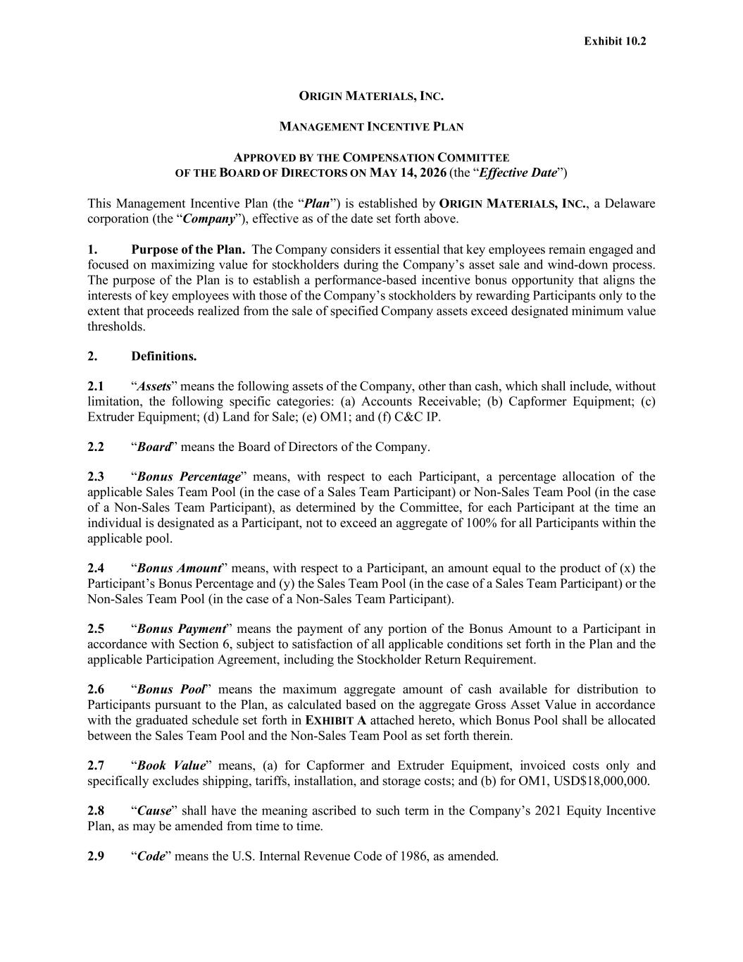
41
ORIGIN MATERIALS, INC. MANAGEMENT INCENTIVE PLAN APPROVED BY THE COMPENSATION COMMITTEE OF THE BOARD OF DIRECTORS ON MAY 14, 2026 (the “Effective Date”) This Management Incentive Plan (the “Plan”) is established by ORIGIN MATERIALS, INC., a Delaware corporation (the “Company”), effective as of the date set forth above. 1. Purpose of the Plan. The Company considers it essential that key employees remain engaged and focused on maximizing value for stockholders during the Company’s asset sale and wind-down process. The purpose of the Plan is to establish a performance-based incentive bonus opportunity that aligns the interests of key employees with those of the Company’s stockholders by rewarding Participants only to the extent that proceeds realized from the sale of specified Company assets exceed designated minimum value thresholds. 2. Definitions. 2.1 “Assets” means the following assets of the Company, other than cash, which shall include, without limitation, the following specific categories: (a) Accounts Receivable; (b) Capformer Equipment; (c) Extruder Equipment; (d) Land for Sale; (e) OM1; and (f) C&C IP. 2.2 “Board” means the Board of Directors of the Company. 2.3 “Bonus Percentage” means, with respect to each Participant, a percentage allocation of the applicable Sales Team Pool (in the case of a Sales Team Participant) or Non-Sales Team Pool (in the case of a Non-Sales Team Participant), as determined by the Committee, for each Participant at the time an individual is designated as a Participant, not to exceed an aggregate of 100% for all Participants within the applicable pool. 2.4 “Bonus Amount” means, with respect to a Participant, an amount equal to the product of (x) the Participant’s Bonus Percentage and (y) the Sales Team Pool (in the case of a Sales Team Participant) or the Non-Sales Team Pool (in the case of a Non-Sales Team Participant). 2.5 “Bonus Payment” means the payment of any portion of the Bonus Amount to a Participant in accordance with Section 6, subject to satisfaction of all applicable conditions set forth in the Plan and the applicable Participation Agreement, including the Stockholder Return Requirement. 2.6 “Bonus Pool” means the maximum aggregate amount of cash available for distribution to Participants pursuant to the Plan, as calculated based on the aggregate Gross Asset Value in accordance with the graduated schedule set forth in EXHIBIT A attached hereto, which Bonus Pool shall be allocated between the Sales Team Pool and the Non-Sales Team Pool as set forth therein. 2.7 “Book Value” means, (a) for Capformer and Extruder Equipment, invoiced costs only and specifically excludes shipping, tariffs, installation, and storage costs; and (b) for OM1, USD$18,000,000. 2.8 “Cause” shall have the meaning ascribed to such term in the Company’s 2021 Equity Incentive Plan, as may be amended from time to time. 2.9 “Code” means the U.S. Internal Revenue Code of 1986, as amended.

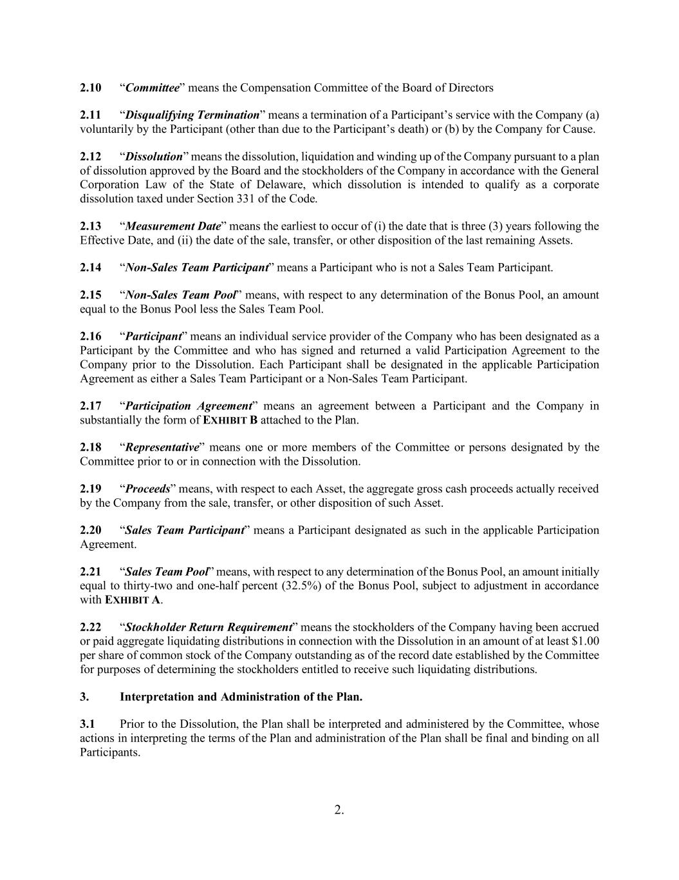
2. 2.10 “Committee” means the Compensation Committee of the Board of Directors 2.11 “Disqualifying Termination” means a termination of a Participant’s service with the Company (a) voluntarily by the Participant (other than due to the Participant’s death) or (b) by the Company for Cause. 2.12 “Dissolution” means the dissolution, liquidation and winding up of the Company pursuant to a plan of dissolution approved by the Board and the stockholders of the Company in accordance with the General Corporation Law of the State of Delaware, which dissolution is intended to qualify as a corporate dissolution taxed under Section 331 of the Code. 2.13 “Measurement Date” means the earliest to occur of (i) the date that is three (3) years following the Effective Date, and (ii) the date of the sale, transfer, or other disposition of the last remaining Assets. 2.14 “Non-Sales Team Participant” means a Participant who is not a Sales Team Participant. 2.15 “Non-Sales Team Pool” means, with respect to any determination of the Bonus Pool, an amount equal to the Bonus Pool less the Sales Team Pool. 2.16 “Participant” means an individual service provider of the Company who has been designated as a Participant by the Committee and who has signed and returned a valid Participation Agreement to the Company prior to the Dissolution. Each Participant shall be designated in the applicable Participation Agreement as either a Sales Team Participant or a Non-Sales Team Participant. 2.17 “Participation Agreement” means an agreement between a Participant and the Company in substantially the form of EXHIBIT B attached to the Plan. 2.18 “Representative” means one or more members of the Committee or persons designated by the Committee prior to or in connection with the Dissolution. 2.19 “Proceeds” means, with respect to each Asset, the aggregate gross cash proceeds actually received by the Company from the sale, transfer, or other disposition of such Asset. 2.20 “Sales Team Participant” means a Participant designated as such in the applicable Participation Agreement. 2.21 “Sales Team Pool” means, with respect to any determination of the Bonus Pool, an amount initially equal to thirty-two and one-half percent (32.5%) of the Bonus Pool, subject to adjustment in accordance with EXHIBIT A. 2.22 “Stockholder Return Requirement” means the stockholders of the Company having been accrued or paid aggregate liquidating distributions in connection with the Dissolution in an amount of at least $1.00 per share of common stock of the Company outstanding as of the record date established by the Committee for purposes of determining the stockholders entitled to receive such liquidating distributions. 3. Interpretation and Administration of the Plan. 3.1 Prior to the Dissolution, the Plan shall be interpreted and administered by the Committee, whose actions in interpreting the terms of the Plan and administration of the Plan shall be final and binding on all Participants.

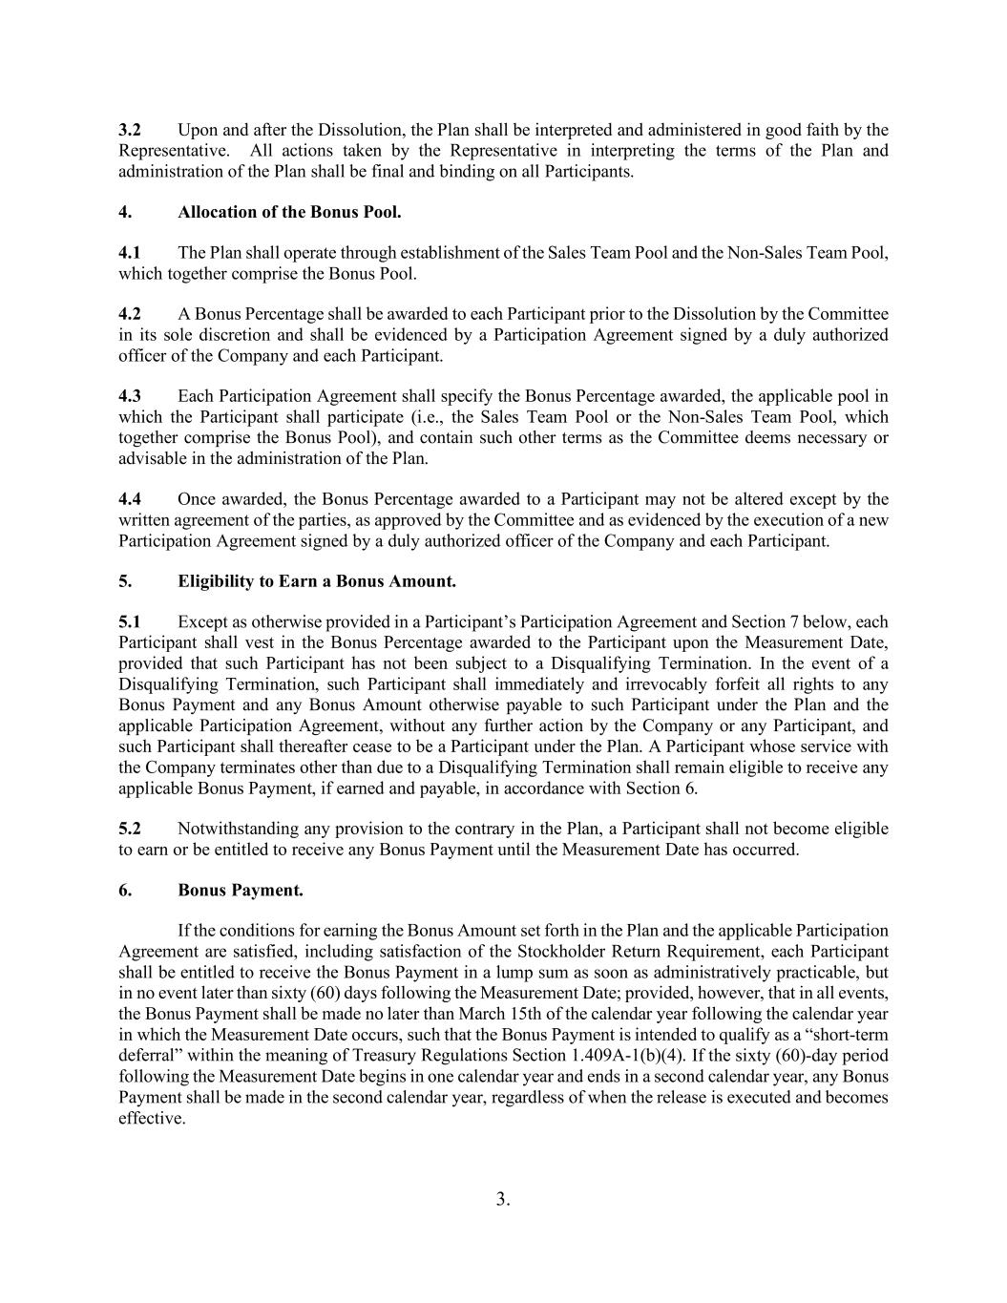
3. 3.2 Upon and after the Dissolution, the Plan shall be interpreted and administered in good faith by the Representative. All actions taken by the Representative in interpreting the terms of the Plan and administration of the Plan shall be final and binding on all Participants. 4. Allocation of the Bonus Pool. 4.1 The Plan shall operate through establishment of the Sales Team Pool and the Non-Sales Team Pool, which together comprise the Bonus Pool. 4.2 A Bonus Percentage shall be awarded to each Participant prior to the Dissolution by the Committee in its sole discretion and shall be evidenced by a Participation Agreement signed by a duly authorized officer of the Company and each Participant. 4.3 Each Participation Agreement shall specify the Bonus Percentage awarded, the applicable pool in which the Participant shall participate (i.e., the Sales Team Pool or the Non-Sales Team Pool, which together comprise the Bonus Pool), and contain such other terms as the Committee deems necessary or advisable in the administration of the Plan. 4.4 Once awarded, the Bonus Percentage awarded to a Participant may not be altered except by the written agreement of the parties, as approved by the Committee and as evidenced by the execution of a new Participation Agreement signed by a duly authorized officer of the Company and each Participant. 5. Eligibility to Earn a Bonus Amount. 5.1 Except as otherwise provided in a Participant’s Participation Agreement and Section 7 below, each Participant shall vest in the Bonus Percentage awarded to the Participant upon the Measurement Date, provided that such Participant has not been subject to a Disqualifying Termination. In the event of a Disqualifying Termination, such Participant shall immediately and irrevocably forfeit all rights to any Bonus Payment and any Bonus Amount otherwise payable to such Participant under the Plan and the applicable Participation Agreement, without any further action by the Company or any Participant, and such Participant shall thereafter cease to be a Participant under the Plan. A Participant whose service with the Company terminates other than due to a Disqualifying Termination shall remain eligible to receive any applicable Bonus Payment, if earned and payable, in accordance with Section 6. 5.2 Notwithstanding any provision to the contrary in the Plan, a Participant shall not become eligible to earn or be entitled to receive any Bonus Payment until the Measurement Date has occurred. 6. Bonus Payment. If the conditions for earning the Bonus Amount set forth in the Plan and the applicable Participation Agreement are satisfied, including satisfaction of the Stockholder Return Requirement, each Participant shall be entitled to receive the Bonus Payment in a lump sum as soon as administratively practicable, but in no event later than sixty (60) days following the Measurement Date; provided, however, that in all events, the Bonus Payment shall be made no later than March 15th of the calendar year following the calendar year in which the Measurement Date occurs, such that the Bonus Payment is intended to qualify as a “short-term deferral” within the meaning of Treasury Regulations Section 1.409A-1(b)(4). If the sixty (60)-day period following the Measurement Date begins in one calendar year and ends in a second calendar year, any Bonus Payment shall be made in the second calendar year, regardless of when the release is executed and becomes effective.

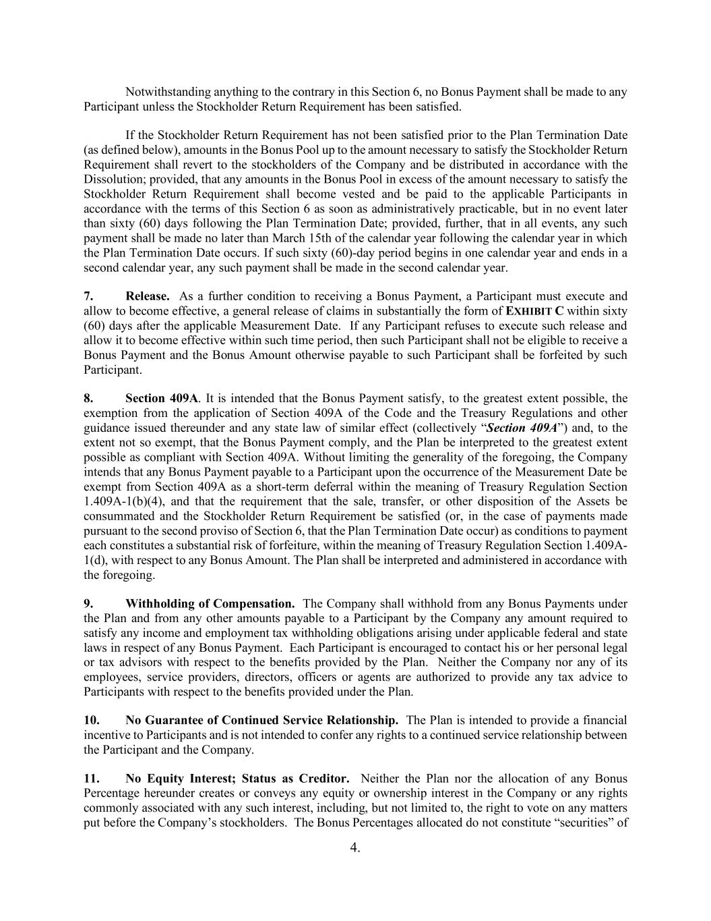
4. Notwithstanding anything to the contrary in this Section 6, no Bonus Payment shall be made to any Participant unless the Stockholder Return Requirement has been satisfied. If the Stockholder Return Requirement has not been satisfied prior to the Plan Termination Date (as defined below), amounts in the Bonus Pool up to the amount necessary to satisfy the Stockholder Return Requirement shall revert to the stockholders of the Company and be distributed in accordance with the Dissolution; provided, that any amounts in the Bonus Pool in excess of the amount necessary to satisfy the Stockholder Return Requirement shall become vested and be paid to the applicable Participants in accordance with the terms of this Section 6 as soon as administratively practicable, but in no event later than sixty (60) days following the Plan Termination Date; provided, further, that in all events, any such payment shall be made no later than March 15th of the calendar year following the calendar year in which the Plan Termination Date occurs. If such sixty (60)-day period begins in one calendar year and ends in a second calendar year, any such payment shall be made in the second calendar year. 7. Release. As a further condition to receiving a Bonus Payment, a Participant must execute and allow to become effective, a general release of claims in substantially the form of EXHIBIT C within sixty (60) days after the applicable Measurement Date. If any Participant refuses to execute such release and allow it to become effective within such time period, then such Participant shall not be eligible to receive a Bonus Payment and the Bonus Amount otherwise payable to such Participant shall be forfeited by such Participant. 8. Section 409A. It is intended that the Bonus Payment satisfy, to the greatest extent possible, the exemption from the application of Section 409A of the Code and the Treasury Regulations and other guidance issued thereunder and any state law of similar effect (collectively “Section 409A”) and, to the extent not so exempt, that the Bonus Payment comply, and the Plan be interpreted to the greatest extent possible as compliant with Section 409A. Without limiting the generality of the foregoing, the Company intends that any Bonus Payment payable to a Participant upon the occurrence of the Measurement Date be exempt from Section 409A as a short-term deferral within the meaning of Treasury Regulation Section 1.409A-1(b)(4), and that the requirement that the sale, transfer, or other disposition of the Assets be consummated and the Stockholder Return Requirement be satisfied (or, in the case of payments made pursuant to the second proviso of Section 6, that the Plan Termination Date occur) as conditions to payment each constitutes a substantial risk of forfeiture, within the meaning of Treasury Regulation Section 1.409A- 1(d), with respect to any Bonus Amount. The Plan shall be interpreted and administered in accordance with the foregoing. 9. Withholding of Compensation. The Company shall withhold from any Bonus Payments under the Plan and from any other amounts payable to a Participant by the Company any amount required to satisfy any income and employment tax withholding obligations arising under applicable federal and state laws in respect of any Bonus Payment. Each Participant is encouraged to contact his or her personal legal or tax advisors with respect to the benefits provided by the Plan. Neither the Company nor any of its employees, service providers, directors, officers or agents are authorized to provide any tax advice to Participants with respect to the benefits provided under the Plan. 10. No Guarantee of Continued Service Relationship. The Plan is intended to provide a financial incentive to Participants and is not intended to confer any rights to a continued service relationship between the Participant and the Company. 11. No Equity Interest; Status as Creditor. Neither the Plan nor the allocation of any Bonus Percentage hereunder creates or conveys any equity or ownership interest in the Company or any rights commonly associated with any such interest, including, but not limited to, the right to vote on any matters put before the Company’s stockholders. The Bonus Percentages allocated do not constitute “securities” of

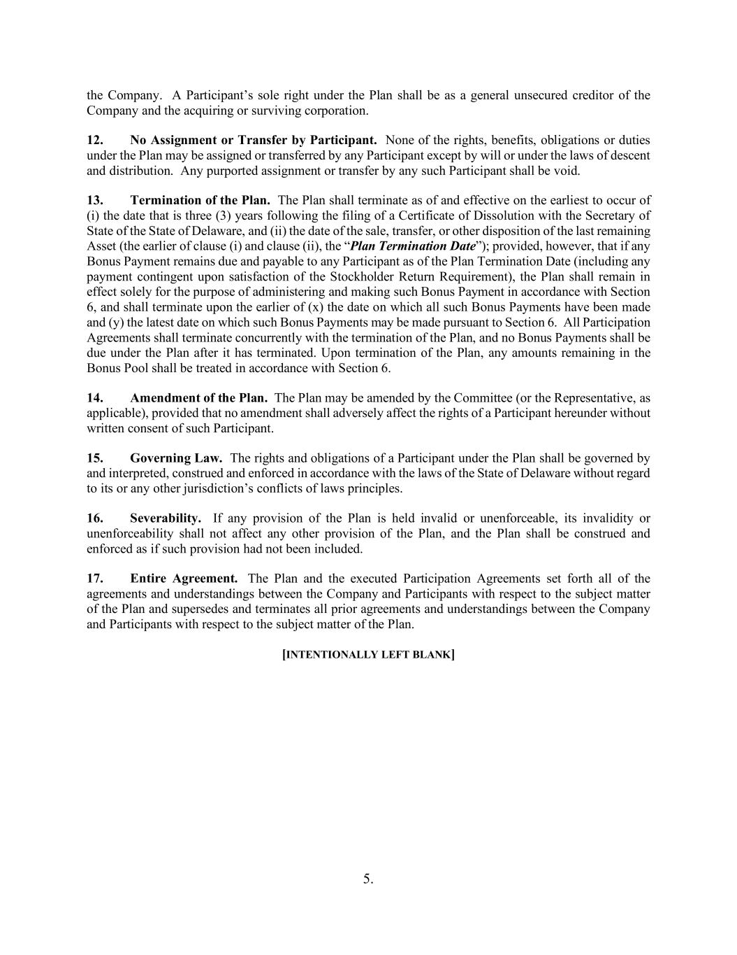
5. the Company. A Participant’s sole right under the Plan shall be as a general unsecured creditor of the Company and the acquiring or surviving corporation. 12. No Assignment or Transfer by Participant. None of the rights, benefits, obligations or duties under the Plan may be assigned or transferred by any Participant except by will or under the laws of descent and distribution. Any purported assignment or transfer by any such Participant shall be void. 13. Termination of the Plan. The Plan shall terminate as of and effective on the earliest to occur of (i) the date that is three (3) years following the filing of a Certificate of Dissolution with the Secretary of State of the State of Delaware, and (ii) the date of the sale, transfer, or other disposition of the last remaining Asset (the earlier of clause (i) and clause (ii), the “Plan Termination Date”); provided, however, that if any Bonus Payment remains due and payable to any Participant as of the Plan Termination Date (including any payment contingent upon satisfaction of the Stockholder Return Requirement), the Plan shall remain in effect solely for the purpose of administering and making such Bonus Payment in accordance with Section 6, and shall terminate upon the earlier of (x) the date on which all such Bonus Payments have been made and (y) the latest date on which such Bonus Payments may be made pursuant to Section 6. All Participation Agreements shall terminate concurrently with the termination of the Plan, and no Bonus Payments shall be due under the Plan after it has terminated. Upon termination of the Plan, any amounts remaining in the Bonus Pool shall be treated in accordance with Section 6. 14. Amendment of the Plan. The Plan may be amended by the Committee (or the Representative, as applicable), provided that no amendment shall adversely affect the rights of a Participant hereunder without written consent of such Participant. 15. Governing Law. The rights and obligations of a Participant under the Plan shall be governed by and interpreted, construed and enforced in accordance with the laws of the State of Delaware without regard to its or any other jurisdiction’s conflicts of laws principles. 16. Severability. If any provision of the Plan is held invalid or unenforceable, its invalidity or unenforceability shall not affect any other provision of the Plan, and the Plan shall be construed and enforced as if such provision had not been included. 17. Entire Agreement. The Plan and the executed Participation Agreements set forth all of the agreements and understandings between the Company and Participants with respect to the subject matter of the Plan and supersedes and terminates all prior agreements and understandings between the Company and Participants with respect to the subject matter of the Plan. [INTENTIONALLY LEFT BLANK]

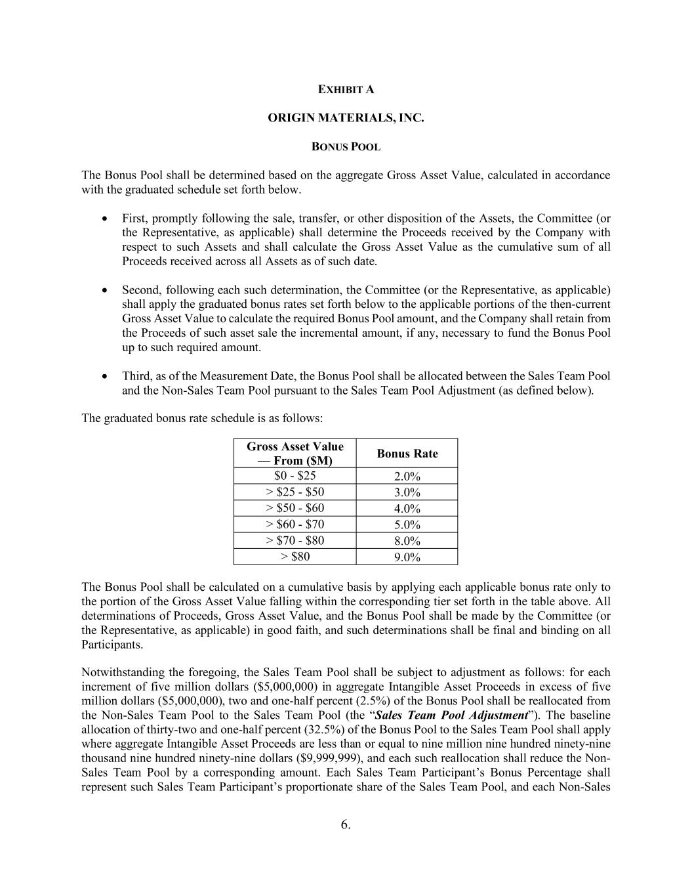
6. EXHIBIT A ORIGIN MATERIALS, INC. BONUS POOL The Bonus Pool shall be determined based on the aggregate Gross Asset Value, calculated in accordance with the graduated schedule set forth below. First, promptly following the sale, transfer, or other disposition of the Assets, the Committee (or the Representative, as applicable) shall determine the Proceeds received by the Company with respect to such Assets and shall calculate the Gross Asset Value as the cumulative sum of all Proceeds received across all Assets as of such date. Second, following each such determination, the Committee (or the Representative, as applicable) shall apply the graduated bonus rates set forth below to the applicable portions of the then-current Gross Asset Value to calculate the required Bonus Pool amount, and the Company shall retain from the Proceeds of such asset sale the incremental amount, if any, necessary to fund the Bonus Pool up to such required amount. Third, as of the Measurement Date, the Bonus Pool shall be allocated between the Sales Team Pool and the Non-Sales Team Pool pursuant to the Sales Team Pool Adjustment (as defined below). The graduated bonus rate schedule is as follows: Gross Asset Value — From ($M) Bonus Rate $0 - $25 2.0% > $25 - $50 3.0% > $50 - $60 4.0% > $60 - $70 5.0% > $70 - $80 8.0% > $80 9.0% The Bonus Pool shall be calculated on a cumulative basis by applying each applicable bonus rate only to the portion of the Gross Asset Value falling within the corresponding tier set forth in the table above. All determinations of Proceeds, Gross Asset Value, and the Bonus Pool shall be made by the Committee (or the Representative, as applicable) in good faith, and such determinations shall be final and binding on all Participants. Notwithstanding the foregoing, the Sales Team Pool shall be subject to adjustment as follows: for each increment of five million dollars ($5,000,000) in aggregate Intangible Asset Proceeds in excess of five million dollars ($5,000,000), two and one-half percent (2.5%) of the Bonus Pool shall be reallocated from the Non-Sales Team Pool to the Sales Team Pool (the “Sales Team Pool Adjustment”). The baseline allocation of thirty-two and one-half percent (32.5%) of the Bonus Pool to the Sales Team Pool shall apply where aggregate Intangible Asset Proceeds are less than or equal to nine million nine hundred ninety-nine thousand nine hundred ninety-nine dollars ($9,999,999), and each such reallocation shall reduce the Non- Sales Team Pool by a corresponding amount. Each Sales Team Participant’s Bonus Percentage shall represent such Sales Team Participant’s proportionate share of the Sales Team Pool, and each Non-Sales

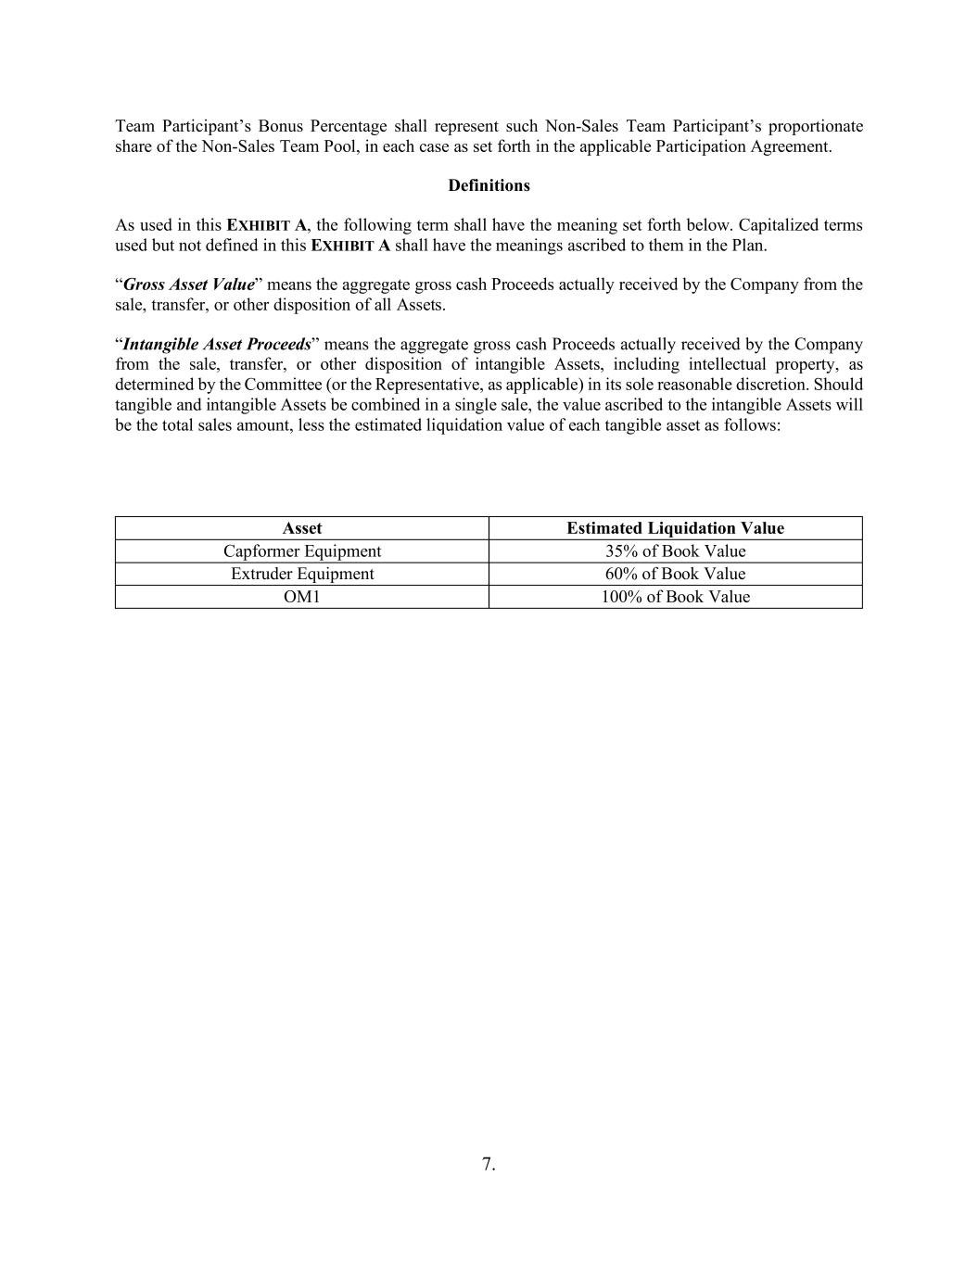
7. Team Participant’s Bonus Percentage shall represent such Non-Sales Team Participant’s proportionate share of the Non-Sales Team Pool, in each case as set forth in the applicable Participation Agreement. Definitions As used in this EXHIBIT A, the following term shall have the meaning set forth below. Capitalized terms used but not defined in this EXHIBIT A shall have the meanings ascribed to them in the Plan. “Gross Asset Value” means the aggregate gross cash Proceeds actually received by the Company from the sale, transfer, or other disposition of all Assets. “Intangible Asset Proceeds” means the aggregate gross cash Proceeds actually received by the Company from the sale, transfer, or other disposition of intangible Assets, including intellectual property, as determined by the Committee (or the Representative, as applicable) in its sole reasonable discretion. Should tangible and intangible Assets be combined in a single sale, the value ascribed to the intangible Assets will be the total sales amount, less the estimated liquidation value of each tangible asset as follows: Asset Estimated Liquidation Value Capformer Equipment 35% of Book Value Extruder Equipment 60% of Book Value OM1 100% of Book Value

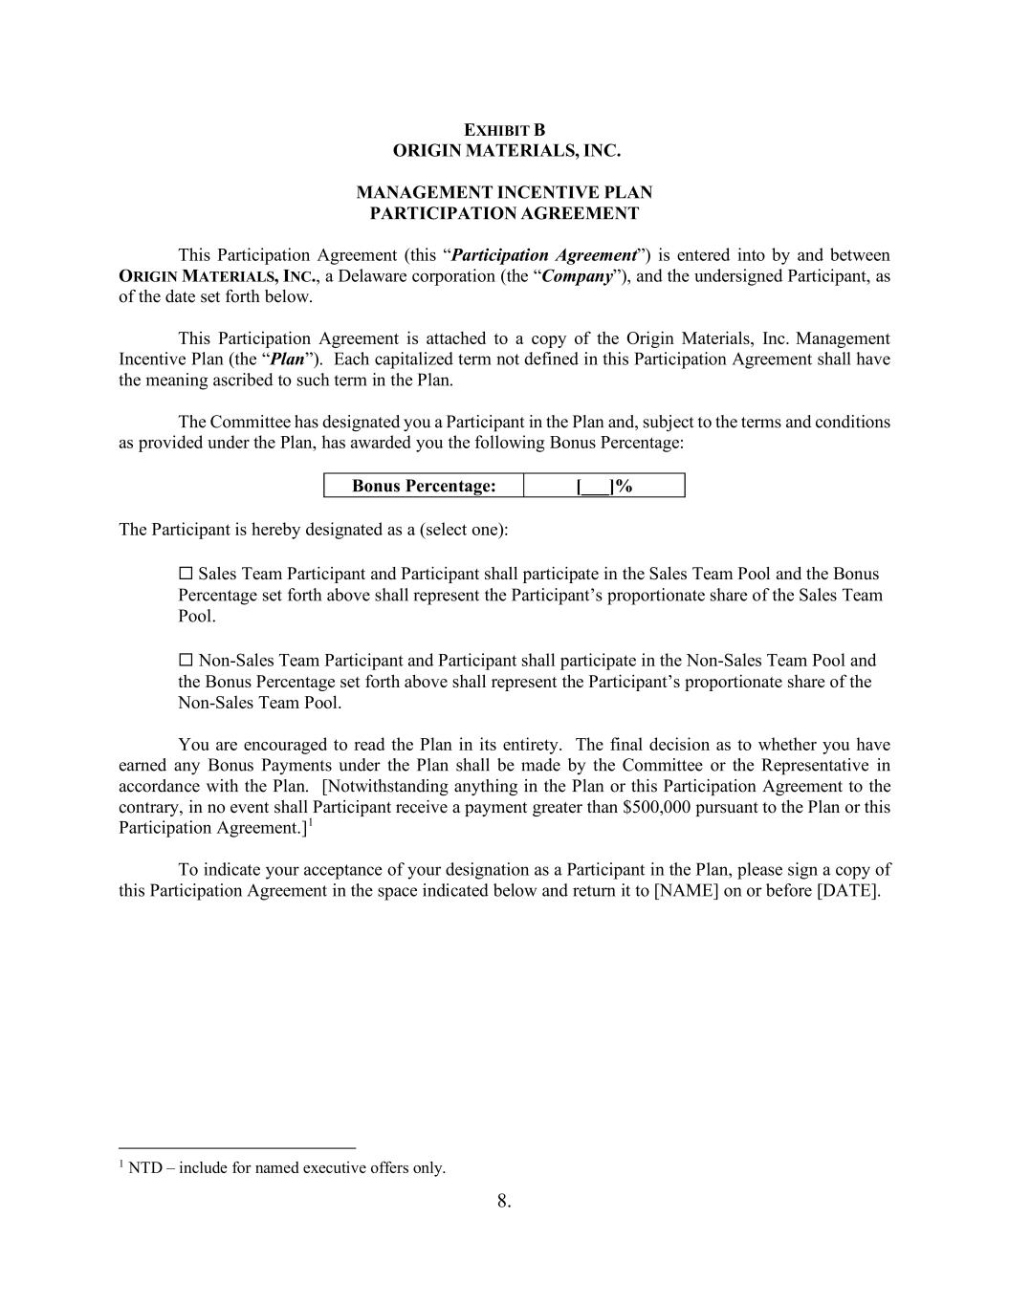
8. EXHIBIT B ORIGIN MATERIALS, INC. MANAGEMENT INCENTIVE PLAN PARTICIPATION AGREEMENT This Participation Agreement (this “Participation Agreement”) is entered into by and between ORIGIN MATERIALS, INC., a Delaware corporation (the “Company”), and the undersigned Participant, as of the date set forth below. This Participation Agreement is attached to a copy of the Origin Materials, Inc. Management Incentive Plan (the “Plan”). Each capitalized term not defined in this Participation Agreement shall have the meaning ascribed to such term in the Plan. The Committee has designated you a Participant in the Plan and, subject to the terms and conditions as provided under the Plan, has awarded you the following Bonus Percentage: Bonus Percentage: [___]% The Participant is hereby designated as a (select one): Sales Team Participant and Participant shall participate in the Sales Team Pool and the Bonus Percentage set forth above shall represent the Participant’s proportionate share of the Sales Team Pool. Non-Sales Team Participant and Participant shall participate in the Non-Sales Team Pool and the Bonus Percentage set forth above shall represent the Participant’s proportionate share of the Non-Sales Team Pool. 1 NTD – include for named executive offers only. You are encouraged to read the Plan in its entirety. The final decision as to whether you have earned any Bonus Payments under the Plan shall be made by the Committee or the Representative in accordance with the Plan. [Notwithstanding anything in the Plan or this Participation Agreement to the contrary, in no event shall Participant receive a payment greater than $500,000 pursuant to the Plan or this Participation Agreement.]1 To indicate your acceptance of your designation as a Participant in the Plan, please sign a copy of this Participation Agreement in the space indicated below and return it to [NAME] on or before [DATE].

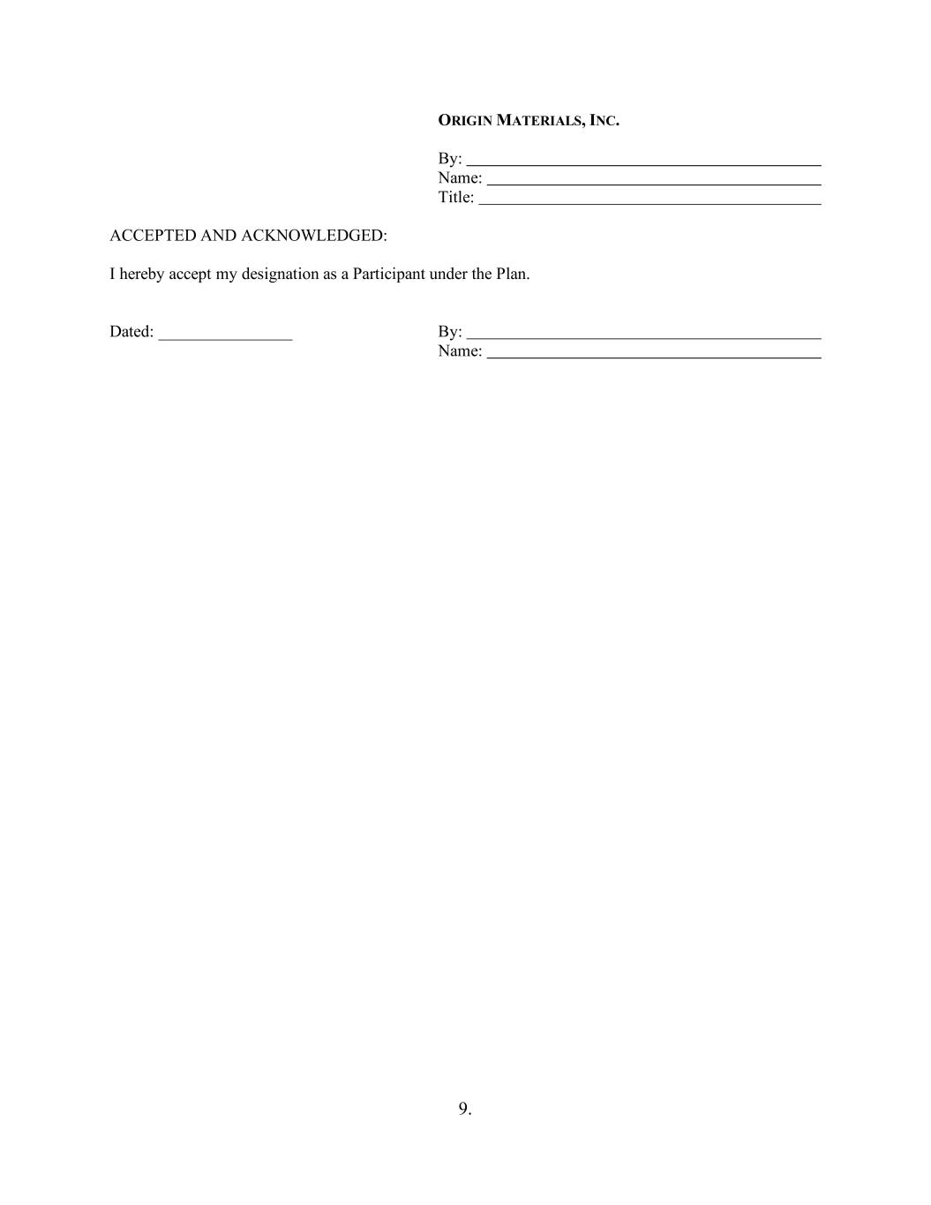
9. ORIGIN MATERIALS, INC. By: Name: Title: ACCEPTED AND ACKNOWLEDGED: I hereby accept my designation as a Participant under the Plan. Dated: ________________ By: Name:

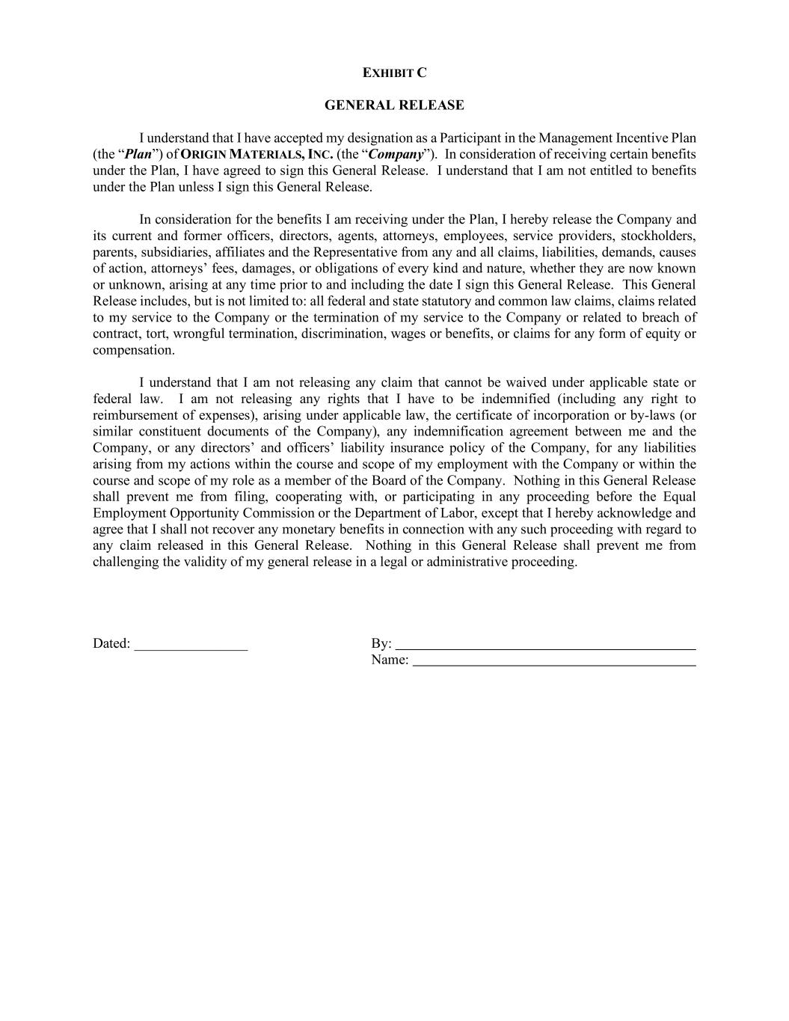
EXHIBIT C GENERAL RELEASE I understand that I have accepted my designation as a Participant in the Management Incentive Plan (the “Plan”) of ORIGIN MATERIALS, INC. (the “Company”). In consideration of receiving certain benefits under the Plan, I have agreed to sign this General Release. I understand that I am not entitled to benefits under the Plan unless I sign this General Release. In consideration for the benefits I am receiving under the Plan, I hereby release the Company and its current and former officers, directors, agents, attorneys, employees, service providers, stockholders, parents, subsidiaries, affiliates and the Representative from any and all claims, liabilities, demands, causes of action, attorneys’ fees, damages, or obligations of every kind and nature, whether they are now known or unknown, arising at any time prior to and including the date I sign this General Release. This General Release includes, but is not limited to: all federal and state statutory and common law claims, claims related to my service to the Company or the termination of my service to the Company or related to breach of contract, tort, wrongful termination, discrimination, wages or benefits, or claims for any form of equity or compensation. I understand that I am not releasing any claim that cannot be waived under applicable state or federal law. I am not releasing any rights that I have to be indemnified (including any right to reimbursement of expenses), arising under applicable law, the certificate of incorporation or by-laws (or similar constituent documents of the Company), any indemnification agreement between me and the Company, or any directors’ and officers’ liability insurance policy of the Company, for any liabilities arising from my actions within the course and scope of my employment with the Company or within the course and scope of my role as a member of the Board of the Company. Nothing in this General Release shall prevent me from filing, cooperating with, or participating in any proceeding before the Equal Employment Opportunity Commission or the Department of Labor, except that I hereby acknowledge and agree that I shall not recover any monetary benefits in connection with any such proceeding with regard to any claim released in this General Release. Nothing in this General Release shall prevent me from challenging the validity of my general release in a legal or administrative proceeding. Dated: ________________ By: Name:

Exhibit 31.1
CERTIFICATION PURSUANT TO
RULES 13a-14(a) AND 15d-14(a) UNDER THE SECURITIES EXCHANGE ACT OF 1934,
AS ADOPTED PURSUANT TO SECTION 302 OF THE SARBANES-OXLEY ACT OF 2002
I, Matthew Plavan, certify that:
1.I have reviewed this Quarterly Report on Form 10-Q of Origin Materials, Inc.;
2.Based on my knowledge, this report does not contain any untrue statement of a material fact or omit to state a material fact necessary to make the statements made, in light of the circumstances under which such statements were made, not misleading with respect to the period covered by this report;
3.Based on my knowledge, the financial statements, and other financial information included in this report, fairly present in all material respects the financial condition, results of operations and cash flows of the registrant as of, and for, the periods presented in this report;
4.I am responsible for establishing and maintaining disclosure controls and procedures (as defined in Exchange Act Rules 13a-15(e) and 15d-15(e)) and internal control over financial reporting (as defined in Exchange Act Rules 13a-15(f) and 15d-15(f)) for the registrant and have:
a)Designed such disclosure controls and procedures, or caused such disclosure controls and procedures to be designed under our supervision, to ensure that material information relating to the registrant, including its consolidated subsidiaries, is made known to us by others within those entities, particularly during the period in which this report is being prepared;
b)Designed such internal control over financial reporting, or caused such internal control over financial reporting to be designed under our supervision, to provide reasonable assurance regarding the reliability of financial reporting and the preparation of financial statements for external purposes in accordance with generally accepted accounting principles;
c)Evaluated the effectiveness of the registrant’s disclosure controls and procedures and presented in this report our conclusions about the effectiveness of the disclosure controls and procedures, as of the end of the period covered by this report based on such evaluation; and
d)Disclosed in this report any change in the registrant’s internal control over financial reporting that occurred during the registrant’s most recent fiscal quarter (the registrant’s fourth fiscal quarter in the case of an annual report) that has materially affected, or is reasonably likely to materially affect, the registrant’s internal control over financial reporting; and
5.I have disclosed, based on my most recent evaluation of internal control over financial reporting, to the registrant’s auditors and the audit committee of the registrant’s board of directors (or persons performing the equivalent functions):
a)All significant deficiencies and material weaknesses in the design or operation of internal control over financial reporting which are reasonably likely to adversely affect the registrant’s ability to record, process, summarize and report financial information; and
b)Any fraud, whether or not material, that involves management or other employees who have a significant role in the registrant’s internal control over financial reporting.
Date: May 14, 2026 |  |  | By: |  |  | /s/ Matthew Plavan
 |  |  |  |  |  | Matthew Plavan
 |  |  |  |  |  | Interim Chief Executive Officer, Chief Financial Officer and Chief Operating Officer
 |  |  |  |  |  | (Principal Executive Officer and Principal Financial and Accounting Officer)

Exhibit 32.1
CERTIFICATION PURSUANT TO
18 U.S.C. SECTION 1350, AS ADOPTED PURSUANT TO
SECTION 906 OF THE SARBANES-OXLEY ACT OF 2002
Pursuant to the requirement set forth in Rule 13a-14(b) of the Securities Exchange Act of 1934, as amended (the “Exchange Act”) and Section 1350 of Chapter 63 of Title 18 of the United States Code (18 U.S.C. § 1350), Matthew Plavan, Interim Chief Executive Officer, Chief Financial Officer and Chief Operating Officer of Origin Materials, Inc (the “Company”), hereby certifies that, to the best of his knowledge:
1.The Company’s Quarterly Report on Form 10-Q for the quarterly period ended March 31, 2026, to which this Certification is attached as Exhibit 32.1 (the “Report”), fully complies with the requirements of Section 13(a) or Section 15(d) of the Exchange Act; and
2.The information contained in the Report fairly presents, in all material respects, the financial condition and results of operations of the Company.
Date: May 14, 2026 |  |  | By: |  |  | /s/ Matthew Plavan
 |  |  |  |  |  | Matthew Plavan
 |  |  |  |  |  | Interim Chief Executive Officer, Chief Financial Officer and Chief Operating Officer
 |  |  |  |  |  | (Principal Executive Officer and Principal Financial and Accounting Officer)
This certification accompanies the Form 10-Q to which it relates, is not deemed filed with the Securities and Exchange Commission and is not to be incorporated by reference into any filing of Origin Materials, Inc. under the Securities Act of 1933, as amended, or the Securities Exchange Act of 1934, as amended (whether made before or after the date of the Form 10-Q), irrespective of any general incorporation language contained in such filing.

